

Fundamentals of Composition

Fundamentals of Composition

Joseph Donica, Bronx Community College

Fundamentals of Composition by Lumen Learning is licensed under a Creative Commons Attribution 4.0 International License, except where otherwise noted.

Contents
- Faculty Resources
- I Need Help
- Module 1
- Reading: Defining Social Stratification
- Reading: Class Structure in the United States
- Common Sentence Structures
- Module 2
- Reading: Introduction to Global Inequality
- Reading: Social Mobility
- Rhetorical Context
- Module 3
- Outcome: Global Wealth and Poverty
- Reading: The Impact of Poverty
- How to Write a Thesis Statement
- Essay 1 Prompt
- Module 4
- Reading: Theoretical Perspectives on Social Stratification
- Reading: Theoretical Perspectives on Global Stratification
- The Perfect Paragraph
- Module 5
- Introductions and Conclusions
- The Great Recession
- New Horizons
- Essay 2 Prompt
- Module 6
- Higher Order Concerns for Editing
- Who Governs? Elitism, Pluralism, and Tradeoffs
- Engagement in a Democracy
- Module 7
- Reading: Levels of Social Movements
- Reading: Collective Behavior
- Lower Order Concerns for Proofreading
- Module 8
- Reading: Types and Stages of Social Movements
- Reading: Theoretical Perspectives on Social Movements
- Preliminary Research Strategies
- Module 9
- Reading: Occupy Wall Street
- Reading: Social Change and Modernization
- Advanced Search Strategies
- Essay 3 Prompt
- Module 10
- Primary, Secondary, and Tertiary Sources
- Farmers Revolt in the Populist Era
- The African American Struggle for Civil Rights
- Module 11
- Using Sources in Your Paper
- The Civil Rights Movement Marches On
- New Century, Old Disputes
- Essay 4 Prompt
- Module 12
- The War on Terror
- Hope and Change
- Introduction to MLA Documentation

PART I

Faculty Resources

Chapter 1

I Need Help

Need more information about this course? Have questions about faculty resources? Can’t find what you’re looking for? Experiencing technical difficulties?
We’re here to help! Take advantage of the following Lumen customer-support resources:
- Check out one of Lumen’s Faculty User Guides here.
- Submit a support ticket here and tell us what you need.
- Talk and screen-share with a live human during Lumen’s OER office hours. See available times here.

PART II

Module 1

Chapter 2

Reading: Defining Social Stratification


Sociologists use the term social stratification to describe the system of social standing. Social stratification refers to a society’s categorization of its people into rankings of socioeconomic tiers based on factors like wealth, income, race, education, and power.
You may remember the word “stratification” from geology class. The distinct vertical layers found in rock, called stratification, are a good way to visualize social structure. Society’s layers are made of people, and society’s resources are distributed unevenly throughout the layers. The people who have more resources represent the top layer of the social structure of stratification. Other groups of people, with progressively fewer and fewer resources, represent the lower layers of our society.

In the United States, people like to believe everyone has an equal chance at success. To a certain extent, Aaron illustrates the belief that hard work and talent—not prejudicial treatment or societal values—determine social rank. This emphasis on self-effort perpetuates the belief that people control their own social standing.
However, sociologists recognize that social stratification is a society-wide system that makes inequalities apparent. While there are always inequalities between individuals, sociologists are interested in larger social patterns. Stratification is not about individual inequalities, but about systematic inequalities based on group membership, classes, and the like. No individual, rich or poor, can be blamed for social inequalities. The structure of society affects a person’s social standing. Although individuals may support or fight inequalities, social stratification is created and supported by society as a whole.

Factors that define stratification vary in different societies. In most societies, stratification is an economic system, based on wealth, the net value of money and assets a person has, and income, a person’s wages or investment dividends. While people are regularly categorized based on how rich or poor they are, other important factors influence social standing. For example, in some cultures, wisdom and charisma are valued, and people who have them are revered more than those who don’t. In some cultures, the elderly are esteemed; in others, the elderly are disparaged or overlooked. Societies’ cultural beliefs often reinforce the inequalities of stratification.
One key determinant of social standing is the social standing of our parents. Parents tend to pass their social position on to their children. People inherit not only social standing but also the cultural norms that accompany a certain lifestyle. They share these with a network of friends and family members. Social standing becomes a comfort zone, a familiar lifestyle, and an identity. This is one of the reasons first-generation college students do not fare as well as other students.
Other determinants are found in a society’s occupational structure. Teachers, for example, often have high levels of education but receive relatively low pay. Many believe that teaching is a noble profession, so teachers should do their jobs for love of their profession and the good of their students—not for money. Yet no successful executive or entrepreneur would embrace that attitude in the business world, where profits are valued as a driving force. Cultural attitudes and beliefs like these support and perpetuate social inequalities.

Recent Economic Changes and U.S. Stratification
As a result of the Great Recession that rocked our nation’s economy in the last few years, many families and individuals found themselves struggling like never before. The nation fell into a period of prolonged and exceptionally high unemployment. While no one was completely insulated from the recession, perhaps those in the lower classes felt the impact most profoundly. Before the recession, many were living paycheck to paycheck or even had been living comfortably. As the recession hit, they were often among the first to lose their jobs. Unable to find replacement employment, they faced more than loss of income. Their homes were foreclosed, their cars were repossessed, and their ability to afford healthcare was taken away. This put many in the position of deciding whether to put food on the table or fill a needed prescription.
While we’re not completely out of the woods economically, there are several signs that we’re on the road to recovery. Many of those who suffered during the recession are back to work and are busy rebuilding their lives. The Affordable Health Care Act has provided health insurance to millions who lost or never had it.
But the Great Recession, like the Great Depression, has changed social attitudes. Where once it was important to demonstrate wealth by wearing expensive clothing items like Calvin Klein shirts and Louis Vuitton shoes, now there’s a new, thriftier way of thinking. In many circles, it has become hip to be frugal. It’s no longer about how much we spend, but about how much we don’t spend. Think of shows like Extreme Couponing on TLC and songs like Macklemore’s “Thrift Shop.”

Think It Over
Review the concept of stratification. Now choose a group of people you have observed and been a part of—for example, cousins, high school friends, classmates, sport teammates, or coworkers. How does the structure of the social group you chose adhere to the concept of stratification?

Practice

1. Which person best illustrates opportunities for upward social mobility in the United States?
- First-shift factory worker
- First-generation college student
- Firstborn son who inherits the family business
- First-time interviewee who is hired for a job

b

income:
the money a person earns from work or investments
social stratification:
a socioeconomic system that divides society’s members into categories ranking from high to low, based on things like wealth, power, and prestige
wealth:
the value of money and assets a person has from, for example, inheritance

Chapter 3

Reading: Class Structure in the United States

Class Traits
Class traits, also called class markers, are the typical behaviors, customs, and norms that define each class. Class traits indicate the level of exposure a person has to a wide range of cultures. Class traits also indicate the amount of resources a person has to spend on items like hobbies, vacations, and leisure activities.
People may associate the upper class with enjoyment of costly, refined, or highly cultivated tastes—expensive clothing, luxury cars, high-end fund-raisers, and opulent vacations. People may also believe that the middle and lower classes are more likely to enjoy camping, fishing, or hunting, shopping at large retailers, and participating in community activities. While these descriptions may identify class traits, they may also simply be stereotypes. Moreover, just as class distinctions have blurred in recent decades, so too have class traits. A very wealthy person may enjoy bowling as much as opera. A factory worker could be a skilled French cook. A billionaire might dress in ripped jeans, and a low-income student might own designer shoes.

Social Classes in the United States
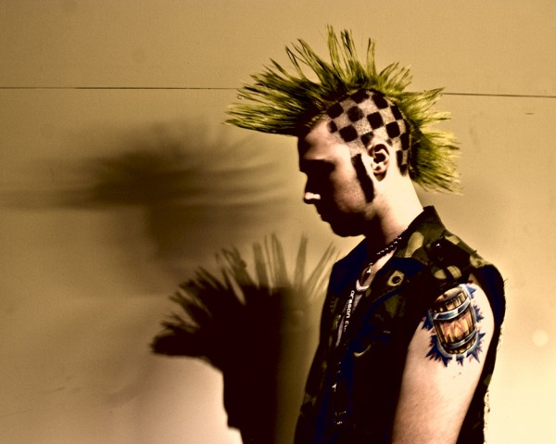
Does a person’s appearance indicate class? Can you tell a man’s education level based on his clothing? Do you know a woman’s income by the car she drives?
For sociologists, categorizing class is a fluid science. Sociologists generally identify three levels of class in the United States: upper, middle, and lower class. Within each class, there are many subcategories. Wealth is the most significant way of distinguishing classes, because wealth can be transferred to one’s children and perpetuate the class structure. One economist, J.D. Foster, defines the 20 percent of U.S. citizens’ highest earners as “upper income,” and the lower 20 percent as “lower income.” The remaining 60 percent of the population make up the middle class. But by that distinction, annual household incomes for the middle class range between $25,000 and $100,000 (Mason and Sullivan 2010).
One sociological perspective distinguishes the classes, in part, according to their relative power and control over their lives. The upper class not only have power and control over their own lives but also their social status gives them power and control over others’ lives. The middle class doesn’t generally control other strata of society, but its members do exert control over their own lives. In contrast, the lower class has little control over their work or lives. Below, we will explore the major divisions of U.S. social class and their key subcategories.

Upper Class

The upper class is considered the top, and only the powerful elite get to see the view from there. In the United States, people with extreme wealth make up 1 percent of the population, and they own one-third of the country’s wealth (Beeghley 2008).
Money provides not just access to material goods, but also access to a lot of power. As corporate leaders, members of the upper class make decisions that affect the job status of millions of people. As media owners, they influence the collective identity of the nation. They run the major network television stations, radio broadcasts, newspapers, magazines, publishing houses, and sports franchises. As board members of the most influential colleges and universities, they influence cultural attitudes and values. As philanthropists, they establish foundations to support social causes they believe in. As campaign contributors, they sway politicians and fund campaigns, sometimes to protect their own economic interests.
U.S. society has historically distinguished between “old money” (inherited wealth passed from one generation to the next) and “new money” (wealth you have earned and built yourself). While both types may have equal net worth, they have traditionally held different social standings. People of old money, firmly situated in the upper class for generations, have held high prestige. Their families have socialized them to know the customs, norms, and expectations that come with wealth. Often, the very wealthy don’t work for wages. Some study business or become lawyers in order to manage the family fortune. Others, such as Paris Hilton and Kim Kardashian, capitalize on being a rich socialite and transform that into celebrity status, flaunting a wealthy lifestyle.
However, new-money members of the upper class are not oriented to the customs and mores of the elite. They haven’t gone to the most exclusive schools. They have not established old-money social ties. People with new money might flaunt their wealth, buying sports cars and mansions, but they might still exhibit behaviors attributed to the middle and lower classes.

The Middle Class

Many people consider themselves middle class, but there are differing ideas about what that means. People with annual incomes of $150,000 call themselves middle class, as do people who annually earn $30,000. That helps explain why, in the United States, the middle class is broken into upper and lower subcategories.
Upper-middle-class people tend to hold bachelor’s and postgraduate degrees. They’ve studied subjects such as business, management, law, or medicine. Lower-middle-class members hold bachelor’s degrees from four-year colleges or associate’s degrees from two-year community or technical colleges.
Comfort is a key concept to the middle class. Middle-class people work hard and live fairly comfortable lives. Upper-middle-class people tend to pursue careers that earn comfortable incomes. They provide their families with large homes and nice cars. They may go skiing or boating on vacation. Their children receive high-quality education and healthcare (Gilbert 2010).
In the lower middle class, people hold jobs supervised by members of the upper middle class. They fill technical, lower-level management or administrative support positions. Compared to lower-class work, lower-middle-class jobs carry more prestige and come with slightly higher paychecks. With these incomes, people can afford a decent, mainstream lifestyle, but they struggle to maintain it. They generally don’t have enough income to build significant savings. In addition, their grip on class status is more precarious than in the upper tiers of the class system. When budgets are tight, lower-middle-class people are often the ones to lose their jobs.

The Lower Class

The lower class is also referred to as the working class. Just like the middle and upper classes, the lower class can be divided into subsets: the working class, the working poor, and the underclass. Compared to the lower middle class, lower-class people have less of an educational background and earn smaller incomes. They work jobs that require little prior skill or experience and often do routine tasks under close supervision.
Working-class people, the highest subcategory of the lower class, often land decent jobs in fields like custodial or food service. The work is hands-on and often physically demanding, such as landscaping, cooking, cleaning, or building.
Beneath the working class is the working poor. Like the working class, they have unskilled, low-paying employment. However, their jobs rarely offer benefits such as healthcare or retirement planning, and their positions are often seasonal or temporary. They work as sharecroppers, migrant farm workers, housecleaners, and day laborers. Some are high school dropouts. Some are illiterate, unable to read job ads.
How can people work full-time and still be poor? Even working full-time, millions of the working poor earn incomes too meager to support a family. Minimum wage varies from state to state, but in many states it is approaching $8.00 per hour (Department of Labor 2014). At that rate, working 40 hours a week earns $320. That comes to $16,640 a year, before tax and deductions. Even for a single person, the pay is low. A married couple with children will have a hard time covering expenses.
The underclass is the United States’ lowest tier. Members of the underclass live mainly in inner cities. Many are unemployed or underemployed. Those who do hold jobs typically perform menial tasks for little pay. Some of the underclass are homeless. For many, welfare systems provide a much-needed support through food assistance, medical care, housing, and the like.

Further Research
Watch this short video to see an example of how social classes influence family life and spending on children. As you watch it, think about the long-term societal impacts of the tendency for wealthier parents to spend more money on their kids.

Think It Over

- What class traits define your peer group? For example, what speech patterns or clothing trends do you and your friends share? What cultural elements, such as taste in music or hobbies, define your peer group? How do you see this set of class traits as different from other classes either above or below yours?
- Write a list of ten to twenty class traits that describe the environment of your upbringing. Which of these seem like true class traits, and which seem like stereotypes? What items might fall into both categories? How do you imagine a sociologist might address the conflation of class traits and stereotypes?

Practice

1. In the United States, most people define themselves as:
- middle class
- upper class
- lower class
- no specific class

a

2. The behaviors, customs, and norms associated with a class are known as:
- class traits
- power
- prestige
- underclass

a

3. Occupational prestige means that jobs are:
- all equal in status
- not equally valued
- assigned to a person for life
- not part of a person’s self-identity

b

class traits:
the typical behaviors, customs, and norms that define each class (also called class markers)

Chapter 4

Common Sentence Structures

Basic Sentence Patterns

Subject + verb
The simplest of sentence patterns is composed of a subject and verb without a direct object or subject complement. It uses an intransitive verb, that is, a verb requiring no direct object:
- Control rods remain inside the fuel assembly of the reactor.
- The development of wind power practically ceased until the early 1970s.
- The cross-member exposed to abnormal stress eventually broke.
- Only two types of charge exist in nature.

Subject + verb + direct object
Another common sentence pattern uses the direct object:
- Siliconconductselectricity in an unusual way.
- The anti-reflective coating on the the silicon cell reduces reflection from 32 to 22 percent.

Subject + verb + indirect object + direct object
The sentence pattern with the indirect object and direct object is similar to the preceding pattern:
- Iam writingher about a number of problems that I have had with my computer.
- Austin, Texas, has recently built its citizens a system of bike lanes.

Practice
Identify the basic sentence pattern of the sentences below:
- All amplitude-modulation (AM) receivers work in the same way.
- The supervisor mailed the applicant a description of the job.
- We have mailed the balance of the payment in this letter.
- This is a subject + verb sentence:
  - All amplitude-modulation (AM) receivers work in the same way.

- This is a subject + verb + indirect object + direct object sentence:
  - The supervisor mailed the applicant a description of the job.

- This is a subject + verb + direct object sentence:
  - Wehave mailed the balance of the payment in this letter.

Sentence Types

Simple Sentences
A simple sentence is one that contains a subject and a verb and no other independent or dependent clause.
- One of the tubes is attached to the manometer part of the instrument indicating the pressure of the air within the cuff.
- There are basically two types of stethoscopes.
  - In this sentence, the subject and verb are inverted; that is, the verb comes before the subject. However, it is still classified as a simple sentence.

- To measure blood pressure, a sphygmomanometer and a stethoscope are needed.
  - This sentence has a compound subject—that is, there are two subjects—but it is still classified as a simple sentence.

Command sentences are a subtype of simple sentences. These sentences are unique because they don’t actually have a subject:
- Clean the dishes.
- Make sure to take good notes today.
- After completing the reading, answer the following questions.
In each of these sentences, there is an implied subject: you. These sentences are instructing the reader to complete a task. Command sentences are the only sentences in English that are complete without a subject.

Compound Predicates
A predicate is everything in the verb part of the sentence after the subject (unless the sentence uses inverted word order). A compound predicate is two or more predicates joined by a coordinating conjunction. Traditionally, the conjunction in a sentence consisting of just two compound predicates is not punctuated.
- Another library media specialist has been using Accelerated Reader for ten years and has seen great results.
- This cell phone app lets users share pictures instantly with followers and categorize photos with hashtags.

Compound Sentences
A compound sentence is made up of two or more independent clauses joined by a coordinating conjunction (and, or, nor, but, yet, for) and a comma, an adverbial conjunction and a semicolon, or just a semicolon.
- In sphygmomanometers, too narrow a cuff can result in erroneously high readings, and too wide a cuff can result in erroneously low readings.
- Some cuff hook together; others wrap or snap into place.

Practice
Identify the type of each sentence below:
- The sphygmomanometer is usually covered with cloth and has two rubber tubes attached to it.
- There are several types of sentences; using different types can keep your writing lively.
- Words, sentences, and paragraphs are all combined to create a book.
- Before giving up, take a deep breath and look at things from a different perspective.
Put Answer Here
- This sentence has a compound predicate—that is, there are two predicates, joined with the conjunction and:
  - is usually covered with cloth
  - has two rubber tubes attached to it

- This is a compound sentence. There are two independent clauses joined together by a semicolon.
- This is a simple sentence with a compound subject.
  - Subject: Words, sentences, and paragraphs
  - Predicate: are all combined to create a book

- This is a command sentence with a compound predicate—that is, there are two predicates, joined with the conjunction and:
  - take a deep breath
  - look at things from a different perspective.

PART III

Module 2

Chapter 5

Reading: Introduction to Global Inequality

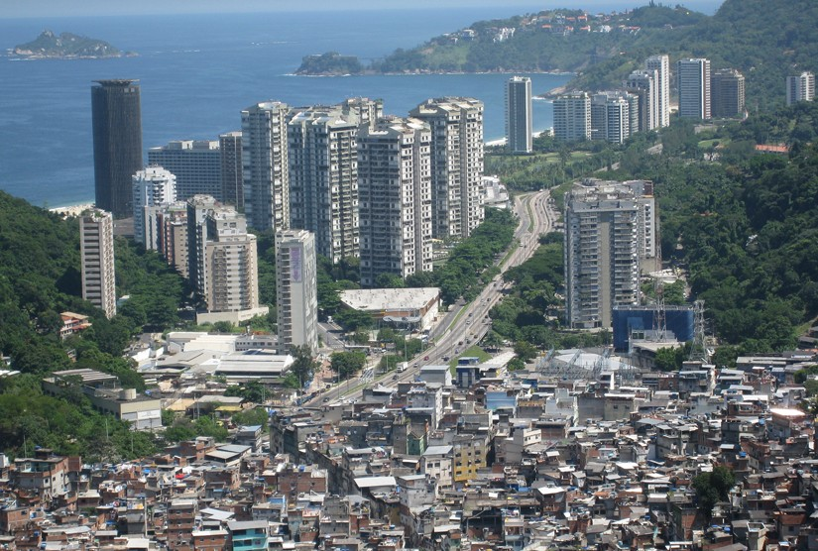
The April 24, 2013 collapse of the Rana Plaza in Dhaka, Bangladesh that killed over 1,100 people, was the deadliest garment factory accident in history, and it was preventable (International Labour Organization, Department of Communication 2014).
In addition to garment factories employing about 5,000 people, the building contained a bank, apartments, childcare facilities, and a variety of shops. Many of these closed the day before the collapse when cracks were discovered in the building walls. When some of the garment workers refused to enter the building, they were threatened with the loss of a month’s pay. Most were young women, aged twenty or younger. They typically worked over thirteen hours a day, with two days off each month. For this work, they took home between twelve and twenty-two cents an hour, or $10.56 to $12.48 a week. Without that pay, most would have been unable to feed their children. In contrast, the U.S. federal minimum wage is $7.25 an hour, and workers receive wages at time-and-a-half rates for work in excess of forty hours a week.
Did you buy clothes from Walmart in 2012? What about at The Children’s Place? Did you ever think about where those clothes came from? Of the outsourced garments made in the garment factories, thirty-two were intended for U.S, Canadian, and European stores. In the aftermath of the collapse, it was revealed that Walmart jeans were made in the Ether Tex garment factory on the fifth floor of the Rana Plaza building, while 120,000 pounds of clothing for The Children’s Place were produced in the New Wave Style Factory, also located in the building. Afterward, Walmart and The Children’s Place pledged $1 million and $450,000 (respectively) to the Rana Plaza Trust Fund, but fifteen other companies with clothing made in the building have contributed nothing, including U.S. companies Cato and J.C. Penney (Institute for Global Labour and Human Rights 2014).

Chapter 6

Reading: Social Mobility

Social Mobility

refers to the ability to change positions within a social stratification system. When people improve or diminish their economic status in a way that affects social class, they experience social mobility.
Individuals can experience upward or downward social mobility for a variety of reasons. Upward mobility refers to an increase—or upward shift—in social class. In the United States, people applaud the rags-to-riches achievements of celebrities like Jennifer Lopez or Michael Jordan. Bestselling author Stephen King worked as a janitor prior to being published. Oprah Winfrey grew up in poverty in rural Mississippi before becoming a powerful media personality. There are many stories of people rising from modest beginnings to fame and fortune. But the truth is that relative to the overall population, the number of people who rise from poverty to wealth is very small. Still, upward mobility is not only about becoming rich and famous. In the United States, people who earn a college degree, get a job promotion, or marry someone with a good income may move up socially. In contrast, downward mobility indicates a lowering of one’s social class. Some people move downward because of business setbacks, unemployment, or illness. Dropping out of school, losing a job, or getting a divorce may result in a loss of income or status and, therefore, downward social mobility.

It is not uncommon for different generations of a family to belong to varying social classes. This is known as intergenerational mobility. For example, an upper-class executive may have parents who belonged to the middle class. In turn, those parents may have been raised in the lower class. Patterns of intergenerational mobility can reflect long-term societal changes.

Similarly, intragenerational mobility describes a difference in social class that between different members of the same generation. For example, the wealth and prestige experienced by one person may be quite different from that of his or her siblings.

Structural mobility happens when societal changes enable a whole group of people to move up or down the social class ladder. Structural mobility is attributable to changes in society as a whole, not individual changes. In the first half of the twentieth century, industrialization expanded the U.S. economy, raising the standard of living and leading to upward structural mobility. In today’s work economy, the recent recession and the outsourcing of jobs overseas have contributed to high unemployment rates. Many people have experienced economic setbacks, creating a wave of downward structural mobility.

When analyzing the trends and movements in social mobility, sociologists consider all modes of mobility. Scholars recognize that mobility is not as common or easy to achieve as many people think. In fact, some consider social mobility a myth.

Turn-of-the-Century “Social Problem Novels”: Sociological Gold Mines
Class distinctions were sharper in the nineteenth century and earlier, in part because people easily accepted them. The ideology of social order made class structure seem natural, right, and just.
In the late nineteenth and early twentieth centuries, U.S. and British novelists played a role in changing public perception. They published novels in which characters struggled to survive against a merciless class system. These dissenting authors used gender and morality to question the class system and expose its inequalities. They protested the suffering of urbanization and industrialization, drawing attention to these issues.
These “social problem novels,” sometimes called Victorian realism, forced middle-class readers into an uncomfortable position: they had to question and challenge the natural order of social class.
For speaking out so strongly about the social issues of class, authors were both praised and criticized. Most authors did not want to dissolve the class system. They wanted to bring about an awareness that would improve conditions for the lower classes, while maintaining their own higher class positions (DeVine 2005).
Soon, middle-class readers were not their only audience. In 1870, Forster’s Elementary Education Act required all children ages five through twelve in England and Wales to attend school. The act increased literacy levels among the urban poor, causing a rise in sales of cheap newspapers and magazines. The increasing number of people who rode public transit systems created a demand for “railway literature,” as it was called (Williams 1984). These reading materials are credited with the move toward democratization in England. By 1900 the British middle class had established a rigid definition for itself, and England’s working class also began to self-identify and demand a better way of life.
Many of the novels of that era are seen as sociological goldmines. They are studied as existing sources because they detail the customs and mores of the upper, middle, and lower classes of that period in history.
Examples of “social problem” novels include Charles Dickens’s The Adventures of Oliver Twist (1838), which shocked readers with its brutal portrayal of the realities of poverty, vice, and crime. Thomas Hardy’s Tess of the d’Urbervilles (1891) was considered revolutionary by critics for its depiction of working-class women (DeVine 2005), and U.S. novelist Theodore Dreiser’s Sister Carrie

Further Research
PBS made a documentary about social class called “People Like Us: Social Class in America” in 2001. The filmmakers interviewed people who lived in Park Avenue penthouses and Appalachian trailer parks. The accompanying web site is full of information, interactive games, and life stories from those who participated. You can watch the entire episode here.

Practice

- an individual moves up the class ladder
- an individual moves down the class ladder
- a large group moves up or down the class ladder due to societal changes
- a member of a family belongs to a different class than his or her siblings

c

2. Which of the following scenarios is an example of intragenerational mobility?
- A janitor belongs to the same social class as his grandmother did.
- An executive belongs to a different class than her parents.
- An editor shares the same social class as his cousin.
- A lawyer belongs to a different class than her sister.

b

downward mobility:
a lowering of one’s social class
intergenerational mobility:
a difference in social class between different generations of a family
intragenerational mobility:
a difference in social class between different members of the same generation
social mobility:
the ability to change positions within a social stratification system
structural mobility:
a societal change that enables a whole group of people to move up or down the class ladder
upward mobility:
an increase—or upward shift—in social class

Self-Check: Social Stratification in the United States
You’ll have more success on the Self-Check, if you’ve completed the three Readings in this section.
An interactive or media element has been excluded from this version of the text. You can view it online here: https://library.achievingthedream.org/bcccomposition/?p=27

Chapter 7

Rhetorical Context
Any piece of writing is shaped by external factors before the first word is ever set down on the page. These factors are referred to as the rhetorical situation, or rhetorical context, and are often presented in the form of a pyramid.
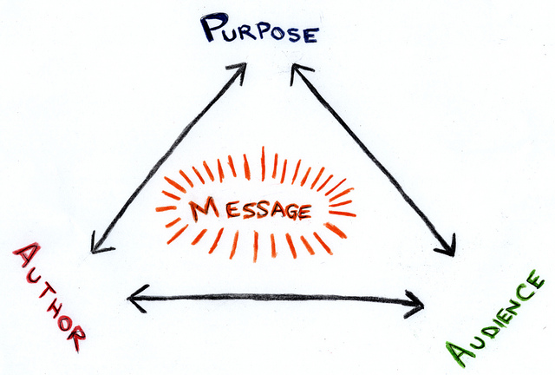
The three key factors–purpose, author, and audience–all work together to influence what the text itself says, and how it says it. Let’s examine each of the three in more detail.

Purpose
Any time you are preparing to write, you should first ask yourself, “Why am I writing?” All writing, no matter the type, has a purpose. Purpose will sometimes be given to you (by a teacher, for example), while other times, you will decide for yourself. As the author, it’s up to you to make sure that purpose is clear not only for yourself, but also–especially–for your audience. If your purpose is not clear, your audience is not likely to receive your intended message.
There are, of course, many different reasons to write (e.g., to inform, to entertain, to persuade, to ask questions), and you may find that some writing has more than one purpose. When this happens, be sure to consider any conflict between purposes, and remember that you will usually focus on one main purpose as primary.
Bottom line: Thinking about your purpose before you begin to write can help you create a more effective piece of writing.

Why Purpose Matters
- If you’ve ever listened to a lecture or read an essay and wondered “so what” or “what is this person talking about,” then you know how frustrating it can be when an author’s purpose is not clear. By clearly defining your purpose before you begin writing, it’s less likely you’ll be that author who leaves the audience wondering.
- If readers can’t identify the purpose in a text, they usually quit reading. You can’t deliver a message to an audience who quits reading.
- If a teacher can’t identify the purpose in your text, they will likely assume you didn’t understand the assignment and, chances are, you won’t receive a good grade.

Useful Questions
Consider how the answers to the following questions may affect your writing:
- What is my primary purpose for writing? How do I want my audience to think, feel, or respond after they read my writing?
- Do my audience’s expectations affect my purpose? Should they?
- How can I best get my point across (e.g., tell a story, argue, cite other sources)?
- Do I have any secondary or tertiary purposes? Do any of these purposes conflict with one another or with my primary purpose?

Audience
In order for your writing to be maximally effective, you have to think about the audience you’re writing for and adapt your writing approach to their needs, expectations, backgrounds, and interests. Being aware of your audience helps you make better decisions about what to say and how to say it. For example, you have a better idea if you will need to define or explain any terms, and you can make a more conscious effort not to say or do anything that would offend your audience.
Sometimes you know who will read your writing – for example, if you are writing an email to your boss. Other times you will have to guess who is likely to read your writing – for example, if you are writing a newspaper editorial. You will often write with a primary audience in mind, but there may be secondary and tertiary audiences to consider as well.

What to Think About
When analyzing your audience, consider these points. Doing this should make it easier to create a profile of your audience, which can help guide your writing choices.
Background-knowledge or Experience — In general, you don’t want to merely repeat what your audience already knows about the topic you’re writing about; you want to build on it. On the other hand, you don’t want to talk over their heads. Anticipate their amount of previous knowledge or experience based on elements like their age, profession, or level of education.
Expectations and Interests — Your audience may expect to find specific points or writing approaches, especially if you are writing for a teacher or a boss. Consider not only what they do want to read about, but also what they do not want to read about.
Attitudes and Biases — Your audience may have predetermined feelings about you or your topic, which can affect how hard you have to work to win them over or appeal to them. The audience’s attitudes and biases also affect their expectations – for example, if they expect to disagree with you, they will likely look for evidence that you have considered their side as well as your own.
Demographics — Consider what else you know about your audience, such as their age, gender, ethnic and cultural backgrounds, political preferences, religious affiliations, job or professional background, and area of residence. Think about how these demographics may affect how much background your audience has about your topic, what types of expectations or interests they have, and what attitudes or biases they may have.

Applying Your Analysis to Your Writing
Here are some general rules about writing, each followed by an explanation of how audience might affect it. Consider how you might adapt these guidelines to your specific situation and audience. (Note: This is not an exhaustive list. Furthermore, you need not follow the order set up here, and you likely will not address all of these approaches.)
Add information readers need to understand your document / omit information readers don’t need. Part of your audience may know a lot about your topic, while others don’t know much at all. When this happens, you have to decide if you should provide explanation or not. If you don’t offer explanation, you risk alienating or confusing those who lack the information. If you offer explanation, you create more work for yourself and you risk boring those who already know the information, which may negatively affect the larger view those readers have of you and your work. In the end, you may want to consider how many people need an explanation, whether those people are in your primary audience (rather than a secondary audience), how much time you have to complete your writing, and any length limitations placed on you.
Change the level of the information you currently have. Even if you have the right information, you might be explaining it in a way that doesn’t make sense to your audience. For example, you wouldn’t want to use highly advanced or technical vocabulary in a document for first-grade students or even in a document for a general audience, such as the audience of a daily newspaper, because most likely some (or even all) of the audience wouldn’t understand you.
Add examples to help readers understand. Sometimes just changing the level of information you have isn’t enough to get your point across, so you might try adding an example. If you are trying to explain a complex or abstract issue to an audience with a low education level, you might offer a metaphor or an analogy to something they are more familiar with to help them understand. Or, if you are writing for an audience that disagrees with your stance, you might offer examples that create common ground and/or help them see your perspective.
Change the level of your examples. Once you’ve decided to include examples, you should make sure you aren’t offering examples your audience finds unacceptable or confusing. For example, some teachers find personal stories unacceptable in academic writing, so you might use a metaphor instead.
Change the organization of your information. Again, you might have the correct information, but you might be presenting it in a confusing or illogical order. If you are writing a paper about physics for a physics professor who has his or her PhD, chances are you won’t need to begin your paper with a lot of background. However, you probably would want to include background information in the beginning of your paper if you were writing for a fellow student in an introductory physics class.
Strengthen transitions. You might make decisions about transitions based on your audience’s expectations. For example, most teachers expect to find topic sentences, which serve as transitions between paragraphs. In a shorter piece of writing such as a memo to co-workers, however, you would probably be less concerned with topic sentences and more concerned with transition words. In general, if you feel your readers may have a hard time making connections, providing transition words (e.g., “therefore” or “on the other hand”) can help lead them.
Write stronger introductions – both for the whole document and for major sections. In general, readers like to get the big picture up front. You can offer this in your introduction and thesis statement, or in smaller introductions to major sections within your document. However, you should also consider how much time your audience will have to read your document. If you are writing for a boss who already works long hours and has little or no free time, you wouldn’t want to write an introduction that rambles on for two and a half pages before getting into the information your boss is looking for.
Create topic sentences for paragraphs and paragraph groups. A topic sentence (the first sentence of a paragraph) functions much the same way an introduction does – it offers readers a preview of what’s coming and how that information relates to the overall document or your overall purpose. As mentioned earlier, some readers will expect topic sentences. However, even if your audience isn’t expecting them, topic sentences can make it easier for readers to skim your document while still getting the main idea and the connections between smaller ideas.
Change sentence style and length. Using the same types and lengths of sentences can become boring after awhile. If you already worry that your audience may lose interest in your issue, you might want to work on varying the types of sentences you use.
Use graphics, or use different graphics. Graphics can be another way to help your audience visualize an abstract or complex topic. Sometimes a graphic might be more effective than a metaphor or step-by-step explanation. Graphics may also be an effective choice if you know your audience is going to skim your writing quickly; a graphic can be used to draw the reader’s eye to information you want to highlight. However, keep in mind that some audiences may see graphics as inappropriate.

Author
The final unique aspect of anything written down is who it is, exactly, that does the writing. In some sense, this is the part you have the most control over–it’s you who’s writing, after all! You can harness the aspects of yourself that will make the text most effective to its audience, for its purpose.
Analyzing yourself as an author allows you to make explicit why your audience should pay attention to what you have to say, and why they should listen to you on the particular subject at hand.

Questions for Consideration
- What personal motivations do you have for writing about this topic?
- What background knowledge do you have on this subject matter?
- What personal experiences directly relate to this subject? How do those personal experiences influence your perspectives on the issue?
- What formal training or professional experience do you have related to this subject?
- What skills do you have as a communicator? How can you harness those in this project?
- What should audience members know about you, in order to trust what you have to tell them? How will you convey that in your writing?

(Rules adapted from David McMurrey’s online text,
)

PART IV

Module 3

Chapter 8

Outcome: Global Wealth and Poverty

Compare poverty throughout the world and explain its consequences
What does it mean to be poor? Does it mean being a single mother with two kids in New York City, waiting for the next paycheck in order to buy groceries? Does it mean living with almost no furniture in your apartment because your income doesn’t allow for extras like beds or chairs? Or does it mean having to live with the distended bellies of the chronically malnourished throughout the peripheral nations of Sub-Saharan Africa and South Asia? Poverty has a thousand faces and a thousand gradations; there is no single definition that pulls together every part of the spectrum. You might feel you are poor if you can’t afford cable television or buy your own car. Every time you see a fellow student with a new laptop and smartphone you might feel that you, with your ten-year-old desktop computer, are barely keeping up. However, someone else might look at the clothes you wear and the calories you consume and consider you rich.

What you’ll learn to do:
- Understand the differences between relative, absolute, and subjective poverty
- Describe the economic situation of some of the world’s most impoverished areas
- Explain the cyclical impact of the consequences of poverty

Learning Activities
The learning activities for this section include:
- Reading: Types of Global Poverty
- Reading: Poverty Around the World
- Reading: The Impact of Poverty
- Self-Check: Global Wealth and Poverty

Chapter 9

Reading: The Impact of Poverty

Consequences of Poverty


Not surprisingly, the consequences of poverty are often also causes. The poor often experience inadequate healthcare, limited education, and the inaccessibility of birth control. But those born into these conditions are incredibly challenged in their efforts to break out since these consequences of poverty are also causes of poverty, perpetuating a cycle of disadvantage.
According to sociologists Neckerman and Torche (2007) in their analysis of global inequality studies, the consequences of poverty are many. Neckerman and Torche have divided them into three areas. The first, termed “the sedimentation of global inequality,” relates to the fact that once poverty becomes entrenched in an area, it is typically very difficult to reverse. As mentioned above, poverty exists in a cycle where the consequences and causes are intertwined. The second consequence of poverty is its effect on physical and mental health. Poor people face physical health challenges, including malnutrition and high infant mortality rates. Mental health is also detrimentally affected by the emotional stresses of poverty, with relative deprivation carrying the most robust effect. Again, as with the ongoing inequality, the effects of poverty on mental and physical health become more entrenched as time goes on. Neckerman and Torche’s third consequence of poverty is the prevalence of crime. Cross-nationally, crime rates are higher, particularly for violent crime, in countries with higher levels of income inequality (Fajnzylber, Lederman, and Loayza 2002).

Slavery
While most of us are accustomed to thinking of slavery in terms of the antebellum South, modern day slavery goes hand-in-hand with global inequality. In short, slavery refers to any situation in which people are sold, treated as property, or forced to work for little or no pay. Just as in the pre-Civil War United States, these humans are at the mercy of their employers. Chattel slavery, the form of slavery once practiced in the American South, occurs when one person owns another as property. Child slavery, which may include child prostitution, is a form of chattel slavery. In debt bondage, or bonded labor, the poor pledge themselves as servants in exchange for the cost of basic necessities like transportation, room, and board. In this scenario, people are paid less than they are charged for room and board. When travel is required, they can arrive in debt for their travel expenses and be unable to work their way free, since their wages do not allow them to ever get ahead.
The global watchdog group Anti-Slavery International recognizes other forms of slavery: human trafficking (in which people are moved away from their communities and forced to work against their will), child domestic work and child labor, and certain forms of servile marriage, in which women are little more than chattel slaves (Anti-Slavery International 2012).

Further Research
People often think that the United States is immune to the atrocity of human trafficking. Check out this link to learn more about trafficking in the United States.
For more information about the ongoing practices of slavery in the modern world click here.

Practice

1. Slavery in the pre-Civil War U.S. South most closely resembled
- chattel slavery
- debt bondage
- relative poverty
- peonage

a

2. In a U.S. town, a mining company owns all the stores and most of the houses. It sells goods to the workers at inflated prices, offers house rentals for twice what a mortgage would be, and makes sure to always pay the workers less than needed to cover food and rent. Once the workers are in debt, they have no choice but to continue working for the company, since their skills will not transfer to a new position. This situation most closely resembles:
- child slavery
- chattel slavery
- debt slavery
- servile marriage

c

chattel slavery:
a form of slavery in which one person owns another
debt bondage:
the act of people pledging themselves as servants in exchange for money for passage, and are subsequently paid too little to regain their freedom

Self-Check: Global Wealth and Poverty
You’ll have more success on the Self-Check, if you’ve completed the three Readings in this section.
An interactive or media element has been excluded from this version of the text. You can view it online here: https://library.achievingthedream.org/bcccomposition/?p=31

Chapter 10

How to Write a Thesis Statement
Whether you are writing a short essay or a doctoral dissertation, your thesis statement will arguably be the most difficult sentence to formulate. An effective thesis statement states the purpose of the paper and, therefore, functions to control, assert and structure your entire argument. Without a sound thesis, your argument may sound weak, lacking in direction, and uninteresting to the reader.

Start with a question — then make the answer your thesis
Regardless of how complicated the subject is, almost any thesis can be constructed by answering a question.
- Question: “What are the benefits of using computers in a fourth-grade classroom?”
  - Thesis: “Computers allow fourth graders an early advantage in technological and scientific education.”
- Question: “Why is the Mississippi River so important in Mark Twain’s Huckleberry Finn?”Thesis: “The river comes to symbolize both division and progress, as it separates our characters and country while still providing the best chance for Huck and Jim to get to know one another.”

Tailor your thesis to the type of paper you’re writing
Not all essays persuade, and not all essays teach. The goals of your paper will help you find the best thesis.
- Analytical: Breaks down something to better examine and understand it.Ex. “This dynamic between different generations sparks much of the play’s tension, as age becomes a motive for the violence and unrest that rocks King Lear.”

Ensure your thesis is provable
Do not come up with your thesis and then look it up later. The thesis is the end point of your research, not the beginning. You need to use a thesis you can actually back up with evidence.

Good Theses Examples:
- “By owning up to the impossible contradictions, embracing them and questioning them, Blake forges his own faith, and is stronger for it. Ultimately, the only way for his poems to have faith is to temporarily lose it.”
- “According to its well-documented beliefs and philosophies, an existential society with no notion of either past or future cannot help but become stagnant.”
- “By reading “Ode to a Nightingale” through a modern deconstructionist lens, we can see how Keats viewed poetry as shifting and subjective, not some rigid form.”

Bad Theses Examples:
- “The wrong people won the American Revolution.” While striking and unique, who is “right” and who is “wrong” is exceptionally hard to prove, and very subjective.
- “The theory of genetic inheritance is the binding theory of every human interaction.” Too complicated and overzealous. The scope of “every human interaction” is just too big
- “Paul Harding’s novel Tinkers is ultimately a cry for help from a clearly depressed author.” Unless you interviewed Harding extensively, or had a lot of real-life sources, you have no way of proving what is fact and what is fiction.”

Get the sound right
You want your thesis statement to be identifiable as a thesis statement. You do this by taking a very particular tone and using specific kinds of phrasing and words. Use words like “because” and language which is firm and definitive.
Example thesis statements with good statement language include:
- “Because of William the Conqueror’s campaign into England, that nation developed the strength and culture it would need to eventually build the British Empire.”
- “Hemingway significantly changed literature by normalizing simplistic writing and frank tone.”

Know where to place a thesis statement
Because of the role thesis statements play, they appear at the beginning of the paper, usually at the end of the first paragraph or somewhere in the introduction. Although most people look for the thesis at the end of the first paragraph, its location can depend on a number of factors such as how lengthy of an introduction you need before you can introduce your thesis or the length of your paper.

Limit a thesis statement to one or two sentences in length
Thesis statements are clear and to the point, which helps the reader identify the topic and direction of the paper, as well as your position towards the subject.

Chapter 11

Essay 1 Prompt
For the first essay you should complete the following tasks:

Task 1:
Read the following on descriptive essays:
https://courses.lumenlearning.com/englishcomp1v2xmaster/chapter/definitional-argument-essay/

Task 2:
Go back to your Module 1 Discussion and look at your definition of the different types of inequality and their causes.

Task 3:
Find an example of a social or economic inequality either online, in conversations with people, or in your daily life in the city.

Task 4:
In your essay describe why you think your example is a good example of the inequality based on your original definition, the readings, and what we discussed in class. You may also revise your definition if you do not think it was accurate initially. In your essay describe the reasons why you think your initial definition was not accurate.

Requirements:
500-700 Words
Written in Word document and uploaded on Blackboard
10-12 Point TNR Font

Due:

PART V

Module 4

Chapter 12

Reading: Theoretical Perspectives on Social Stratification

Functionalism
In sociology, the functionalist perspective examines how society’s parts operate. According to functionalism, different aspects of society exist because they serve a needed purpose. What is the function of social stratification?
In 1945, sociologists Kingsley Davis and Wilbert Moore published the Davis-Moore thesis, which argued that the greater the functional importance of a social role, the greater must be the reward. The theory posits that social stratification represents the inherently unequal value of different work. Certain tasks in society are more valuable than others. Qualified people who fill those positions must be rewarded more than others.
According to Davis and Moore, a firefighter’s job is more important than, for instance, a grocery store cashier’s. The cashier position does not require the same skill and training level as firefighting. Without the incentive of higher pay and better benefits, why would someone be willing to rush into burning buildings? If pay levels were the same, the firefighter might as well work as a grocery store cashier. Davis and Moore believed that rewarding more important work with higher levels of income, prestige, and power encourages people to work harder and longer.
Davis and Moore stated that, in most cases, the degree of skill required for a job determines that job’s importance. They also stated that the more skill required for a job, the fewer qualified people there would be to do that job. Certain jobs, such as cleaning hallways or answering phones, do not require much skill. The employees don’t need a college degree. Other work, like designing a highway system or delivering a baby, requires immense skill.
In 1953, Melvin Tumin countered the Davis-Moore thesis in “Some Principles of Stratification: A Critical Analysis.” Tumin questioned what determined a job’s degree of importance. The Davis-Moore thesis does not explain, he argued, why a media personality with little education, skill, or talent becomes famous and rich on a reality show or a campaign trail. The thesis also does not explain inequalities in the education system or inequalities due to race or gender. Tumin believed social stratification prevented qualified people from attempting to fill roles (Tumin 1953). For example, an underprivileged youth has less chance of becoming a scientist, no matter how smart she is, because of the relative lack of opportunity available to her. The Davis-Moore thesis also does not explain why a basketball player earns millions of dollars a year when a doctor who saves lives, a soldier who fights for others’ rights, and a teacher who helps form the minds of tomorrow will likely not make millions over the course of their careers.
The Davis-Moore thesis, though open for debate, was an early attempt to explain why stratification exists. The thesis states that social stratification is necessary to promote excellence, productivity, and efficiency, thus giving people something to strive for. Davis and Moore believed that the system serves society as a whole because it allows everyone to benefit to a certain extent.

Conflict Theory
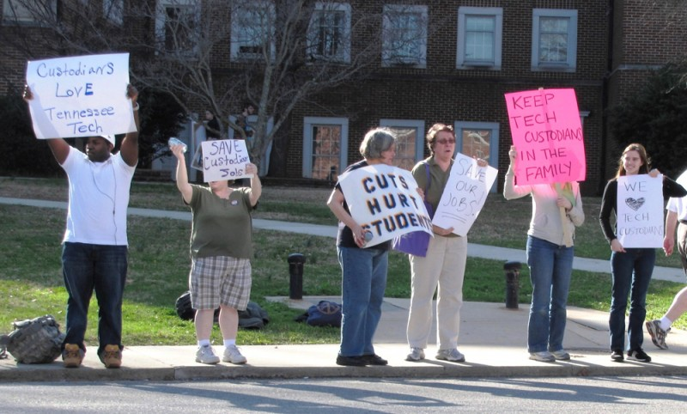
Conflict theorists are deeply critical of social stratification, asserting that it benefits only some people, not all of society. For instance, to a conflict theorist, it seems wrong that a basketball player is paid millions for an annual contract while a public school teacher earns $35,000 a year. Stratification, conflict theorists believe, perpetuates inequality. Conflict theorists try to bring awareness to inequalities, such as how a rich society can have so many poor members.
Many conflict theorists draw on the work of Karl Marx. During the nineteenth-century era of industrialization, Marx believed social stratification resulted from people’s relationship to production. People were divided by a single line: they either owned factories or worked in them. In Marx’s time, bourgeois capitalists owned high-producing businesses, factories, and land, as they still do today. Proletariats were the workers who performed the manual labor to produce goods. Upper-class capitalists raked in profits and got rich, while working-class proletariats earned skimpy wages and struggled to survive. With such opposing interests, the two groups were divided by differences of wealth and power. Marx saw workers experience deep alienation, isolation and misery resulting from powerless status levels (Marx 1848). Marx argued that proletariats were oppressed by the money-hungry bourgeois.
Today, while working conditions have improved, conflict theorists believe that the strained working relationship between employers and employees still exists. Capitalists own the means of production, and a system is in place to make business owners rich and keep workers poor. According to conflict theorists, the resulting stratification creates class conflict. If he were alive in today’s economy, as it recovers from a prolonged recession, Marx would likely have argued that the recession resulted from the greed of capitalists, satisfied at the expense of working people.

Symbolic Interactionism
Symbolic interactionism is a theory that uses everyday interactions of individuals to explain society as a whole. Symbolic interactionism examines stratification from a micro-level perspective. This analysis strives to explain how people’s social standing affects their everyday interactions.
In most communities, people interact primarily with others who share the same social standing. It is precisely because of social stratification that people tend to live, work, and associate with others like themselves, people who share their same income level, educational background, or racial background, and even tastes in food, music, and clothing. The built-in system of social stratification groups people together. This is one of the reasons why it was rare for a royal prince like England’s Prince William to marry a commoner.
Symbolic interactionists also note that people’s appearance reflects their perceived social standing. Housing, clothing, and transportation indicate social status, as do hairstyles, taste in accessories, and personal style.

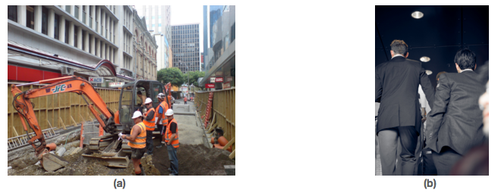

To symbolically communicate social standing, people often engage in conspicuous consumption, which is the purchase and use of certain products to make a social statement about status. Carrying pricey but eco-friendly water bottles could indicate a person’s social standing. Some people buy expensive trendy sneakers even though they will never wear them to jog or play sports. A $17,000 car provides transportation as easily as a $100,000 vehicle, but the luxury car makes a social statement that the less expensive car can’t live up to. All these symbols of stratification are worthy of examination by an interactionist.

Think It Over

- Analyze the Davis-Moore thesis. Do you agree with Davis and Moore? Does social stratification play an important function in society? What examples can you think of that support the thesis? What examples can you think of that refute the thesis?
- Consider social stratification from the symbolic interactionist perspective. How does social stratification influence the daily interactions of individuals? How do systems of class, based on factors such as prestige, power, income, and wealth, influence your own daily routines, as well as your beliefs and attitudes? Illustrate your ideas with specific examples and anecdotes from your own life and the lives of people in your community.

Practice

1. The basic premise of the Davis-Moore thesis is that the unequal distribution of rewards in social stratification:
- is an outdated mode of societal organization
- is an artificial reflection of society
- serves a purpose in society
- cannot be justified

c

2. Unlike Davis and Moore, Melvin Tumin believed that, because of social stratification, some qualified people were _______ higher-level job positions.
- denied the opportunity to obtain
- encouraged to train for
- often fired from
- forced into

a

3. Which statement represents stratification from the perspective of symbolic interactionism?
- Men often earn more than women, even working the same job.
- After work, Pat, a janitor, feels more comfortable eating in a truck stop than a French restaurant.
- Doctors earn more money because their job is more highly valued.
- Teachers continue to struggle to keep benefits such as health insurance.

b

4. When Karl Marx said workers experience alienation, he meant that workers:
- must labor alone, without companionship
- do not feel connected to their work
- move from one geographical location to another
- have to put forth self-effort to get ahead

b

5. Conflict theorists view capitalists as those who:
- are ambitious
- fund social services
- spend money wisely
- get rich while workers stay poor

d

conspicuous consumption:
the act of buying and using products to make a statement about social standing
Davis-Moore thesis:
a thesis that argues some social stratification is a social necessity

Chapter 13

Reading: Theoretical Perspectives on Global Stratification
As with any social issue, global or otherwise, scholars have developed a variety of theories to study global stratification. The two most widely applied perspectives are modernization theory and dependency theory.

Modernization Theory
According to modernization theory, low-income countries are affected by their lack of industrialization and can improve their global economic standing through (Armer and Katsillis 2010):
- an adjustment of cultural values and attitudes to work
- industrialization and other forms of economic growth
Critics point out the inherent ethnocentric bias of this theory. It supposes all countries have the same resources and are capable of following the same path. In addition, it assumes that the goal of all countries is to be as “developed” as possible. There is no room within this theory for the possibility that industrialization and technology are not the best goals.
There is, of course, some basis for this assumption. Data show that core nations tend to have lower maternal and child mortality rates, longer life spans, and less absolute poverty. It is also true that in the poorest countries, millions of people die from the lack of clean drinking water and sanitation facilities, which are benefits most of us take for granted. At the same time, the issue is more complex than the numbers might suggest. Cultural equality, history, community, and local traditions are all at risk as modernization pushes into peripheral countries. The challenge, then, is to allow the benefits of modernization while maintaining a cultural sensitivity to what already exists.

Dependency Theory
Dependency theory was created in part as a response to the Western-centric mindset of modernization theory. It states that global inequality is primarily caused by core nations (or high-income nations) exploiting semi-peripheral and peripheral nations (or middle-income and low-income nations), which creates a cycle of dependence (Hendricks 2010). As long as peripheral nations are dependent on core nations for economic stimulus and access to a larger piece of the global economy, they will never achieve stable and consistent economic growth. Further, the theory states that since core nations, as well as the World Bank, choose which countries to make loans to, and for what they will loan funds, they are creating highly segmented labor markets that are built to benefit the dominant market countries.
At first glance, it seems this theory ignores the formerly low-income nations that are now considered middle-income nations and are on their way to becoming high-income nations and major players in the global economy, such as China. But some dependency theorists would state that it is in the best interests of core nations to ensure the long-term usefulness of their peripheral and semi-peripheral partners. Following that theory, sociologists have found that entities are more likely to outsource a significant portion of a company’s work if they are the dominant player in the equation; in other words, companies want to see their partner countries healthy enough to provide work, but not so healthy as to establish a threat (Caniels and Roeleveld 2009).

Factory Girls
We’ve examined functionalist and conflict theorist perspectives on global inequality, as well as modernization and dependency theories. How might a symbolic interactionist approach this topic?
The book Factory Girls: From Village to City in Changing China, by Leslie T. Chang, provides this opportunity. Chang follows two young women (Min and Chunming) employed at a handbag plant. They help manufacture coveted purses and bags for the global market. As part of the growing population of young people who are leaving behind the homesteads and farms of rural China, these female factory workers are ready to enter the urban fray and pursue an ambitious income.
Although Chang’s study is based in a town many have never heard of (Dongguan), this city produces one-third of all shoes on the planet (Nike and Reebok are major manufacturers here) and 30 percent of the world’s computer disk drives, in addition to an abundance of apparel (Chang 2008).
But Chang’s focus is centered less on this global phenomenon on a large scale, than on how it affects these two women. As a symbolic interactionist would do, Chang examines the daily lives and interactions of Min and Chunming—their workplace friendships, family relationships, gadgets and goods—in this evolving global space where young women can leave tradition behind and fashion their own futures. Their story is one that all people, not just scholars, can learn from as we contemplate sociological issues like global economies, cultural traditions and innovations, and opportunities for women in the workforce.

Further Research
For more information about economic modernization, check out the Hudson Institute.
Learn more about economic dependency at the University of Texas Inequality Project.

Think It Over
- There is much criticism that modernization theory is Eurocentric. Do you think dependency theory is also biased? Why, or why not?
- Compare and contrast modernization theory and dependency theory. Which do you think is more useful for explaining global inequality? Explain, using examples.

Practice
1. One flaw in dependency theory is the unwillingness to recognize _______.
- that previously low-income nations such as China have successfully developed their economies and can no longer be classified as dependent on core nations
- that previously high-income nations such as China have been economically overpowered by low-income nations entering the global marketplace
- that countries such as China are growing more dependent on core nations
- that countries such as China do not necessarily want to be more like core nations
a
2. One flaw in modernization theory is the unwillingness to recognize _________.
- that semi-peripheral nations are incapable of industrializing
- that peripheral nations prevent semi-peripheral nations from entering the global market
- its inherent ethnocentric bias
- the importance of semi-peripheral nations industrializing
c
3. If a sociologist says that nations evolve toward more advanced technology and more complex industry as their citizens learn cultural values that celebrate hard work and success, she is using _______ theory to study the global economy.
- modernization theory
- dependency theory
- modern dependency theory
- evolutionary dependency theory
a
- functionalist
- dependency theorist
- modernization theorist
- symbolic interactionist
b
- core nations and peripheral nations exploit semi-peripheral nations
- semi-peripheral nations exploit core nations
- peripheral nations exploit core nations
- core nations exploit peripheral nations
d
dependency theory:
a theory which states that global inequity is due to the exploitation of peripheral and semi-peripheral nations by core nations
modernization theory:
a theory that low-income countries can improve their global economic standing by industrialization of infrastructure and a shift in cultural attitudes towards work

Self-Check: Theoretical Perspectives on Stratification
You’ll have more success on the Self-Check, if you’ve completed both Readings in this section.
An interactive or media element has been excluded from this version of the text. You can view it online here: https://library.achievingthedream.org/bcccomposition/?p=36

Chapter 14

The Perfect Paragraph
As Michael Harvey writes, paragraphs are “in essence—a form of punctuation, and like other forms of punctuation they are meant to make written material easy to read.” Effective paragraphs are the fundamental units of academic writing; consequently, the thoughtful, multifaceted arguments that your professors expect depend on them. Without good paragraphs, you simply cannot clearly convey sequential points and their relationships to one another.
Many novice writers tend to make a sharp distinction between content and style, thinking that a paper can be strong in one and weak in the other, but focusing on organization shows how content and style converge in deliberative academic writing. Your professors will view even the most elegant prose as rambling and tedious if there isn’t a careful, coherent argument to give the text meaning. Paragraphs are the “stuff ” of academic writing and, thus, worth our attention here.

Key Sentences (a.k.a. Topic Sentences)
In academic writing, readers expect each paragraph to have a sentence or two that captures its main point. They’re often called “topic sentences,” though many writing instructors prefer to call them “key sentences.” There are at least two downsides of the phrase “topic sentence.” First, it makes it seem like the paramount job of that sentence is simply to announce the topic of the paragraph. Second, it makes it seem like the topic sentence must always be a single grammatical sentence. Calling it a “key sentence” reminds us that it expresses the central idea of the paragraph. And sometimes a question or a two-sentence construction functions as the key.
Key sentences in academic writing do two things. First, they establish the main point that the rest of the paragraph supports. Second, they situate each paragraph within the sequence of the argument, a task that requires transitioning from the prior paragraph. Consider these two examples:
Version A:
Now we turn to the epidemiological evidence.
Version B:
The epidemiological evidence provides compelling support for the hypothesis emerging from etiological studies.
Both versions convey a topic; it’s pretty easy to predict that the paragraph will be about epidemiological evidence, but only the second version establishes an argumentative point and puts it in context. The paragraph doesn’t just describe the epidemiological evidence; it shows how epidemiology is telling the same story as etiology. Similarly, while Version A doesn’t relate to anything in particular, Version B immediately suggests that the prior paragraph addresses the biological pathway (i.e. etiology) of a disease and that the new paragraph will bolster the emerging hypothesis with a different kind of evidence. As a reader, it’s easy to keep track of how the paragraph about cells and chemicals and such relates to the paragraph about populations in different places.
A last thing to note about key sentences is that academic readers expect them to be at the beginning of the paragraph. (The first sentence this paragraph is a good example of this in action!) This placement helps readers comprehend your argument. To see how, try this: find an academic piece (such as a textbook or scholarly article) that strikes you as well written and go through part of it reading just the first sentence of each paragraph. You should be able to easily follow the sequence of logic. When you’re writing for professors, it is especially effective to put your key sentences first because they usually convey your own original thinking. It’s a very good sign when your paragraphs are typically composed of a telling key sentence followed by evidence and explanation.
Knowing this convention of academic writing can help you both read and write more effectively. When you’re reading a complicated academic piece for the first time, you might want to go through reading only the first sentence or two of each paragraph to get the overall outline of the argument. Then you can go back and read all of it with a clearer picture of how each of the details fit in. And when you’re writing, you may also find it useful to write the first sentence of each paragraph (instead of a topic-based outline) to map out a thorough argument before getting immersed in sentence-level wordsmithing.

Cohesion and Coherence
With a key sentence established, the next task is to shape the body of your paragraph to be both cohesive and coherent. As Williams and Bizup explain, cohesion is about the “sense of flow” (how each sentence fits with the next), while coherence is about the “sense of the whole.”
For the most part, a text reads smoothly when it conveys a thoughtful and well organized argument or analysis. Focus first and most on your ideas, on crafting an ambitious analysis. The most useful guides advise you to first focus on getting your ideas on paper and then revising for organization and word choice later, refining the analysis as you go. Thus, consider the advice here as if you already have some rough text written and are in the process of smoothing out your prose to clarify your argument for both your reader and yourself.

Cohesion
Cohesion refers to the flow from sentence to sentence. For example, compare these passages:
Version A:
Granovetter begins by looking at balance theory. If an actor, A, is strongly tied to both B and C, it is extremely likely that B and C are, sooner or later, going to be tied to each other, according to balance theory (1973:1363). Bridge ties between cliques are always weak ties, Granovetter argues (1973:1364). Weak ties may not necessarily be bridges, but Granovetter argues that bridges will be weak. If two actors share a strong tie, they will draw in their other strong relations and will eventually form a clique. Only weak ties that do not have the strength to draw together all the “friends of friends” can connect people in different cliques.
Version B:
Granovetter begins by looking at balance theory. In brief, balance theory tells us that if an actor, A, is strongly tied to both B and C, it is extremely likely that B and C are, sooner or later, going to be tied to each other (1973:1363). Granovetter argues that because of this, bridge ties between cliques are always weak ties (1973:1364). Weak ties may not necessarily be bridges, but Granovetter argues that bridges will be weak. This is because if two actors share a strong tie, they will draw in their other strong relations and will eventually form a clique. The only way, therefore, that people in different cliques can be connected is through weak ties that do not have the strength to draw together all the “friends of friends.”
Version A has the exact same information as version B, but it is harder to read because it is less cohesive. Each sentence in version B begins with old information and bridges to new information.
The first sentence establishes the key idea of balance theory. The next sentence begins with balance theory and ends with social ties, which is the focus of the third sentence. The concept of weak ties connects the third and fourth sentences and concept of cliques the fifth and sixth sentences. In Version A, in contrast, the first sentence focuses on balance theory, but then the second sentence makes a new point about social ties before telling the reader that the point comes from balance theory. The reader has to take in a lot of unfamiliar information before learning how it fits in with familiar concepts. Version A is coherent, but the lack of cohesion makes it tedious to read.
The lesson is this: if you or others perceive a passage you’ve written to be awkward or choppy, even though the topic is consistent, try rewriting it to ensure that each sentence begins with a familiar term or concept. If your points don’t naturally daisy-chain together like the examples given here, consider numbering them. For example, you may choose to write, “Proponents of the legislation point to four major benefits.” Then you could discuss four loosely related ideas without leaving your reader wondering how they relate.

Coherence
While cohesion is about the sense of flow, coherence is about the sense of the whole. For example, here’s a passage that is cohesive (from sentence to sentence) but lacks coherence:
Your social networks and your location within them shape the kinds and amount of information that you have access to. Information is distinct from data, in that makes some kind of generalization about a person, thing, or population. Defensible generalizations about society can be either probabilities (i.e., statistics) or patterns (often from qualitative analysis). Such probabilities and patterns can be temporal, spatial, or simultaneous.
Each sentence in the above passage starts with a familiar idea and progresses to a new one, but it lacks coherence—a sense of being about one thing. Good writers often write passages like that when they’re free-writing or using the drafting stage to cast a wide net for ideas. A writer weighing the power and limits of social network analysis may free-write something like that example and, from there, develop a more specific plan for summarizing key insights about social networks and then discussing them with reference to the core tenets of social science. As a draft, an incoherent paragraph often points to a productive line of reasoning; one just has to continue thinking it through in order to identify a clear argumentative purpose for each paragraph. With its purpose defined, each paragraph, then, becomes a lot easier to write. Coherent paragraphs aren’t just about style; they are a sign of a thoughtful, well developed analysis.

The Wind-Up
Some guides advise you to end each paragraph with a specific concluding sentence, in a sense, to treat each paragraph as a kind of mini-essay. But that’s not a widely held convention. Most well written academic pieces don’t adhere to that structure. The last sentence of the paragraph should certainly be in your own words (as in, not a quote), but as long as the paragraph succeeds in carrying out the task that it has been assigned by its key sentence, you don’t need to worry about whether that last sentence has an air of conclusiveness. For example, consider these paragraphs about the cold fusion controversy of the 1980s that appeared in a best-selling textbook:
The experiment seemed straightforward and there were plenty of scientists willing to try it. Many did. It was wonderful to have a simple laboratory experiment on fusion to try after the decades of embarrassing attempts to control hot fusion. This effort required multi-billion dollar machines whose every success seemed to be capped with an unanticipated failure. ‘Cold fusion’ seemed to provide, as Martin Fleischmann said during the course of that famous Utah press conference, ‘another route’—the route of little science.
In that example, the first and last sentences in the paragraph are somewhat symmetrical: the authors introduce the idea of accessible science, contrast it with big science, and bring it back to the phrase “little science.” Here’s an example from the same chapter of the same book that does not have any particular symmetry:
The struggle between proponents and critics in a scientific controversy is always a struggle for credibility. When scientists make claims which are literally ‘incredible’, as in the cold fusion case, they face an uphill struggle. The problem Pons and Fleischmann had to overcome was that they had credibility as electrochemists but not as nuclear physicists. And it was nuclear physics where their work was likely to have its main impact.
The last sentence of the paragraph doesn’t mirror the first, but the paragraph still works just fine. In general, every sentence of academic writing should add some unique content. Don’t trouble yourself with having the last sentence in every paragraph serve as a mini-conclusion. Instead, worry about developing each point sufficiently and making your logical sequence clear.

Conclusion: Paragraphs as Punctuation
To reiterate the initial point, it is useful to think of paragraphs as punctuation that organize your ideas in a readable way. Each paragraph should be an irreplaceable node within a coherent sequence of logic. Thinking of paragraphs as “building blocks” evokes the “five-paragraph theme” structure explained earlier: if you have identical stone blocks, it hardly matters what order they’re in. In the successful organically structured college paper, the structure and tone of each paragraph reflects its indispensable role within the overall piece. Make every bit count and have each part situated within the whole.

Michael Harvey,
, Second Edition (Indianapolis, IN: Hackett Publishing, 2013), 70.

Joseph M. Williams.and Joseph Bizup. Style: Lessons in Clarity and Grace 11th edition (New York: Longman, 2014), 68. Joseph M. Williams and Joseph Bizup.
11th edition (New York: Longman, 2014), 68.

The quote uses a version of an ASA-style in-text citation for Mark S. Granovetter, “The Strength of Weak Ties,”
78 (1973): 1360-80.

Guiffre.
, 98.

Harry Collins and Trevor Pinch,
2nd ed. (Cambridge: Canto, 1998), 58.

PART VI

Module 5

Chapter 15

Introductions and Conclusions
A key piece of advice many writers either do not ever get or don’t believe is that it’s not necessary to write introductions first or to write conclusions last. Just because the introduction appears first and the conclusion appears last doesn’t mean they have to be written that way. Here’s a really tired metaphor to help explain: just because you walk into a building through the door doesn’t mean the door was built first. The foundation went in first, even though you rarely if ever see that part. And lots of imperfections in the foundation and the walls were covered up before you even moved in, so you can’t see those either unless you look closely.

Introductions
Even though a nearly infinite number of topics and arrangements is possible in English prose, introductions generally follow one of several patterns. If you’re writing a children’s story, you’d probably start with “once upon a time” or something similar. If you’re writing a research article in biomechanical engineering, you’d probably start with a statement about how previous research has examined the problem of loading soldiers with daypacks on various surfaces, including sand, concrete, and railroad ballast. These examples are poles apart, but their introductions share very similar purposes: they orient their imagined readers to the topic, time, and place.
In working toward the overall goal of orienting readers, introductions may
- Provide background about a topic.
- Locate readers in a specific time and/or place.
- Start with a compelling quotation or statistic—something concrete.
- Include an ethical appeal, with which you (explicitly or implicitly) show that you’ve done your homework and are credible.
- Articulate a main claim/thesis.
- Lay out the stakes for the piece of writing—that is, why the reader should bother reading on.
The following video addresses how to do several of these things, starting with the very first sentence of your introduction.

A YouTube element has been excluded from this version of the text. You can view it online here: https://library.achievingthedream.org/bcccomposition/?p=39

Conclusions
Conclusions usually
- Summarize the argument (especially in longer pieces of writing)
- “Bookend” a story that started in the introduction
- Include an emotional appeal, with which you (explicitly or implicitly) connect the “logic” of the argument to a more passionate reason intended to sway the reader
- Issue a call to action
Ideally, a conclusion will work in tandem with an introduction, having some kind of “call back” element to remind your reader of the powerful opening you provided. Additional advice for conclusions is found in the following video.
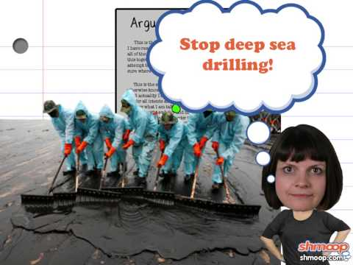
A YouTube element has been excluded from this version of the text. You can view it online here: https://library.achievingthedream.org/bcccomposition/?p=39

Chapter 16

The Great Recession
The Great Recession began, as most American economic catastrophes began, with the bursting of a speculative bubble. Throughout the 1990s and into the new millennium, home prices continued to climb, and financial services firms looked to cash in on what seemed to be a safe but lucrative investment. Especially after the dot-com bubble burst, investors searched for a secure investment that was rooted in clear value and not trendy technological speculation. And what could be more secure than real estate? But mortgage companies began writing increasingly risky loans and then bundling them together and selling them over and over again, sometimes so quickly that it became difficult to determine exactly who owned what. Decades of lax regulation had again enabled risky business practices to dominate the world of American finance. When American homeowners began to default on their loans, the whole system tumbled quickly. Seemingly solid financial services firms disappeared almost overnight. In order to prevent the crisis from spreading, the federal government poured billions of dollars into the industry, propping up hobbled banks. Massive giveaways to bankers created shock waves of resentment throughout the rest of the country. On the Right, conservative members of the Tea Party decried the cronyism of an Obama administration filled with former Wall Street executives. The same energies also motivated the Occupy Wall Street movement, as mostly young left-leaning New Yorkers protesting an American economy that seemed overwhelmingly tilted toward “the one percent.”

Chapter 17

New Horizons
Much public commentary in the early twenty-first century concerned the “millennials,” the new generation that had come of age in the new millennium. Commentators, demographers, and political prognosticators continue to ask what the new generation will bring. Pollsters have found certain features that distinguish the millennials from older Americans. They are, the pollsters say, more diverse, more liberal, less religious, and wracked by economic insecurity.
Millennial attitudes toward homosexuality and gay marriage reflect one of the most dramatic changes in popular attitudes toward recent years. After decades of advocacy, attitudes over the past two decades have shifted rapidly. Gay characters–and characters with depth and complexity–can be found across the cultural landscape and, while national politicians have refused to advocate for it, a majority of Americans now favor the legalization of gay marriage.
Even as anti-immigrant initiatives like California’s Proposition 187 (1994) and Arizona’s SB1070 (2010) reflected the anxieties of many, younger Americans proved far more comfortable with immigration and diversity–which makes sense, given that they are the most diverse American generation in living memory. Since Lyndon Johnson’s Great Society liberalized immigration laws, the demographics of the United States have been transformed. In 2012, nearly one-quarter of all Americans were immigrants or the sons and daughters of immigrants. Half came from Latin America. The ongoing “Hispanicization” of the United States and the ever shrinking proportion of non-Hispanic whites have been the most talked about trends among demographic observers. By 2013, 17% of the nation was Hispanic. In 2014, Latinos surpassed non-Latino whites to became the largest ethnic group in California. In Texas, the image of a white cowboy hardly captures the demographics of a “minority-majority” state in which Hispanic Texans will soon become the largest ethnic group. For the nearly 1.5 million people of Texas’s Rio Grande Valley, for instance, where a majority of residents speak Spanish at home, a full three-fourths of the population is bilingual. Political commentators often wonder what political transformations these populations will bring about when they come of age and begin voting in larger numbers.
Younger Americans are also more concerned about the environment and climate change, and yet, on that front, little has changed. In the 1970s and 1980s, experts substantiated the theory of anthropogenic (human-caused) global warming. Eventually, the most influential of these panels, the UN’s Intergovernmental Panel on Climate Change (IPCC) concluded in 1995 that there was a “discernable human influence on global climate.” This conclusion, though stated conservatively, was by that point essentially a scientific consensus. By 2007, the IPCC considered the evidence “unequivocal” and warned that “unmitigated climate change would, in the long term, be likely to exceed the capacity of natural, managed and human systems to adapt.”
Climate change became a permanent and major topic of public discussion and policy in the twenty-first century. Fueled by popular coverage, most notably, perhaps, the documentary An Inconvenient Truth, based on Al Gore’s book and presentations of the same name, climate change entered much of the American left. And yet American public opinion and political action still lagged far behind the scientific consensus on the dangers of global warming. Conservative politicians, conservative, think tanks, and energy companies waged war against to sow questions in the minds of Americans, who remain divided on the question, and so many others.
Much of the resistance to addressing climate change is economic. As Americans look over their shoulder at China, many refuse to sacrifice immediate economic growth for long-term environmental security. Twenty-first century relations with China are characterized by contradictions and interdependence. After the collapse of the Soviet Union, China reinvigorated its efforts to modernize its country. By liberating and subsidizing much of its economy and drawing enormous foreign investments, China has posted enormous growth rates during the last several decades. Enormous cities rise by the day. In 2000 China had a gross domestic product around an eighth the size of the United States. Based on growth rates and trends, analysts suggest that China’s economy will bypass the United States’ soon. American concerns about China’s political system have persisted, but money sometimes speaks matters more to Americans. China has become one of the country’s leading trade partners. Cultural exchange has increased, and more and more Americans visit China each year, with many settling down to work and study. Conflict between the two societies is not inevitable, but managing bilateral relations will be one of the great challenges of the next decade. It is but one of several aspects of the world confronting Americans of the twenty-first century.

Chapter 18

Essay 2 Prompt
For the second essay you should complete the following tasks.

Task 1:
Read the following on illustrative essays:

https://courses.lumenlearning.com/englishcomp1v2xmaster/chapter/introduction-to-illustrationexample-essay/

Task 2:
Go back through the readings on inequality and your example of it in essay 1.

Task 3:
Write an essay in which you illustrate what inequality looks like in the particular situation you chose and support this with at least two outside sources.

Requirements:

500-1000 Words
Written in Word document and uploaded on Blackboard
10-12 Point TNR Font
Two outside sources cited using MLA style

Due:

PART VII

Module 6

Chapter 19

Higher Order Concerns for Editing

Introduction
Regardless of writers’ levels of experience or areas of expertise, many struggle with revision, a component of the writing process that encompasses everything from transformative changes in content and argumentation to minor corrections in grammar and punctuation. Perhaps because revision involves so many forms of modification, it is the focus of most scientific writing guides and handbooks. Revision can be daunting; how does one progress from initial drafts (called “rough drafts” for good reason) to a polished piece of scholarly writing?
Developing a process for revision can help writers produce thoughtful, polished texts and grow their written communication skills. Consider, then, a systematic approach to revision, including strategies to employ at every step of the process.

A System for Approaching Revision
Generally, revision should be approached in a top-down manner by addressing higher-order concerns (HOCs) before moving on to lower-order concerns (LOCs). In writing studies, the term “higher order” is used to denote major or global issues such as thesis, argumentation, and organization, whereas “lower order” is used to denote minor or local issues such as grammar and mechanics. The more analytical work of revising HOCs often has ramifications for the entire piece. Perhaps in refining the argument, a writer will realize that the discussion section does not fully consider the study’s implications. Or, a writer will try a new organizational scheme and find that a paragraph no longer fits and should be cut. Such revisions may have far-reaching implications for the text.
Dedicating time to tweaking wording or correcting grammatical errors is unproductive if the sentence will be changed or deleted. Focusing on HOCs before LOCs allows writers to revise more effectively and efficiently.

Revision Strategies
Bearing in mind the general system of revising from HOCs to LOCs, you can employ several revision strategies.
- Begin by evaluating how your argument addresses your rhetorical situation—that is, the specific context surrounding your writing, including the audience, exigence, and constraints.
  - For example, you may write an article describing a new treatment. If the target journal’s audience comes from a variety of disciplines, you may need to include substantial background explanation, consider the implications for practitioners and scholars in multiple fields, and define technical terms. By contrast, if you are addressing a highly specialized audience, you may be able to dispense with many of the background explanations and definitions because of your shared knowledge base. You may consider the implications only for specialists, as they are your primary audience. Because this sort of revision affects the entire text, beginning by analyzing your rhetorical situation is effective.
- Analyze your thesis or main argument for clarity.
- Evaluate the global organization of your text by writing a reverse outline. Unlike traditional outlines, which are written before drafting, reverse outlines reflect the content of written drafts.
  - In a separate document or in your text’s margins, record the main idea of each paragraph. Then, consider whether the order of your ideas is logical. This method also will help you identify ideas that are out of place or digressive. You may also evaluate organization by printing the text and cutting it up so that each paragraph appears on a separate piece of paper. You may then easily reorder the paragraphs to test different organizational schemes.

Completing a Post-Draft Outline
The reverse outline mentioned above is also known as a post-draft outline. Guidance for how to complete one for an entire essay draft, as well as for an individual problematic paragraph, are found in this presentation.

McAndrew DA, Registad TJ.
. Portsmouth (NH): Boynton/Cook; 2001.

Bitzer L. "The rhetorical situation."
1968; 1 (1): 1-14.

Chapter 20

Who Governs? Elitism, Pluralism, and Tradeoffs

Learning Objectives
By the end of this section, you will be able to:
- Describe the pluralism-elitism debate
- Explain the tradeoffs perspective on government
The United States allows its citizens to participate in government in many ways. The United States also has many different levels and branches of government that any citizen or group might approach. Many people take this as evidence that U.S. citizens, especially as represented by competing groups, are able to influence government actions. Some political theorists, however, argue that this is not the case. They claim that only a handful of economic and political elites have any influence over government.

ELITISM VS. PLURALISM
Many Americans fear that a set of elite citizens is really in charge of government in the United States and that others have no influence. This belief is called the elite theory of government. In contrast to that perspective is the pluralist theory of government, which says that political power rests with competing interest groups who share influence in government. Pluralist theorists assume that citizens who want to get involved in the system do so because of the great number of access points to government. That is, the U.S. system, with several levels and branches, has many places where people and groups can engage the government.
The foremost supporter of elite theory was C. Wright Mills. In his book, The Power Elite, Mills argued that government was controlled by a combination of business, military, and political elites.
Most are highly educated, often graduating from prestigious universities. According to elite theory, the wealthy use their power to control the nation’s economy in such a way that those below them cannot advance economically. Their wealth allows the elite to secure for themselves important positions in politics. They then use this power to make decisions and allocate resources in ways that benefit them. Politicians do the bidding of the wealthy instead of attending to the needs of ordinary people, and order is maintained by force. Indeed, those who favor government by the elite believe the elite are better fit to govern and that average citizens are content to allow them to do so.
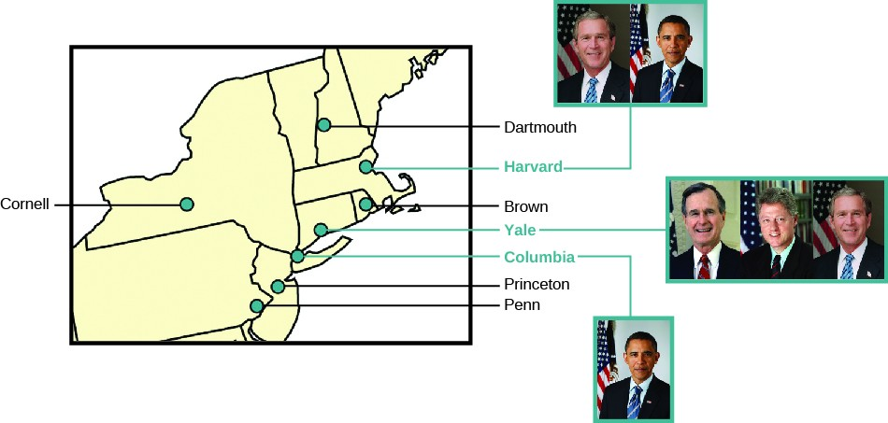
In apparent support of the elite perspective, one-third of U.S. presidents have attended Ivy League schools, a much higher percentage than the rest of the U.S. population.
All four of the most recent U.S. presidents attended Ivy League schools such as Harvard, Yale, or Columbia. Among members of the House of Representatives, 93 percent have a bachelor’s degree, as do 99 percent of members of the Senate.
Fewer than 40 percent of U.S. adults have even an associate’s degree.
The majority of the men and women in Congress also engaged in either state or local politics, were business people, or practiced law before being elected to Congress.
Approximately 80 percent of both the Senate and the House of Representatives are male, and fewer than 20 percent of members of Congress are people of color. The nation’s laws are made primarily by well-educated white male professionals and businessmen.
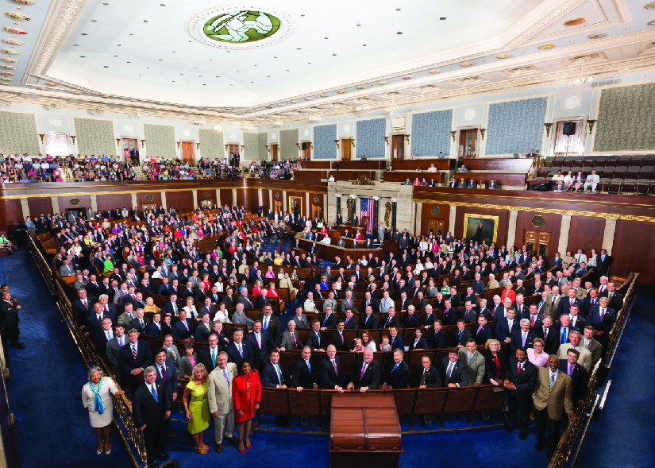
The makeup of Congress is important because race, sex, profession, education, and socioeconomic class have an important effect on people’s political interests. For example, changes in the way taxes are levied and spent do not affect all citizens equally. A flat tax, which generally requires that everyone pay the same percentage rate, hurts the poor more than it does the rich. If the income tax rate was flat at 10 percent, all Americans would have to pay 10 percent of their income to the federal government. Someone who made $40,000 a year would have to pay $4,000 and be left with only $36,000 to live on. Someone who made $1,000,000 would have to pay $100,000, a greater sum, but he or she would still be left with $900,000. People who were not wealthy would probably pay more than they could comfortably afford, while the wealthy, who could afford to pay more and still live well, would not see a real impact on their daily lives. Similarly, the allocation of revenue affects the rich and the poor differently. Giving more money to public education does not benefit the wealthy as much as it does the poor, because the wealthy are more likely than the poor to send their children to private schools or to at least have the option of doing so. However, better funded public schools have the potential to greatly improve the upward mobility of members of other socioeconomic classes who have no other option than to send their children to public schools.
Currently, more than half of the members of Congress are millionaires; their median net worth is just over $1 million, and some have much more.
As of 2003, more than 40 percent of Congress sent their children to private schools. Overall, only10 percent of the American population does so.
Therefore, a Congress dominated by millionaires who send their children to private schools is more likely to believe that flat taxes are fair and that increased funding for public education is not a necessity. Their experience, however, does not reflect the experience of average Americans.
Pluralist theory rejects this approach, arguing that although there are elite members of society they do not control government. Instead, pluralists argue, political power is distributed throughout society. Rather than resting in the hands of individuals, a variety of organized groups hold power, with some groups having more influence on certain issues than others. Thousands of interest groups exist in the United States.
Approximately 70–90 percent of Americans report belonging to at least one group.
According to pluralist theory, people with shared interests will form groups in order to make their desires known to politicians. These groups include such entities as environmental advocates, unions, and organizations that represent the interests of various businesses. Because most people lack the inclination, time, or expertise necessary to decide political issues, these groups will speak for them. As groups compete with one another and find themselves in conflict regarding important issues, government policy begins to take shape. In this way, government policy is shaped from the bottom up and not from the top down, as we see in elitist theory. Robert Dahl, author of Who Governs?, was one of the first to advance the pluralist theory, and argued that politicians seeking an “electoral payoff” are attentive to the concerns of politically active citizens and, through them, become acquainted with the needs of ordinary people. They will attempt to give people what they want in exchange for their votes.
The Center for Responsive Politics is a non-partisan research group that provides data on who gives to whom in elections. Visit OpenSecrets.org: Center for Responsive Politics to track campaign contributions, congressional bills and committees, and interest groups and lobbyists.

THE TRADEOFFS PERSPECTIVE
Although elitists and pluralists present political influence as a tug-of-war with people at opposite ends of a rope trying to gain control of government, in reality government action and public policy are influenced by an ongoing series of tradeoffs or compromises. For instance, an action that will meet the needs of large numbers of people may not be favored by the elite members of society. Giving the elite what they want may interfere with plans to help the poor. As pluralists argue, public policy is created as a result of competition among groups. In the end, the interests of both the elite and the people likely influence government action, and compromises will often attempt to please them both.
Since the framing of the U.S. Constitution, tradeoffs have been made between those who favor the supremacy of the central government and those who believe that state governments should be more powerful. Should state governments be able to respond to the desires of citizen groups by legalizing the use of marijuana? Should the national government be able to close businesses that sell marijuana even in states where it is legal? Should those who control the Federal Bureau of Investigation (FBI) and the National Security Agency (NSA) be allowed to eavesdrop on phone conversations of Americans and read their email? Should groups like the American Civil Liberties Union (ACLU), which protect all citizens’ rights to freedom of speech, be able to prevent this?
Many of the tradeoffs made by government are about freedom of speech. The First Amendment of the Constitution gives Americans the right to express their opinions on matters of concern to them; the federal government cannot interfere with this right. Because of the Fourteenth Amendment, state governments must protect this right also. At the same time, neither the federal government nor state governments can allow someone’s right to free expression to interfere with someone else’s ability to exercise his or her own rights. For example, in the United States, it is legal for women to have abortions. Many people oppose this right, primarily for religious reasons, and often protest outside facilities that provide abortions. In 2007, the state of Massachusetts enacted a law that required protestors to stand thirty-five feet away from clinic entrances. The intention was to prevent women seeking abortions from being harassed or threatened with violence. Groups favoring the protection of women’s reproductive rights supported the law. Groups opposed to abortion argued that the buffer zone prevented them from speaking to women to try to persuade them not to have the procedure done. In 2014, in the case of McCullen v. Coakley, the U.S. Supreme Court struck down the law that created a buffer zone between protestors and clinic entrances.
The federal government does not always side with those who oppose abortion, however. Several states have attempted to pass laws requiring women to notify their husbands, and often obtain their consent, before having an abortion. All such laws have been found unconstitutional by the courts.
Tradeoffs also occur as a result of conflict between groups representing the competing interests of citizens. Many Americans believe that the U.S. must become less dependent on foreign sources of energy. Many also would like people to have access to inexpensive sources of energy. Such people are likely to support fracking: the process of hydraulic fracturing that gives drilling companies access to natural gas trapped between layers of shale underground. Fracking produces abundant, inexpensive natural gas, a great benefit to people who live in parts of the country where it is expensive to heat homes during the winter. Fracking also creates jobs. At the same time, many scholars argue that fracking can result in the contamination of drinking water, air pollution, and increased risk of earthquakes. One study has even linked fracking to cancer. Thus, those who want to provide jobs and inexpensive natural gas are in conflict with those who wish to protect the natural environment and human health. Both sides are well intentioned, but they disagree over what is best for people
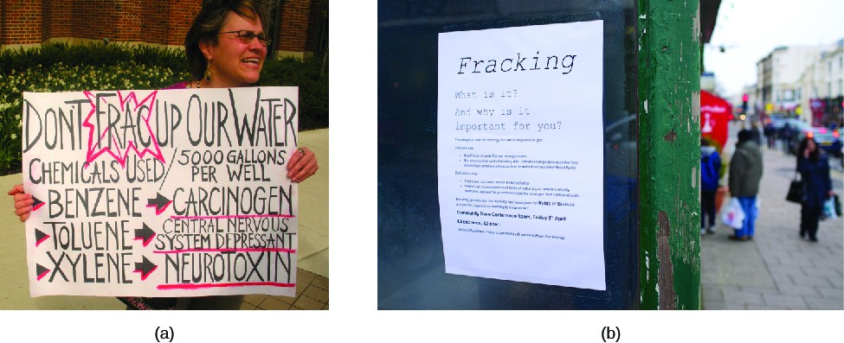
Tradeoffs are especially common in the United States Congress. Members of the Senate and the House of Representatives usually vote according to the concerns of people who live in their districts. Not only does this often pit the interests of people in different parts of the country against one another, but it also frequently favors the interests of certain groups of people over the interests of others within the same state. For example, allowing oil companies to drill off the state’s coast may please those who need the jobs that will be created, but it will anger those who wish to preserve coastal lands as a refuge for wildlife and, in the event of an accident, may harm the interests of people who depend on fishing and tourism for their living. At times, House members and senators in Congress may ignore the voters in their home states and the groups that represent them in order to follow the dictates of the leaders of the political party to which they belong. For example, a member of Congress from a state with a large elderly population may be inclined to vote in favor of legislation to increase benefits for retired people; however, his or her political party leaders, who disapprove of government spending on social programs, may ask for a vote against it. The opposite can occur as well, especially in the case of a legislator soon facing re-election. With two-year terms of office, we are more likely to see House members buck their party in favor of their constituents.
Finally, the government may attempt to resolve conflicting concerns within the nation as a whole through tradeoffs. After repeated incidents of mass shootings at schools, theaters, churches, and shopping malls, many are concerned with protecting themselves and their families from firearm violence. Some groups would like to ban the sale of automatic weapons completely. Some do not want to ban gun ownership; they merely want greater restrictions to be put in place on who can buy guns or how long people must wait between the time they enter the store to make a purchase and the time when they are actually given possession of the weapon. Others represent the interests of those who oppose any restrictions on the number or type of weapons Americans may own. So far, state governments have attempted to balance the interests of both groups by placing restrictions on such things as who can sell guns, where gun sales may take place, or requirements for background checks, but they have not attempted to ban gun sales altogether. For example, although federal law does not require private gun dealers (people who sell guns but do not derive most of their income from doing so) to conduct background checks before selling firearms to people at gun shows, some states have passed laws requiring this.

Summary
Many question whether politicians are actually interested in the needs of average citizens and debate how much influence ordinary people have over what government does. Those who support the elite theory of government argue that a small, wealthy, powerful elite controls government and makes policy to benefit its members and perpetuate their power. Others favor the pluralist theory, which maintains that groups representing the people’s interests do attract the attention of politicians and can influence government policy. In reality, government policy usually is the result of a series of tradeoffs as groups and elites fight with one another for influence and politicians attempt to balance the demands of competing interests, including the interests of the constituents who elected them to office.

An interactive or media element has been excluded from this version of the text. You can view it online here: https://library.achievingthedream.org/bcccomposition/?p=45
elite theory claims political power rests in the hands of a small, elite group of people
pluralist theory claims political power rests in the hands of groups of people

C. Wright Mills. 1956.
. New York: Oxford University Press.

Jack L. Walker. 1966. "A Critique of the Elitist Theory of Democracy,"

60, No. 2: 295.

Jennifer E. Manning, "Membership of the 113th Congress: A Profile,"
, p. 5 (Table 5), November 24, 2014.

Alan Rappeport, "Making it Rain: Members of Congress Are Mostly Millionaires,"

, 12 January 2016.

"The Non-Governmental Order: Will NGOs Democratise, or Merely Disrupt, Global Governance?"
, 9 December 1999.

Ronald J. Hrebenar. 1997.
, 3rd ed. New York: Routledge, 14; Clive S. Thomas. 2004.
. Westport, CT: Praeger, 106.

Dahl,
91–93.

, 573 U.S. __ (2014); Melissa Jeltsen, "The Reality of Abortion Clinics without Buffer Zones,"
, 13 July 2014.

Chapter 21

Engagement in a Democracy

Learning Objectives
By the end of this section, you will be able to:
- Explain the importance of citizen engagement in a democracy
- Describe the main ways Americans can influence and become engaged in government
- Discuss factors that may affect people’s willingness to become engaged in government
Participation in government matters. Although people may not get all that they want, they can achieve many goals and improve their lives through civic engagement. According to the pluralist theory, government cannot function without active participation by at least some citizens. Even if we believe the elite make political decisions, participation in government through the act of voting can change who the members of the elite are.

WHY GET INVOLVED?
Are fewer people today active in politics than in the past? Political scientist Robert Putnam has argued that civic engagement is declining; although many Americans may report belonging to groups, these groups are usually large, impersonal ones with thousands of members. People who join groups such as Amnesty International or Greenpeace may share certain values and ideals with other members of the group, but they do not actually interact with these other members. These organizations are different from the types of groups Americans used to belong to, like church groups or bowling leagues. Although people are still interested in volunteering and working for the public good, they are more interested in either working individually or joining large organizations where they have little opportunity to interact with others. Putnam considers a number of explanations for this decline in small group membership, including increased participation by women in the workforce, a decrease in the number of marriages and an increase in divorces, and the effect of technological developments, such as the internet, that separate people by allowing them to feel connected to others without having to spend time in their presence.
Putnam argues that a decline in social capital—”the collective value of all ‘social networks’ [those whom people know] and the inclinations that arise from these networks to do things for each other”—accompanies this decline in membership in small, interactive groups.
Included in social capital are such things as networks of individuals, a sense that one is part of an entity larger than oneself, concern for the collective good and a willingness to help others, and the ability to trust others and to work with them to find solutions to problems. This, in turn, has hurt people’s willingness and ability to engage in representative government. If Putnam is correct, this trend is unfortunate, because becoming active in government and community organizations is important for many reasons.
To learn more about political engagement in the United States, read “The Current State of Civic Engagement in America” by the Pew Research Center.

Civic engagement can increase the power of ordinary people to influence government actions. Even those without money or connections to important people can influence the policies that affect their lives and change the direction taken by government. U.S. history is filled with examples of people actively challenging the power of elites, gaining rights for themselves, and protecting their interests. For example, slavery was once legal in the United States and large sectors of the U.S. economy were dependent on this forced labor. Slavery was outlawed and blacks were granted citizenship because of the actions of abolitionists. Although some abolitionists were wealthy white men, most were ordinary people, including men and women of both races. White women and blacks were able to actively assist in the campaign to end slavery despite the fact that, with few exceptions, they were unable to vote. Similarly, the right to vote once belonged solely to white men until the Fifteenth Amendment gave the vote to African American men. The Nineteenth Amendment extended the vote to include women, and the Voting Rights Act of 1965 made exercising the right to vote a reality for African American men and women in the South. None of this would have happened, however, without the efforts of people who marched in protest, participated in boycotts, delivered speeches, wrote letters to politicians, and sometimes risked arrest in order to be heard. The tactics used to influence the government and effect change by abolitionists and members of the women’s rights and African American civil rights movements are still used by many activists today.
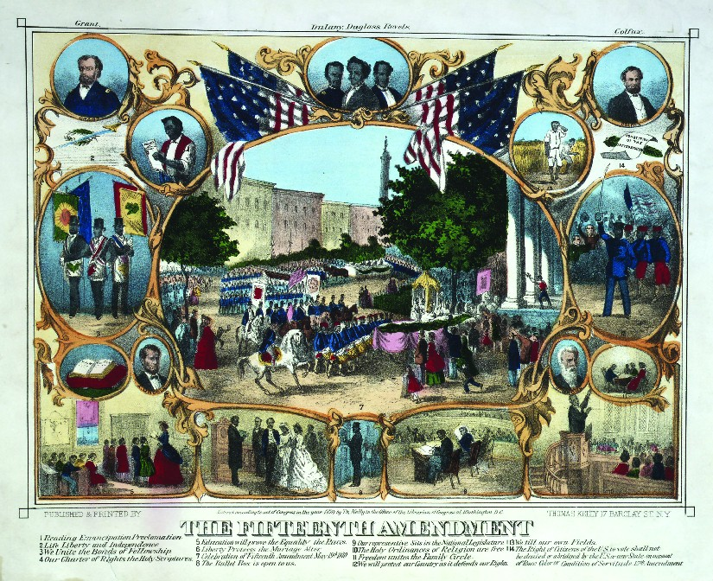
The rights gained by these activists and others have dramatically improved the quality of life for many in the United States. Civil rights legislation did not focus solely on the right to vote or to hold public office; it also integrated schools and public accommodations, prohibited discrimination in housing and employment, and increased access to higher education. Activists for women’s rights fought for, and won, greater reproductive freedom for women, better wages, and access to credit. Only a few decades ago, homosexuality was considered a mental disorder, and intercourse between consenting adults of the same sex was illegal in many states. Although legal discrimination against gays and lesbians still remains, consensual intercourse between homosexual adults is no longer illegal anywhere in the United States, and same-sex couples have the right to legally marry.
Activism can improve people’s lives in less dramatic ways as well. Working to make cities clean up vacant lots, destroy or rehabilitate abandoned buildings, build more parks and playgrounds, pass ordinances requiring people to curb their dogs, and ban late-night noise greatly affects people’s quality of life. The actions of individual Americans can make their own lives better and improve their neighbors’ lives as well.
Representative democracy cannot work effectively without the participation of informed citizens, however. Engaged citizens familiarize themselves with the most important issues confronting the country and with the plans different candidates have for dealing with those issues. Then they vote for the candidates they believe will be best suited to the job, and they may join others to raise funds or campaign for those they support. They inform their representatives how they feel about important issues. Through these efforts and others, engaged citizens let their representatives know what they want and thus influence policy. Only then can government actions accurately reflect the interests and concerns of the majority. Even people who believe the elite rule government should recognize that it is easier for them to do so if ordinary people make no effort to participate in public life.

PATHWAYS TO ENGAGEMENT
People can become civically engaged in many ways, either as individuals or as members of groups. Some forms of individual engagement require very little effort. One of the simplest ways is to stay informed about debates and events in the community, in the state, and in the nation. Awareness is the first step toward engagement. News is available from a variety of reputable sources, such as newspapers like the New York Times; national news shows, including those offered by the Public Broadcasting Service and National Public Radio; and reputable internet sites.
Visit Avaaz and Change.org for more information on current political issues.

Another form of individual engagement is to write or email political representatives. Filing a complaint with the city council is another avenue of engagement. City officials cannot fix problems if they do not know anything is wrong to begin with. Responding to public opinion polls, actively contributing to a political blog, or starting a new blog are all examples of different ways to be involved.
One of the most basic ways to engage with government as an individual is to vote. Individual votes do matter. City council members, mayors, state legislators, governors, and members of Congress are all chosen by popular vote. Although the president of the United States is not chosen directly by popular vote but by a group called the Electoral College, the votes of individuals in their home states determine how the Electoral College ultimately votes. Registering to vote beforehand is necessary in most states, but it is usually a simple process, and many states allow registration online. (We discuss voter registration and voter turnout in more depth in a later chapter.)
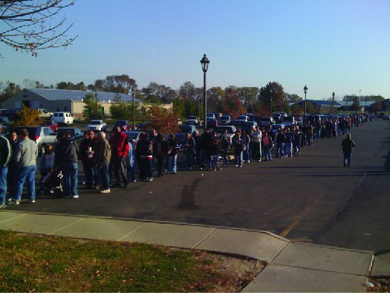
Voting, however, is not the only form of political engagement in which people may participate. Individuals can engage by attending political rallies, donating money to campaigns, and signing petitions. Starting a petition of one’s own is relatively easy, and some websites that encourage people to become involved in political activism provide petitions that can be circulated through email. Taking part in a poll or survey is another simple way to make your voice heard.

Votes for Eighteen-Year-Olds
Young Americans are often reluctant to become involved in traditional forms of political activity. They may believe politicians are not interested in what they have to say, or they may feel their votes do not matter. However, this attitude has not always prevailed. Indeed, today’s college students can vote because of the activism of college students in the 1960s. Most states at that time required citizens to be twenty-one years of age before they could vote in national elections. This angered many young people, especially young men who could be drafted to fight the war in Vietnam. They argued that it was unfair to deny eighteen-year-olds the right to vote for the people who had the power to send them to war. As a result, the Twenty-Sixth Amendment, which lowered the voting age in national elections to eighteen, was ratified by the states and went into effect in 1971.
Are you engaged in or at least informed about actions of the federal or local government? Are you registered to vote? How would you feel if you were not allowed to vote until age twenty-one?
Some people prefer to work with groups when participating in political activities or performing service to the community. Group activities can be as simple as hosting a book club or discussion group to talk about politics. Coffee Party USA provides an online forum for people from a variety of political perspectives to discuss issues that are of concern to them. People who wish to be more active often work for political campaigns. Engaging in fundraising efforts, handing out bumper stickers and campaign buttons, helping people register to vote, and driving voters to the polls on Election Day are all important activities that anyone can engage in. Individual citizens can also join interest groups that promote the causes they favor.

Getting Involved
In many ways, the pluralists were right. There is plenty of room for average citizens to become active in government, whether it is through a city council subcommittee or another type of local organization. Civic organizations always need volunteers, sometimes for only a short while and sometimes for much longer.
For example, Common Cause is a non-partisan organization that seeks to hold government accountable for its actions. It calls for campaign finance reform and paper verification of votes registered on electronic voting machines. Voters would then receive proof that the machine recorded their actual vote. This would help to detect faulty machines that were inaccurately tabulating votes or election fraud. Therefore, one could be sure that election results were reliable and that the winning candidate had in fact received the votes counted in their favor. Common Cause has also advocated that the Electoral College be done away with and that presidential elections be decided solely on the basis of the popular vote.
Follow-up activity: Choose one of the following websites to connect with organizations and interest groups in need of help:
- Common Cause;
- Friends of the Earth which mobilizes people to protect the natural environment;
- Grassroots International which works for global justice;
- The Family Research Council which promotes traditional marriage and Judeo-Christian values; or
- Eagle Forum which supports greater restrictions on immigration and fewer restrictions on home schooling.
Political activity is not the only form of engagement, and many people today seek other opportunities to become involved. This is particularly true of young Americans. Although young people today often shy away from participating in traditional political activities, they do express deep concern for their communities and seek out volunteer opportunities.
Although they may not realize it, becoming active in the community and engaging in a wide variety of community-based volunteer efforts are important forms of civic engagement and help government do its job. The demands on government are great, and funds do not always exist to enable it to undertake all the projects it may deem necessary. Even when there are sufficient funds, politicians have differing ideas regarding how much government should do and what areas it should be active in. Volunteers and community organizations help fill the gaps. Examples of community action include tending a community garden, building a house for Habitat for Humanity, cleaning up trash in a vacant lot, volunteering to deliver meals to the elderly, and tutoring children in after-school programs.
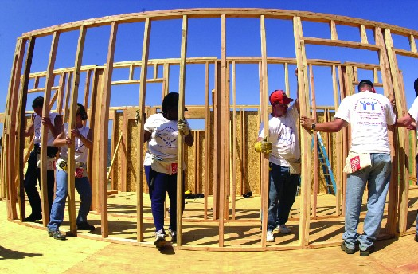
Some people prefer even more active and direct forms of engagement such as protest marches and demonstrations, including civil disobedience. Such tactics were used successfully in the African American civil rights movement of the 1950s and 1960s and remain effective today. Likewise, the sit-ins (and sleep-ins and pray-ins) staged by African American civil rights activists, which they employed successfully to desegregate lunch counters, motels, and churches, have been adopted today by movements such as Black Lives Matter and Occupy Wall Street. Other tactics, such as boycotting businesses of whose policies the activists disapproved, are also still common. Along with boycotts, there are now “buycotts,” in which consumers purchase goods and services from companies that give extensively to charity, help the communities in which they are located, or take steps to protect the environment.
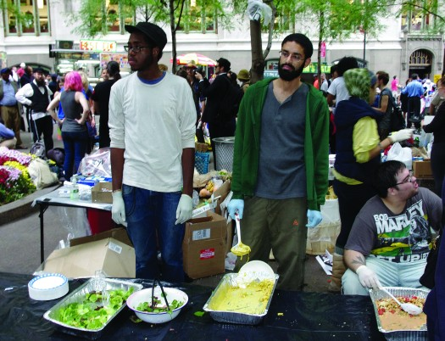
Many ordinary people have become political activists. Read “19 Young Activists Changing America” to learn about people who are working to make people’s lives better.

Ritchie Torres
In 2013, at the age of twenty-five, Ritchie Torres became the youngest member of the New York City Council and the first gay council member to represent the Bronx. Torres became interested in social justice early in his life. He was raised in poverty in the Bronx by his mother and a stepfather who left the family when Torres was twelve. The mold in his family’s public housing apartment caused him to suffer from asthma as a child, and he spent time in the hospital on more than one occasion because of it. His mother’s complaints to the New York City Housing Authority were largely ignored. In high school, Torres decided to become a lawyer, participated in mock trials, and met a young and aspiring local politician named James Vacca. After graduation, he volunteered to campaign for Vacca in his run for a seat on the City Council. After Vacca was elected, he hired Torres to serve as his housing director to reach out to the community on Vacca’s behalf. While doing so, Torres took pictures of the poor conditions in public housing and collected complaints from residents. In 2013, Torres ran for a seat on the City Council himself and won. He remains committed to improving housing for the poor.
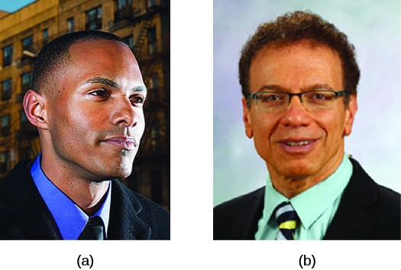
Why don’t more young people run for local office as Torres did? What changes might they effect in their communities if they were elected to a government position?

FACTORS OF ENGAGEMENT
Many Americans engage in political activity on a regular basis. A survey conducted in 2008 revealed that approximately two-thirds of American adults had participated in some type of political action in the past year. These activities included largely non-personal activities that did not require a great deal of interaction with others, such as signing petitions, contacting elected representatives, or contributing money to campaigns.
Americans aged 18–29 were less likely to become involved in traditional forms of political activity than older Americans. A 2015 poll of more than three thousand young adults by Harvard University’s Institute of Politics revealed that only 22 percent claimed to be politically engaged, and fewer than 10 percent said that they belonged to any type of political organization or had volunteered for a political campaign. Only slightly more said that they had gone to political rallies.
However, although Americans under age thirty are less likely than older Americans to engage in traditional types of political participation, many remain engaged in activities on behalf of their communities. One-third reported that they had voluntarily engaged in some form of community service in the past year
Why are younger Americans less likely to become involved in traditional political organizations? One answer may be that as American politics become more partisan in nature, young people turn away. Committed partisanship, which is the tendency to identify with and to support (often blindly) a particular political party, alienates some Americans who feel that elected representatives should vote in support of the nation’s best interests instead of voting in the way their party wishes them to. When elected officials ignore all factors other than their party’s position on a particular issue, some voters become disheartened while others may become polarized. However, a recent study reveals that it is a distrust of the opposing party and not an ideological commitment to their own party that is at the heart of most partisanship among voters.
Young Americans are particularly likely to be put off by partisan politics. More Americans under the age of thirty now identify themselves as Independents instead of Democrats or Republicans. Instead of identifying with a particular political party, young Americans are increasingly concerned about specific issues, such as same-sex marriage.
People whose votes are determined based on single issues are unlikely to vote according to party affiliation.
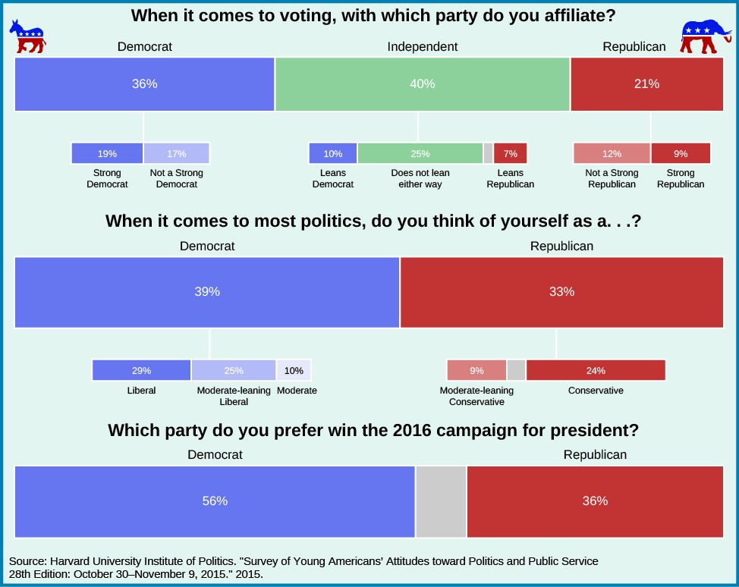
While some Americans disapprove of partisanship in general, others are put off by the ideology—established beliefs and ideals that help shape political policy—of one of the major parties. This is especially true among the young. As some members of the Republican Party have become more ideologically conservative (e.g., opposing same-sex marriage, legalization of certain drugs, immigration reform, gun control, separation of church and state, and access to abortion), those young people who do identify with one of the major parties have in recent years tended to favor the Democratic Party.
Of the Americans under age thirty who were surveyed by Harvard in 2015, more tended to hold a favorable opinion of Democrats in Congress than of Republicans, and 56 percent reported that they wanted the Democrats to win the presidency in 2016. Even those young Americans who identify themselves as Republicans are more liberal on certain issues, such as being supportive of same-sex marriage and immigration reform, than are older Republicans. The young Republicans also may be more willing to see similarities between themselves and Democrats.
Once again, support for the views of a particular party does not necessarily mean that someone will vote for members of that party.
Other factors may keep even those college students who do wish to vote away from the polls. Because many young Americans attend colleges and universities outside of their home states, they may find it difficult to register to vote. In places where a state-issued ID is required, students may not have one or may be denied one if they cannot prove that they paid in-state tuition rates.
The likelihood that people will become active in politics also depends not only on age but on such factors as wealth and education. In a 2006 poll, the percentage of people who reported that they were regular voters grew as levels of income and education increased.
Political involvement also depends on how strongly people feel about current political issues. Unfortunately, public opinion polls, which politicians may rely on when formulating policy or deciding how to vote on issues, capture only people’s latent preferences or beliefs. Latent preferences are not deeply held and do not remain the same over time. They may not even represent a person’s true feelings, since they may be formed on the spot when someone is asked a question about which he or she has no real opinion. Indeed, voting itself may reflect merely a latent preference because even people who do not feel strongly about a particular political candidate or issue vote. On the other hand, intense preferences are based on strong feelings regarding an issue that someone adheres to over time. People with intense preferences tend to become more engaged in politics; they are more likely to donate time and money to campaigns or to attend political rallies. The more money that one has and the more highly educated one is, the more likely that he or she will form intense preferences and take political action.

Summary
Civic and political engagement allows politicians to know how the people feel. It also improves people’s lives and helps them to build connections with others. Individuals can educate themselves on important issues and events, write to their senator or representative, file a complaint at city hall, attend a political rally, or vote. People can also work in groups to campaign or raise funds for a candidate, volunteer in the community, or protest a social injustice or an unpopular government policy. Although wealthier, older, more highly educated citizens are the most likely to be engaged with their government, especially if they have intense preferences about an issue, younger, less wealthy people can do much to change their communities and their country.

Practice Questions
- What kinds of people are most likely to become active in politics or community service?
- What political activities can people engage in other than running for office?
- Is citizen engagement necessary for a democracy to function? Explain.
- Is citizen engagement necessary for a democracy to function? Explain.
- Is citizen engagement necessary for a democracy to function? Explain.
- Which is the more important reason for being engaged: to gain power or improve the quality of life? Why?
- Are all Americans equally able to become engaged in government? What factors make it more possible for some people to become engaged than others? What could be done to change this?
- Which pathways of engagement in U.S. government do you plan to follow? Why do you prefer these approaches?
- Are there any redeeming qualities to elitism and any downsides to pluralism? Are there benefits to having elites rule? Are there problems with allowing interest groups to exercise influence over government? Explain.
- People can pay attention to the news in order to be aware of the most important issues of the day. They can contribute money to a campaign or attend a rally in support of a political candidate whose views they favor. They can write letters to members of Congress and to state and local politicians. They can vote.
An interactive or media element has been excluded from this version of the text. You can view it online here: https://library.achievingthedream.org/bcccomposition/?p=46
ideology the beliefs and ideals that help to shape political opinion and eventually policy
intense preferences beliefs and preferences based on strong feelings regarding an issue that someone adheres to over time
latent preferences beliefs and preferences people are not deeply committed to and that change over time
partisanship strong support, or even blind allegiance, for a particular political party
social capital connections with others and the willingness to interact and aid them

Books
Dahl, Robert A. 1991. Democracy and Its Critics. New Haven, CT: Yale University Press.
———. 1961. Who Governs? Democracy and Power in an American City. New Haven, CT: Yale University Press.
Dolan, Julie, Melissa M. Deckman, and Michele L. Swers. 2015. Women and Politics: Paths to Power and Political Influence. Lanham, MD: Rowman & Littlefield.
Mills, C. Wright. 1956. The Power Elite. New York: Oxford University Press.
Olson, Mancur. 1971. The Logic of Collective Action: Public Goods and the Theory of Groups. Cambridge: Harvard University Press.
Putnam, Robert D. 2001. Bowling Alone: The Collapse and Revival of American Community. New York: Simon & Schuster.

Films
1949. All the King’s Men.
1976. All the President’s Men.
1972. The Candidate.
2007. Charlie Wilson’s War.
2008. Frost/Nixon.
1933. Gabriel over the White House.
2008. Milk.
1939. Mr. Smith Goes to Washington.

Robert D. Putnam. 2001.
. New York: Simon & Schuster, 75.

———. 1995. "Bowling Alone: America’s Declining Social Capital,"
6: 66–67, 69; "About Social Capital," https://www.hks.harvard.edu/programs/saguaro/about-social-capital (May 2, 2016).

Winston Ross, "Ritchie Torres: Gay, Hispanic and Powerful,"
, 25 January 2015.

Marc Hetherington and Thomas Rudolph, "Why Don’t Americans Trust the Government?"
, 30 January 2014.

"Keeping Students from the Polls,"
, 26 December 2011.

PART VIII

Module 7

Chapter 22

Reading: Levels of Social Movements
Social movements are purposeful, organized groups that strive to work toward a common social goal. While most of us learned about social movements in history classes, we tend to take for granted the fundamental changes they caused —and we may be completely unfamiliar with the trend toward global social movements. But from the anti-tobacco movement that has worked to outlaw smoking in public buildings and raise the cost of cigarettes, to political uprisings throughout the Arab world, movements are creating social change on a global scale.

Levels of Social Movements
Movements happen in our towns, in our nation, and around the world. Let’s take a look at examples of social movements, from local to global. No doubt you can think of others on all of these levels, especially since modern technology has allowed us a near-constant stream of information about the quest for social change around the world.

Local
Chicago is a city of highs and lows, from corrupt politicians and failing schools to innovative education programs and a thriving arts scene. Not surprisingly, it has been home to a number of social movements over time. Currently, AREA Chicago is a social movement focused on “building a socially just city” (AREA Chicago 2011). The organization seeks to “create relationships and sustain community through art, research, education, and activism” (AREA Chicago 2011). The movement offers online tools like the Radicalendar––a calendar for getting radical and connected––and events such as an alternative to the traditional Independence Day picnic. Through its offerings, AREA Chicago gives local residents a chance to engage in a movement to help build a socially just city.

State

At the other end of the political spectrum from AREA Chicago is the Texas Secede! social movement in Texas. This statewide organization promotes the idea that Texas can and should secede from the United States to become an independent republic. The organization, which as of 2014 has over 6,000 “likes” on Facebook, references both Texas and national history in promoting secession. The movement encourages Texans to return to their rugged and individualistic roots, and to stand up to what proponents believe is the theft of their rights and property by the U.S. government (Texas Secede! 2009).

National
A recent polarizing national issue that helped spawn many activist groups was gay marriage. While same-sex marriage has been legal nationwide since June 26, 2015, the issue was hotly contested on both sides.
The Human Rights Campaign, a nationwide organization that advocates for LGBT civil rights, has been active for over thirty years and claims more than a million members. One focus of the organization was its Americans for Marriage Equality campaign. Using public celebrities such as athletes, musicians, and political figures, it sought to engage the public in the issue of equal rights under the law. The campaign raised awareness of the over 1,100 different rights, benefits, and protections provided on the basis of marital status under federal law and sought to educate the public about why these protections should be available to all committed couples regardless of gender (Human Rights Campaign 2014).
A movement on the opposite end was the National Organization for Marriage, an organization that funds campaigns to stop same-sex marriage (National Organization for Marriage 2014). Both these organizations worked on the national stage and sought to engage people through grassroots efforts to push their message.

Global
Social organizations worldwide take stands on such general areas of concern as poverty, sex trafficking, and the use of genetically modified organisms (GMOs) in food. Nongovernmental organizations (NGOs) are sometimes formed to support such movements, such as the International Federation of Organic Agriculture Movement (FOAM). Global efforts to reduce poverty are represented by the Oxford Committee for Famine Relief (OXFAM), among others. The Fair Trade movement exists to protect and support food producers in developing countries. Occupy Wall Street, although initially a local movement, also went global throughout Europe and, as the chapter’s introductory photo shows, the Middle East.

Practice

1. Social movements are:
- disruptive and chaotic challenges to the government
- ineffective mass movements
- the collective action of individuals working together in an attempt to establish new norms beliefs, or values
- the singular activities of a collection of groups working to challenge the status quo

c
NGO:
nongovernmental organizations working globally for numerous humanitarian and environmental causes
social movement:
a purposeful organized group hoping to work toward a common social goal

Chapter 23

Reading: Collective Behavior

Flash Mobs

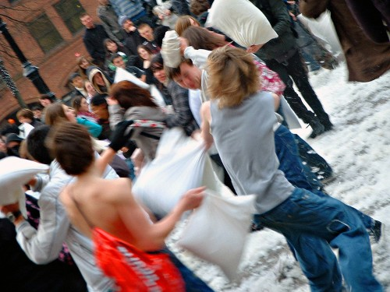
In March 2014, a group of musicians got together in a fish market in Odessa for a spontaneous performance of Beethoven’s “Ode to Joy” from his Ninth Symphony. While tensions were building over Ukraine’s efforts to join the European Union, and even as Russian troops had taken control of the Ukrainian airbase in Belbek, the Odessa Philharmonic Orchestra and Opera Chorus tried to lighten the troubled times for shoppers with music and song.
Spontaneous gatherings like this are called flash mobs. They often are captured on video and shared on the Internet; frequently they go viral. Humans seek connections and shared experiences. Perhaps experiencing a flash mob event enhances this bond. It certainly interrupts our otherwise mundane routine with a reminder that we are social animals.

Forms of Collective Behavior
Flash mobs are examples of collective behavior, noninstitutionalized activity in which several or many people voluntarily engage. Other examples are a group of commuters traveling home from work and a population of teens adopting a favorite singer’s hairstyle. In short, collective behavior is any group behavior that is not mandated or regulated by an institution. There are three primary forms of collective behavior: the crowd, the mass, and the public.
It takes a fairly large number of people in close proximity to form a crowd (Lofland 1993). Examples include a group of people attending an Ani DiFranco concert, tailgating at a Patriots game, or attending a worship service. Turner and Killian (1993) identified four types of crowds. Casual crowds consist of people who are in the same place at the same time but who aren’t really interacting, such as people standing in line at the post office. Conventional crowds are those who come together for a scheduled event that occurs regularly, like a religious service. Expressive crowds are people who join together to express emotion, often at funerals, weddings, or the like. The final type, acting crowds, focuses on a specific goal or action, such as a protest movement or riot.
In addition to the different types of crowds, collective groups can also be identified in two other ways. A mass is a relatively large number of people with a common interest, though they may not be in close proximity (Lofland 1993), such as players of the popular Facebook game Farmville. A public, on the other hand, is an unorganized, relatively diffused group of people who share ideas, such as the Libertarian political party. While these two types of crowds are similar, they are not the same. To distinguish between them, remember that members of a mass share interests, whereas members of a public share ideas.

Theoretical Perspectives on Collective Behavior
Early collective behavior theories (LeBon 1895; Blumer 1969) focused on the irrationality of crowds. Eventually, those theorists who viewed crowds as uncontrolled groups of irrational people were supplanted by theorists who viewed the behavior some crowds engaged in as the rational behavior of logical beings.

Emergent-Norm Perspective

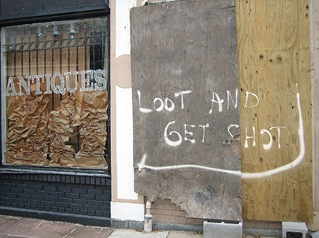
Sociologists Ralph Turner and Lewis Killian (1993) built on earlier sociological ideas and developed what is known as emergent norm theory. They believe that the norms experienced by people in a crowd may be disparate and fluctuating. They emphasize the importance of these norms in shaping crowd behavior, especially those norms that shift quickly in response to changing external factors. Emergent norm theory asserts that, in this circumstance, people perceive and respond to the crowd situation with their particular (individual) set of norms, which may change as the crowd experience evolves. This focus on the individual component of interaction reflects a symbolic interactionist perspective.
For Turner and Killian, the process begins when individuals suddenly find themselves in a new situation, or when an existing situation suddenly becomes strange or unfamiliar. For example, think about human behavior during Hurricane Katrina. New Orleans was decimated and people were trapped without supplies or a way to evacuate. In these extraordinary circumstances, what outsiders saw as “looting” was defined by those involved as seeking needed supplies for survival. Normally, individuals would not wade into a corner gas station and take canned goods without paying, but given that they were suddenly in a greatly changed situation, they established a norm that they felt was reasonable.
Once individuals find themselves in a situation ungoverned by previously established norms, they interact in small groups to develop new guidelines on how to behave. According to the emergent-norm perspective, crowds are not viewed as irrational, impulsive, uncontrolled groups. Instead, norms develop and are accepted as they fit the situation. While this theory offers insight into why norms develop, it leaves undefined the nature of norms, how they come to be accepted by the crowd, and how they spread through the crowd.

Value-Added Theory
Neil Smelser’s (1962) meticulous categorization of crowd behavior, called value-added theory, is a perspective within the functionalist tradition based on the idea that several conditions must be in place for collective behavior to occur. Each condition adds to the likelihood that collective behavior will occur. The first condition is structural conduciveness, which occurs when people are aware of the problem and have the opportunity to gather, ideally in an open area. Structural strain, the second condition, refers to people’s expectations about the situation at hand being unmet, causing tension and strain. The next condition is the growth and spread of a generalized belief, wherein a problem is clearly identified and attributed to a person or group.
Fourth, precipitating factors spur collective behavior; this is the emergence of a dramatic event. The fifth condition is mobilization for action, when leaders emerge to direct a crowd to action. The final condition relates to action by the agents. Called social control, it is the only way to end the collective behavior episode (Smelser 1962).
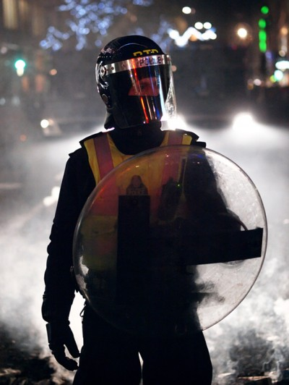
A real-life example of these conditions occurred after the fatal police shooting of teenager Michael Brown, an unarmed eighteen-year-old African American, in Ferguson, MO on August 9, 2014. The shooting drew national attention almost immediately. A large group of mostly black, local residents assembled in protest—a classic example of structural conduciveness. When the community perceived that the police were not acting in the people’s interest and were withholding the name of the officer, structural strain became evident. A growing generalized belief evolved as the crowd of protesters were met with heavily armed police in military-style protective uniforms accompanied by an armored vehicle. The precipitating factor of the arrival of the police spurred greater collective behavior as the residents mobilized by assembling a parade down the street. Ultimately they were met with tear gas, pepper spray, and rubber bullets used by the police acting as agents of social control. The element of social control escalated over the following days until August 18, when the governor called in the National Guard.

Assembling Perspective
Interactionist sociologist Clark McPhail (1991) developed assembling perspective, another system for understanding collective behavior that credited individuals in crowds as rational beings. Unlike previous theories, this theory refocuses attention from collective behavior to collective action. Remember that collective behavior is a noninstitutionalized gathering, whereas collective action is based on a shared interest. McPhail’s theory focused primarily on the processes associated with crowd behavior, plus the lifecycle of gatherings. He identified several instances of convergent or collective behavior, as shown on the chart below.
Clark McPhail identified various circumstances of convergent and collective behavior (McPhail 1991).
Type of crowd | Description | Example
Convergence clusters | Family and friends who travel together | Carpooling parents take several children to the movies
Convergent orientation | Group all facing the same direction | A semi-circle around a stage
Collective vocalization | Sounds or noises made collectively | Screams on a roller coaster
Collective verbalization | Collective and simultaneous participation in a speech or song | Pledge of Allegiance in the school classroom
Collective gesticulation | Body parts forming symbols | The YMCA dance
Collective manipulation | Objects collectively moved around | Holding signs at a protest rally
Collective locomotion | The direction and rate of movement to the event | Children running to an ice cream truck
As useful as this is for understanding the components of how crowds come together, many sociologists criticize its lack of attention on the large cultural context of the described behaviors, instead focusing on individual actions.

Think It Over

- Discuss the differences between a mass and a crowd. What is an example of each? What sets them apart? What do they share in common?
- Can you think of a time when your behavior in a crowd was dictated by the circumstances? Give an example of emergent-norm perspective, using your own experience.
- Discuss the differences between an acting crowd and a collective crowd. Give examples of each.
- Imagine you are at a rally protesting nuclear energy use. Walk us through the hypothetical rally using the value-added theory, imagining it meets all the stages.

Practice

1. Which of the following organizations is not an example of a social movement?
- National Football League
- Tea Party
- Greenpeace
- NAACP

a

2. Sociologists using conflict perspective might study what?
- How social movements develop
- What social purposes a movement serves
- What motivates inequitably treated people to join a movement
- What individuals hope to gain from taking part in a social movement

c

3. Which of the following is an example of collective behavior?
- A soldier questioning orders
- A group of people interested in hearing an author speak
- A class going on a field trip
- Going shopping with a friend

b

4. The protesters at the Egypt uprising rally were:
- a casual crowd
- a conventional crowd
- a mass
- an acting crowd

d

5. According to emergent-norm theory, crowds are:
- irrational and impulsive
- often misinterpreted and misdirected
- able to develop their own definition of the situation
- prone to criminal behavior

c

6. A boy throwing rocks during a demonstration might be an example of ___________.
- structural conduciveness
- structural strain
- precipitating factors
- mobilization for action

c

acting crowds:
crowds of people who are focused on a specific action or goal
assembling perspective:
a theory that credits individuals in crowds as behaving as rational thinkers and views crowds as engaging in purposeful behavior and collective action
casual crowds:
people who share close proximity without really interacting
collective behavior:
a noninstitutionalized activity in which several people voluntarily engage
conventional crowds:
people who come together for a regularly scheduled event
crowd:
a fairly large number of people who share close proximity
emergent norm theory:
a perspective that emphasizes the importance of social norms in crowd behavior
expressive crowds:
crowds who share opportunities to express emotions
flash mob:
a large group of people who gather together in a spontaneous activity that lasts a limited amount of time
mass:
a relatively large group with a common interest, even if they may not be in close proximity
public:
an unorganized, relatively diffuse group of people who share ideas
value-added theory:
a functionalist perspective theory that posits that several preconditions must be in place for collective behavior to occur

Chapter 24

Lower Order Concerns for Proofreading
Previously we examined higher order concerns (HOCs) as part of the revision stage of the writing process. Once we move to the proofreading stage, it’s time to consider the lower order concerns (LOCs). The difference is simple: HOCs are global issues, or issues that affect how a reader understands the entire paper; LOCs are issues that don’t necessarily interrupt understanding of the writing by themselves.
You may find yourself thinking, “Well, it depends,” or, “But what if…?” You’re absolutely right to think so. These lists are just guidelines; every writer will have a different hierarchy of concerns. Always try to think in terms of, “Does this affect my understanding of the writing?”

Are HOCs More Important than LOCs?
No, not necessarily. HOCs tend to interrupt a reader’s understanding of the writing, and that’s why they need to be addressed first. However, if a LOC becomes a major obstacle, then it naturally becomes a higher priority.
Think of an example of how a Lower Order Concern could become a Higher Order Concern.
Here are some other issues you might face. These may be more difficult to categorize, and they may largely depend on the writing. If you think, “It depends,” make notes about the circumstances under which these issues could be a HOC or a LOC.
- Evaluating sources
- citation method
- style
- paragraph structure
- active vs. passive voice
- format

How to Address LOCs
Analyze your use of source material. Check any paraphrases and quotations against the original texts. Quotations should replicate the original author’s words, while paraphrases should maintain the original author’s meaning but have altered language and sentence structures. For each source, confirm that you have adhered to the preferred style guide for the target journal or other venue.
Consider individual sentences in terms of grammar, mechanics, and punctuation. Many LOCs can be revised by isolating and examining different elements of the text. Read the text sentence by sentence, considering the grammar and sentence structure. Remember, a sentence may be grammatically correct and still confuse readers. If you notice a pattern—say, a tendency to misplace modifiers or add unnecessary commas—read the paper looking only for that error. Read the document backwards, word for word, looking for spelling errors. Throughout the writing process and especially at this stage of revision, keep a dictionary, a thesaurus, and a writing handbook nearby.
Strategies such as reading aloud and seeking feedback are useful at all points in the revision process. Reading aloud will give you distance from the text and prevent you from skimming over what is actually written on the page. This strategy will help you to identify both HOCs, such as missing concepts, and LOCs, such as typos. Additionally, seeking feedback will allow you to test your ideas and writing on real readers. Seek feedback from readers both inside and outside of your target audience in order to gain different perspectives.

Proofreading Advice
The following video features two student tutors from the Writing and Reading Center at Fresno City College. In addition to great guidance about proofreading strategies, they also offer insights about what to expect when working with Writing Center tutors.

A YouTube element has been excluded from this version of the text. You can view it online here: https://library.achievingthedream.org/bcccomposition/?p=50

PART IX

Module 8

Chapter 25

Reading: Types and Stages of Social Movements

Types of Social Movements

We know that social movements can occur on the local, national, or even global stage. Are there other patterns or classifications that can help us understand them? Sociologist David Aberle (1966) addresses this question by developing categories that distinguish among social movements based on what they want to change and how much change they want. Reform movements seek to change something specific about the social structure. Examples include antinuclear groups, Mothers Against Drunk Driving (MADD), the Dreamers movement for immigration reform, and the Human Rights Campaign’s advocacy for Marriage Equality. Revolutionary movements seek to completely change every aspect of society. These include the 1960s counterculture movement, including the revolutionary group The Weather Underground, as well as anarchist collectives. Texas Secede! is a revolutionary movement. Religious/Redemptive movements are “meaning seeking,” and their goal is to provoke inner change or spiritual growth in individuals. Organizations pushing these movements include Heaven’s Gate or the Branch Davidians. The latter is still in existence despite government involvement that led to the deaths of numerous Branch Davidian members in 1993. Alternative movements are focused on self-improvement and limited, specific changes to individual beliefs and behavior. These include trends like transcendental meditation or a macrobiotic diet. Resistance movements seek to prevent or undo change to the social structure. The Ku Klux Klan, the Minutemen, and pro-life movements fall into this category.

Stages of Social Movements
Later sociologists studied the lifecycle of social movements—how they emerge, grow, and in some cases, die out. Blumer (1969) and Tilly (1978) outline a four-stage process. In the preliminary stage, people become aware of an issue, and leaders emerge. This is followed by the coalescence stage when people join together and organize in order to publicize the issue and raise awareness. In the institutionalization stage, the movement no longer requires grassroots volunteerism: it is an established organization, typically with a paid staff. When people fall away and adopt a new movement, the movement successfully brings about the change it sought, or when people no longer take the issue seriously, the movement falls into the decline stage. Each social movement discussed earlier belongs in one of these four stages. Where would you put them on the list?

Social Media and Social Change: A Match Made in Heaven


Chances are you have been asked to tweet, friend, like, or donate online for a cause. Maybe you were one of the many people who, in 2010, helped raise over $3 million in relief efforts for Haiti through cell phone text donations. Or maybe you follow presidential candidates on Twitter and retweet their messages to your followers. Perhaps you have “liked” a local nonprofit on Facebook, prompted by one of your neighbors or friends liking it too. Nowadays, social movements are woven throughout our social media activities. After all, social movements start by activating people.
Referring to the ideal type stages discussed above, you can see that social media has the potential to dramatically transform how people get involved. Look at stage one, the preliminary stage: people become aware of an issue, and leaders emerge. Imagine how social media speeds up this step. Suddenly, a shrewd user of Twitter can alert his thousands of followers about an emerging cause or an issue on his mind. Issue awareness can spread at the speed of a click, with thousands of people across the globe becoming informed at the same time. In a similar vein, those who are savvy and engaged with social media emerge as leaders. Suddenly, you don’t need to be a powerful public speaker. You don’t even need to leave your house. You can build an audience through social media without ever meeting the people you are inspiring.
At the next stage, the coalescence stage, social media also is transformative. Coalescence is the point when people join together to publicize the issue and get organized. President Obama’s 2008 campaign was a case study in organizing through social media. Using Twitter and other online tools, the campaign engaged volunteers who had typically not bothered with politics and empowered those who were more active to generate still more activity. It is no coincidence that Obama’s earlier work experience included grassroots community organizing. What is the difference between his campaign and the work he did in Chicago neighborhoods decades earlier? The ability to organize without regard to geographical boundaries by using social media. In 2009, when student protests erupted in Tehran, social media was considered so important to the organizing effort that the U.S. State Department actually asked Twitter to suspend scheduled maintenance so that a vital tool would not be disabled during the demonstrations.
So what is the real impact of this technology on the world? Did Twitter bring down Mubarak in Egypt? Author Malcolm Gladwell (2010) doesn’t think so. In an article in New Yorker magazine, Gladwell tackles what he considers the myth that social media gets people more engaged. He points out that most of the tweets relating to the Iran protests were in English and sent from Western accounts (instead of people on the ground). Rather than increasing engagement, he contends that social media only increases participation; after all, the cost of participation is so much lower than the cost of engagement. Instead of risking being arrested, shot with rubber bullets, or sprayed with fire hoses, social media activists can click “like” or retweet a message from the comfort and safety of their desk (Gladwell 2010).
There are, though, good cases to be made for the power of social media in propelling social movements. In the article, “Parrhesia and Democracy: Truth-telling, WikiLeaks and the Arab Spring,” Theresa Sauter and Gavin Kendall (2011) describe the importance of social media in the Arab Spring uprisings. Parrhesia means “the practice of truth-telling,” which describes the protestors’ use of social media to make up for the lack of coverage and even misrepresentation of events by state-controlled media. The Tunisian blogger Lina Ben Mhenni posted photographs and videos on Facebook and Twitter of events exposing the violence committed by the government. In Egypt the journalist Asmaa Mahfouz used Facebook to gather large numbers of people in Tahrir Square in the capital city of Cairo. Sauter and Kendall maintain that it was the use of Web 2.0 technologies that allowed activists not only to share events with the world but also to organize the actions.
When the Egyptian government shut down the Internet to stop the use of social media, the group Anonymous, a hacking organization noted for online acts of civil disobedience initiated “Operation Egypt” and sent thousands of faxes to keep the public informed of their government’s activities (CBS Interactive Inc. 2014) as well as attacking the government’s web site (Wagensiel 2011). In its Facebook press release the group stated the following: “Anonymous wants you to offer free access to uncensored media in your entire country. When you ignore this message, not only will we attack your government websites, Anonymous will also make sure that the international media sees the horrid reality you impose upon your people.”
Sociologists have identified high-risk activism, such as the civil rights movement, as a “strong-tie” phenomenon, meaning that people are far more likely to stay engaged and not run home to safety if they have close friends who are also engaged. The people who dropped out of the movement––who went home after the danger got too great––did not display any less ideological commitment. But they lacked the strong-tie connection to other people who were staying. Social media, by its very makeup, is “weak-tie” (McAdam and Paulsen 1993). People follow or friend people they have never met. But while these online acquaintances are a source of information and inspiration, the lack of engaged personal contact limits the level of risk we’ll take on their behalf.

Think It Over

- Do you think social media is an important tool in creating social change? Why, or why not? Defend your opinion.
- Describe a social movement in the decline stage. What is its issue? Why has it reached this stage?

Practice

- extension
- amplification
- bridging
- transformation

d

alternative movements:
social movements that limit themselves to self-improvement changes in individuals
reform movements:
movements that seek to change something specific about the social structure
religious/redemptive movements:
movements that work to promote inner change or spiritual growth in individuals
resistance movements:
those who seek to prevent or undo change to the social structure
revolutionary movements:
movements that seek to completely change every aspect of society
social movement organization:
a single social movement group
social movement sector:
the multiple social movement industries in a society, even if they have widely varying constituents and goals

Chapter 26

Reading: Theoretical Perspectives on Social Movements
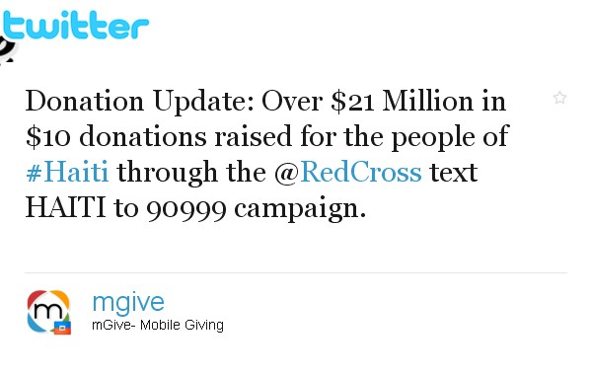

Theoretical Perspectives on Social Movements
Most theories of social movements are called collective action theories, indicating the purposeful nature of this form of collective behavior. The following three theories are but a few of the many classic and modern theories developed by social scientists.

Resource Mobilization
McCarthy and Zald (1977) conceptualize resource mobilization theory as a way to explain movement success in terms of the ability to acquire resources and mobilize individuals. Resources are primarily time and money, and the more of both, the greater the power of organized movements. Numbers of social movement organizations (SMOs), which are single social movement groups, with the same goals constitute a social movement industry (SMI). Together they create what McCarthy and Zald (1977) refer to as “the sum of all social movements in a society.”

Resource Mobilization and the Civil Rights Movement
An example of resource mobilization theory is activity of the civil rights movement in the decade between the mid 1950s and the mid 1960s. Social movements had existed before, notably the Women’s Suffrage Movement and a long line of labor movements, thus constituting an existing social movement sector, which is the multiple social movement industries in a society, even if they have widely varying constituents and goals. The civil rights movement had also existed well before Rosa Parks refused to give up her bus seat to a white man. Less known is that Parks was a member of the NAACP and trained in leadership (AE Television Networks, LLC. 2014). But her action that day was spontaneous and unplanned (Schmitz 2014). Her arrest triggered a public outcry that led to the famous Montgomery bus boycott, turning the movement into what we now think of as the “civil rights movement” (Schmitz 2014).
Mobilization had to begin immediately. Boycotting the bus made other means of transportation necessary, which was provided through car pools. Churches and their ministers joined the struggle, and the protest organization In Friendship was formed as well as The Friendly Club and the Club From Nowhere. A social movement industry, which is the collection of the social movement organizations that are striving toward similar goals, was growing.
Martin Luther King Jr. emerged during these events to become the charismatic leader of the movement, gained respect from elites in the federal government, and aided by even more emerging SMOs such as the Student Non-Violent Coordinating Committee (SNCC), the Congress of Racial Equality (CORE), the National Association for the Advancement of Colored People (NAACP), and the Southern Christian Leadership Conference (SCLC), among others. Several still exist today. Although the movement in that period was an overall success, and laws were changed (even if not attitudes), the “movement” continues. So do struggles to keep the gains that were made, even as the U.S. Supreme Court has recently weakened the Voter Rights Act of 1965, once again making it more difficult for black Americans and other minorities to vote.

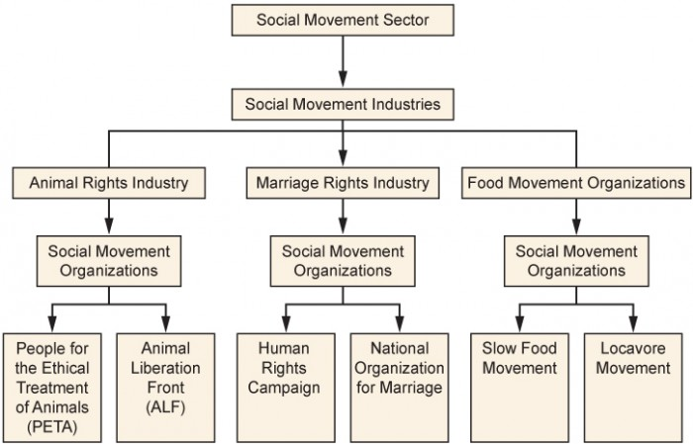

Framing/Frame Analysis
Over the past several decades, sociologists have developed the concept of frames to explain how individuals identify and understand social events and which norms they should follow in any given situation (Goffman 1974; Snow et al. 1986; Benford and Snow 2000). Imagine entering a restaurant. Your “frame” immediately provides you with a behavior template. It probably does not occur to you to wear pajamas to a fine-dining establishment, throw food at other patrons, or spit your drink onto the table. However, eating food at a sleepover pizza party provides you with an entirely different behavior template. It might be perfectly acceptable to eat in your pajamas and maybe even throw popcorn at others or guzzle drinks from cans.
Successful social movements use three kinds of frames (Snow and Benford 1988) to further their goals. The first type, diagnostic framing, states the problem in a clear, easily understood way. When applying diagnostic frames, there are no shades of gray: instead, there is the belief that what “they” do is wrong and this is how “we” will fix it. The anti-gay marriage movement is an example of diagnostic framing with its uncompromising insistence that marriage is only between a man and a woman. Prognostic framing, the second type, offers a solution and states how it will be implemented. Some examples of this frame, when looking at the issue of marriage equality as framed by the anti-gay marriage movement, include the plan to restrict marriage to “one man/one woman” or to allow only “civil unions” instead of marriages. As you can see, there may be many competing prognostic frames even within social movements adhering to similar diagnostic frames. Finally, motivational framing is the call to action: what should you do once you agree with the diagnostic frame and believe in the prognostic frame? These frames are action-oriented. In the gay marriage movement, a call to action might encourage you to vote “no” on Proposition 8 in California (a move to limit marriage to male-female couples), or conversely, to contact your local congressperson to express your viewpoint that marriage should be restricted to male-female couples.
With so many similar diagnostic frames, some groups find it best to join together to maximize their impact. When social movements link their goals to the goals of other social movements and merge into a single group, a frame alignment process (Snow et al. 1986) occurs—an ongoing and intentional means of recruiting participants to the movement.
This frame alignment process has four aspects: bridging, amplification, extension, and transformation. Bridging describes a “bridge” that connects uninvolved individuals and unorganized or ineffective groups with social movements that, though structurally unconnected, nonetheless share similar interests or goals. These organizations join together to create a new, stronger social movement organization. Can you think of examples of different organizations with a similar goal that have banded together?
In the amplification model, organizations seek to expand their core ideas to gain a wider, more universal appeal. By expanding their ideas to include a broader range, they can mobilize more people for their cause. For example, the Slow Food movement extends its arguments in support of local food to encompass reduced energy consumption, pollution, obesity from eating more healthfully, and more.
In extension, social movements agree to mutually promote each other, even when the two social movement organization’s goals don’t necessarily relate to each other’s immediate goals. This often occurs when organizations are sympathetic to each others’ causes, even if they are not directly aligned, such as women’s equal rights and the civil rights movement.

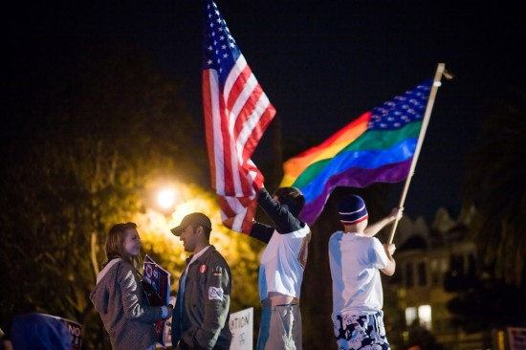
Transformation means a complete revision of goals. Once a movement has succeeded, it risks losing relevance. If it wants to remain active, the movement has to change with the transformation or risk becoming obsolete. For instance, when the women’s suffrage movement gained women the right to vote, members turned their attention to advocating equal rights and campaigning to elect women to office. In short, transformation is an evolution in the existing diagnostic or prognostic frames that generally achieves a total conversion of the movement.

New Social Movement Theory
New social movement theory, a development of European social scientists in the 1950s and 1960s, attempts to explain the proliferation of postindustrial and postmodern movements that are difficult to analyze using traditional social movement theories. Rather than being one specific theory, it is more of a perspective that revolves around understanding movements as they relate to politics, identity, culture, and social change. Some of these more complex interrelated movements include ecofeminism, which focuses on the patriarchal society as the source of environmental problems, and the transgender rights movement. Sociologist Steven Buechler (2000) suggests that we should be looking at the bigger picture in which these movements arise—shifting to a macro-level, global analysis of social movements.

The Movement to Legalize Marijuana
The early history of marijuana in the United States includes its use as an over-the-counter medicine as well as various industrial applications. Its recreational use eventually became a focus of regulatory concern. Public opinion, swayed by a powerful propaganda campaign by the Federal Bureau of Narcotics in the 1930s, remained firmly opposed to the use of marijuana for decades. In the 1936 church-financed propaganda film “Reefer Madness,” marijuana was portrayed as a dangerous drug that caused insanity and violent behavior.
One reason for the recent shift in public attitudes about marijuana, and the social movement pushing for its decriminalization, is a more-informed understanding of its effects that largely contradict its earlier characterization. The public has also become aware that penalties for possession have been significantly disproportionate along racial lines. U.S. Census and FBI data reveal that blacks in the United States are between two to eight times more likely than whites to be arrested for possession of marijuana (Urbina 2013; Matthews 2013). Further, the resulting incarceration costs and prison overcrowding are causing states to look closely at decriminalization and legalization.
In 2012, marijuana was legalized for recreational purposes in Washington and Colorado through ballot initiatives approved by voters. While it remains a Schedule One controlled substance under federal law, the federal government has indicated that it will not intervene in state decisions to ease marijuana laws.

Think It Over
- Think about a social movement industry dealing with a cause that is important to you. How do the different social movement organizations of this industry seek to engage you? Which techniques do you respond to? Why?
- Do you think social media is an important tool in creating social change? Why, or why not? Defend your opinion.
- Describe a social movement in the decline stage. What is its issue? Why has it reached this stage?

Practice

1. If we divide social movements according to their positions among all social movements in a society, we are using the __________ theory to understand social movements.
- framing
- new social movement
- resource mobilization
- value-added

c

2. While PETA is a social movement organization, taken together, the animal rights social movement organizations PETA, ALF, and Greenpeace are a __________.
- social movement industry
- social movement sector
- social movement party
- social industry
a

3. If a movement claims that the best way to reverse climate change is to reduce carbon emissions by outlawing privately owned cars, “outlawing cars” is the ________.
- prognostic framing
- diagnostic framing
- motivational framing
- frame transformation

a

diagnostic framing:
a the social problem that is stated in a clear, easily understood manner
frame alignment process:
using bridging, amplification, extension, and transformation as an ongoing and intentional means of recruiting participants to a movement
motivational framing:
a call to action
new social movement theory:
a theory that attempts to explain the proliferation of postindustrial and postmodern movements that are difficult to understand using traditional social movement theories
prognostic framing:
social movements that state a clear solution and a means of implementation
resource mobilization theory:
a theory that explains social movements’ success in terms of their ability to acquire resources and mobilize individuals
social movement industry:
the collection of the social movement organizations that are striving toward similar goals
social movement organization:
a single social movement group
social movement sector:
the multiple social movement industries in a society, even if they have widely varying constituents and goals

Chapter 27

Preliminary Research Strategies
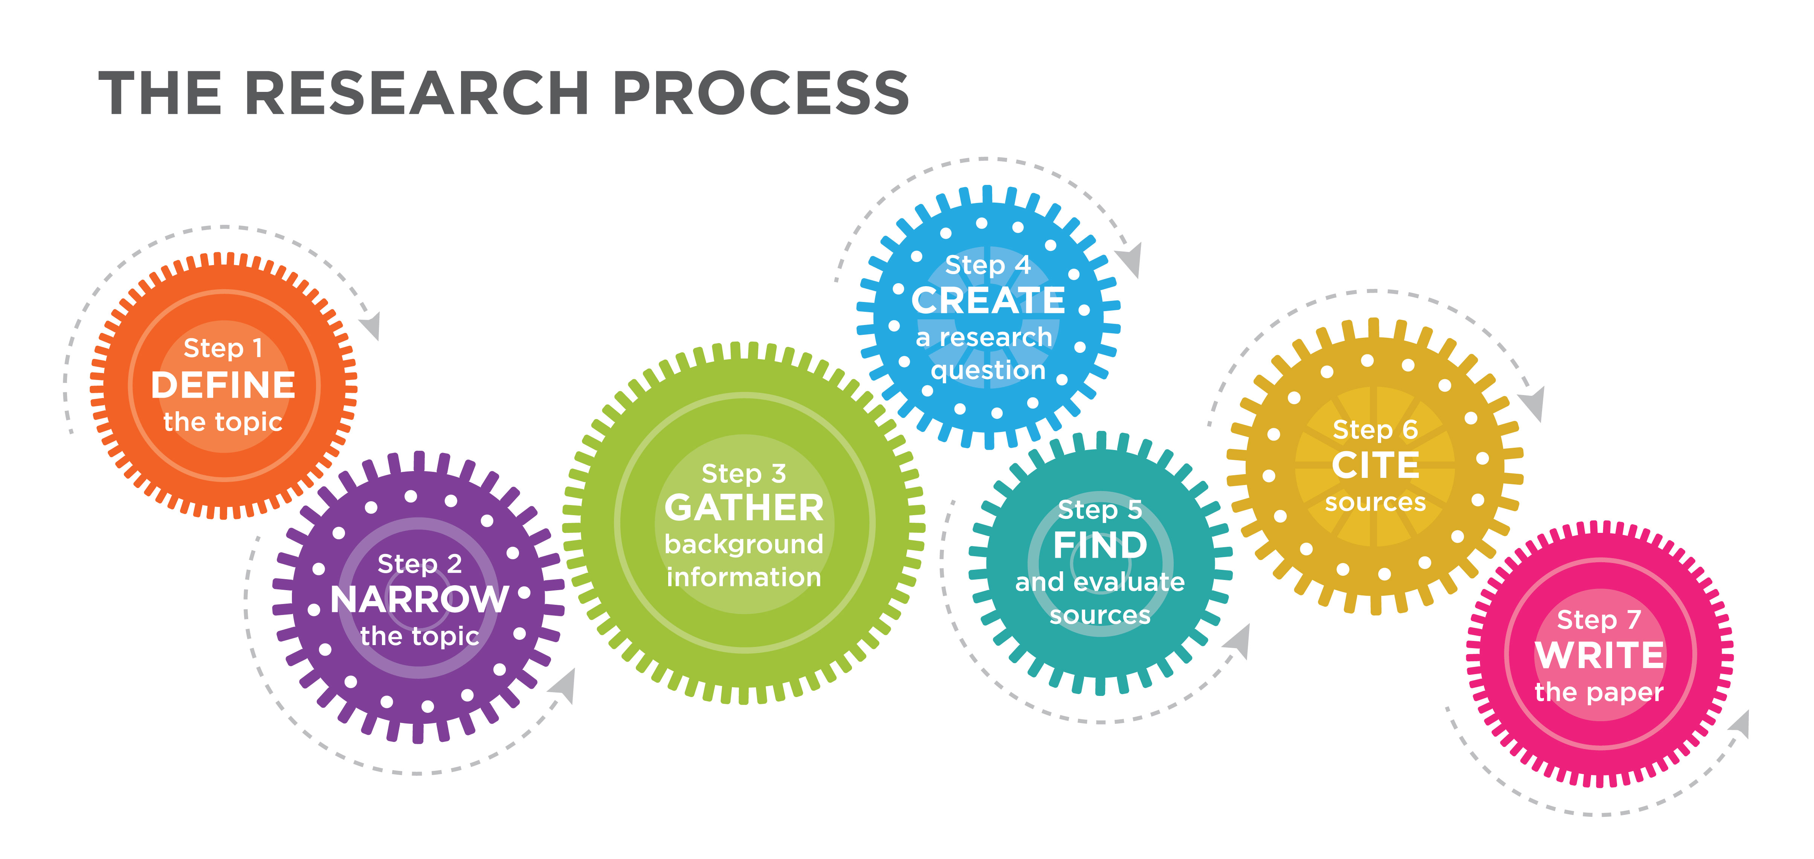
The first step towards writing a research paper is pretty obvious: find sources. Not everything that you find will be good, and those that are good are not always easily found. Having an idea of what you’re looking for–what will most help you develop your essay and enforce your thesis–will help guide your process.

Example of a Research Process
A good research process should go through these steps:
- Decide on the topic.
- Narrow the topic in order to narrow search parameters.
- Create a question that your research will address.
- Generate sub-questions from your main question.
- Determine what kind of sources are best for your argument.
- Create a bibliography as you gather and reference sources.
Each of these is described in greater detail below.


Preliminary Research Strategies
A research plan should begin after you can clearly identify the focus of your argument. First, inform yourself about the basics of your topic (Wikipedia and general online searches are great starting points). Be sure you’ve read all the assigned texts and carefully read the prompt as you gather preliminary information. This stage is sometimes called pre-research.
A broad online search will yield thousands of sources, which no one could be expected to read through. To make it easier on yourself, the next step is to narrow your focus. Think about what kind of position or stance you can take on the topic. What about it strikes you as most interesting? Refer back to the prewriting stage of the writing process, which will come in handy here.

Preliminary Search Tips
- It is okay to start with Wikipedia as a reference, but do not use it as an official source. Look at the links and references at the bottom of the page for more ideas.
- Use “Ctrl+F” to find certain words within a webpage in order to jump to the sections of the article that interest you.
- Use Google Advanced Search to be more specific in your search. You can also use tricks to be more specific within the main Google Search Engine:
  - Use quotation marks to narrow your search from just tanks in WWII to “Tanks in WWII” or “Tanks” in “WWII”.
  - Find specific types of websites by adding “site:.gov” or “site:.edu” or “site:.org”. You can also search for specific file types like “filetype:.pdf”.

- Click on “Search Tools” under the search bar in Google and select “Any time” to see a list of options for time periods to help limit your search. You can find information just in the past month or year, or even for a custom range.

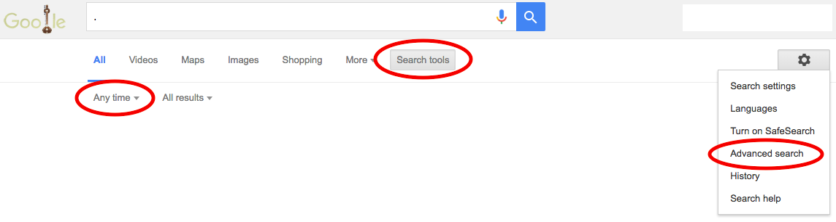

As you narrow your focus, create a list of questions that you’ll need to answer in order to write a good essay on the topic. The research process will help you answer these questions.
Another part of your research plan should include the type of sources you want to gather. Keep track of these sources in a bibliography and jot down notes about the book, article, or document and how it will be useful to your essay. This will save you a lot of time later in the essay process–you’ll thank yourself!

PART X

Module 9

Chapter 28

Reading: Occupy Wall Street



Perhaps the social movement that ran the most contrary to theory in recent history is Occupy Wall Street (OWS). Although it contains many of the classic developmental elements of a social movement we will describe in this chapter, it is set apart by its lack of a single message, its leaderless organization, and its target—financial institutions instead of the government. OWS baffled much of the public, and certainly the mainstream media, leading many to ask, “Who are they, and what do they want?”
On July 13, 2011, the organization Adbusters posted on its blog, “Are you ready for a Tahrir moment? On September 17th, flood into lower Manhattan, set up tents, kitchens, peaceful barricades and occupy Wall Street” (Castells 2012).
The “Tahrir moment” was a reference to the 2010 political uprising that began in Tunisia and spread throughout the Middle East and North Africa, including Egypt’s Tahrir Square in Cairo. Although OWS was a reaction to the continuing financial chaos that resulted from the 2008 market meltdown and not a political movement, the Arab Spring was its catalyst.
Manuel Castells (2012) notes that the years leading up to the Occupy movement had witnessed a dizzying increase in the disparity of wealth in the United States, stemming back to the 1980s. The top 1 percent in the nation had secured 58 percent of the economic growth in the period for themselves, while real hourly wages for the average worker had increased by only 2 percent. The wealth of the top 5 percent had increased by 42 percent. The average pay of a CEO was now 350 times that of the average worker, compared to less than 50 times in 1983 (AFL-CIO 2014). The country’s leading financial institutions, to many clearly to blame for the crisis and dubbed “too big to fail,” were in trouble after many poorly qualified borrowers defaulted on their mortgage loans when the loans’ interest rates rose. The banks were eventually “bailed” out by the government with $700 billion of taxpayer money. According to many reports, that same year top executives and traders received large bonuses.
On September 17, 2011, an anniversary of the signing of the U.S. Constitution, the occupation began. One thousand outraged protestors descended upon Wall Street, and up to 20,000 people moved into Zuccotti Park, only two blocks away, where they began building a village of tents and organizing a system of communication. The protest soon began spreading throughout the nation, and its members started calling themselves “the 99 percent.” More than a thousand cities and towns had Occupy demonstrations.
In answer to the question “Who are they?” Castells notes “. . . by and large the movement was made up of a large majority of democratic voters, as well as of politically independent minded people who were in search of new forms of changing the world . . . ” (Castells 2012). What do they want? Castells has dubbed OWS “A non-demand movement: The process is the message.” Using Facebook, Twitter, Tumblr, and live-stream video, the protesters conveyed a multifold message with a long list of reforms and social change, including the need to address the rising disparity of wealth, the influence of money on election outcomes, the notion of “corporate personhood,” a corporatized political system (to be replaced by “direct democracy”), political favoring of the rich, and rising student debt. Regardless, some in the media appeared confused about the protestors’ intentions, and articles carried titles like, “The Wall Street Protesters: What the Hell Do They Want?” (Gell 2011) from The New York Observer, and person-in-the-street quotations like, “I think they’re idiots. They have no agenda . . . ” from the Los Angeles Times (Le Tellier 2012).
The late James C. Davies suggested in his 1962 paper, “Toward a Theory of Revolution” (from the American Sociological Review, Vol, 27 Issue 1) that revolution depends upon the mood of the people, and that it is extremely unlikely those in absolute poverty will be able to overturn a government, simply because the government has infinitely more power. Instead, a revolution is more possible when expected need satisfaction and actual need satisfaction are out of sync. As actual need satisfaction trends downward and away from what a formerly prosperous people have come to expect—tracing a curve that looks somewhat like an upside-down J and is called the Davies-J curve—the gap between expectations and reality widens. Eventually an intolerable point is reached, and revolution occurs. Thus, change comes not from the very bottom of the social hierarchy, but from somewhere in the middle. Indeed, the Arab Spring was driven by mostly young people whose education had offered promise and expectations that were thwarted by corrupt autocratic governments. OWS too came not from the bottom but from people in the middle, who exploited the power of social media to enhance communication.

Chapter 29

Reading: Social Change and Modernization
Collective behavior and social movements are just two of the forces driving
, which is the change in society created through social movements as well as external factors like environmental shifts or technological innovations. Essentially, any disruptive shift in the status quo, be it intentional or random, human-caused or natural, can lead to social change. Below are some of the likely causes.

Causes of Social Change
Changes to technology, social institutions, population, and the environment, alone or in some combination, create change. Below, we will discuss how these act as agents of social change, and we’ll examine real-world examples. We will focus on four agents of change that social scientists recognize: technology, social institutions, population, and the environment.

Technology
Some would say that improving technology has made our lives easier. Imagine what your day would be like without the Internet, the automobile, or electricity. In The World Is Flat, Thomas Friedman (2005) argues that technology is a driving force behind globalization, while the other forces of social change (social institutions, population, environment) play comparatively minor roles. He suggests that we can view globalization as occurring in three distinct periods. First, globalization was driven by military expansion, powered by horsepower and wind power. The countries best able to take advantage of these power sources expanded the most, and exert control over the politics of the globe from the late fifteenth century to around the year 1800. The second shorter period from approximately 1800 C.E. to 2000 C.E. consisted of a globalizing economy. Steam and rail power were the guiding forces of social change and globalization in this period. Finally, Friedman brings us to the post-millennial era. In this period of globalization, change is driven by technology, particularly the Internet (Friedman 2005).
But also consider that technology can create change in the other three forces social scientists link to social change. Advances in medical technology allow otherwise infertile women to bear children, which indirectly leads to an increase in population. Advances in agricultural technology have allowed us to genetically alter and patent food products, which changes our environment in innumerable ways. From the way we educate children in the classroom to the way we grow the food we eat, technology has impacted all aspects of modern life.
Of course there are drawbacks. The increasing gap between the technological haves and have-nots––sometimes called the digital divide––occurs both locally and globally. Further, there are added security risks: the loss of privacy, the risk of total system failure (like the Y2K panic at the turn of the millennium), and the added vulnerability created by technological dependence. Think about the technology that goes into keeping nuclear power plants running safely and securely. What happens if an earthquake or other disaster, like in the case of Japan’s Fukushima plant, causes the technology to malfunction, not to mention the possibility of a systematic attack to our nation’s relatively vulnerable technological infrastructure?

Crowdsourcing: Using the Web to Get Things Done
Millions of people today walk around with their heads tilted toward a small device held in their hands. Perhaps you are reading this textbook on a phone or tablet. People in developed societies now take communication technology for granted. How has this technology affected social change in our society and others? One very positive way is crowdsourcing.
Thanks to the web, digital crowdsourcing is the process of obtaining needed services, ideas, or content by soliciting contributions from a large group of people, and especially from an online community rather than from traditional employees or suppliers. Web-based companies such as Kickstarter have been created precisely for the purposes of raising large amounts of money in a short period of time, notably by sidestepping the traditional financing process. This book, or virtual book, is the product of a kind of crowdsourcing effort. It has been written and reviewed by several authors in a variety of fields to give you free access to a large amount of data produced at a low cost. The largest example of crowdsourced data is Wikipedia, the online encyclopedia which is the result of thousands of volunteers adding and correcting material.
Perhaps the most striking use of crowdsourcing is disaster relief. By tracking tweets and e-mails and organizing the data in order of urgency and quantity, relief agencies can address the most urgent calls for help, such as for medical aid, food, shelter, or rescue. On January 12, 2010 a devastating earthquake hit the nation of Haiti. By January 25, a crisis map had been created from more than 2,500 incident reports, and more reports were added every day. The same technology was used to assist victims of the Japanese earthquake and tsunami in 2011.

The Darker Side of Technology: Electronic Aggression in the Information Age
The U.S. Center for Disease Control (CDC) uses the term “electronic aggression” to describe “any type of harassment or bullying that occurs through e-mail, a chat room, instant messaging, a website (including blogs), or text messaging” (CDC, n.d.) We generally think of this as cyberbullying. A 2011 study by the U.S. Department of Education found that 27.8 percent of students aged twelve through eighteen reported experiencing bullying. From the same sample 9 percent specifically reported having been a victim of cyberbullying (Robers et al. 2013).
Cyberbullying represents a powerful change in modern society. William F. Ogburn (1922) might have been describing it nearly a century ago when he defined “cultural lag,” which occurs when material culture precedes nonmaterial culture. That is, society may not fully comprehend all the consequences of a new technology and so may initially reject it (such as stem cell research) or embrace it, sometimes with unintended negative consequences (such as pollution).
Cyberbullying is a special feature of the Internet. Unique to electronic aggression is that it can happen twenty-four hours a day, every day; it can reach a child (or an adult) even though she or he might otherwise feel safe in a locked house. The messages and images may be posted anonymously and to a very wide audience, and they might even be impossible to trace. Finally, once posted, the texts and images are very hard to delete. Its effects range from the use of alcohol and drugs to lower self-esteem, health problems, and even suicide (CDC, n.d.).

The Story of Megan Meier
According to the Megan Meier Foundation web site (2014a), Megan Meier had a lifelong struggle with weight, attention deficit disorder, and depression. But then a sixteen-year-old boy named Josh Evans asked Megan, who was thirteen years old, to be friends on the social networking web site MySpace. The two began communicating online regularly, though they never met in person or spoke on the phone. Now Megan finally knew a boy who, she believed, really thought she was pretty.
But things changed, according to the Megan Meier Foundation web site (2014b). Josh began saying he didn’t want to be friends anymore, and the messages became cruel on October 16, 2006, when Josh concluded by telling Megan, “The world would be a better place without you.” The cyberbullying escalated when additional classmates and friends on MySpace began writing disturbing messages and bulletins. That night Megan hanged herself in her bedroom closet, three weeks before what would have been her fourteenth birthday.
According to an ABC News article titled, “Parents: Cyber Bullying Led to Teen’s Death” (2007), it was only later that a neighbor informed Megan’s parents that Josh was not a real person. Instead, “Josh’s” account was created by the mother of a girl who used to be friends with Megan.
You can find out more of Megan’s story at her mother’s web site: http://www.meganmeierfoundation.org/

Social Institutions
Each change in a single social institution leads to changes in all social institutions. For example, the industrialization of society meant that there was no longer a need for large families to produce enough manual labor to run a farm. Further, new job opportunities were in close proximity to urban centers where living space was at a premium. The result is that the average family size shrunk significantly.
This same shift toward industrial corporate entities also changed the way we view government involvement in the private sector, created the global economy, provided new political platforms, and even spurred new religions and new forms of religious worship like Scientology. It has also informed the way we educate our children: originally schools were set up to accommodate an agricultural calendar so children could be home to work the fields in the summer, and even today, teaching models are largely based on preparing students for industrial jobs, despite that being an outdated need. A shift in one area, such as industrialization, means an interconnected impact across social institutions.

Population
Population composition is changing at every level of society. Births increase in one nation and decrease in another. Some families delay childbirth while others start bringing children into their folds early. Population changes can be due to random external forces, like an epidemic, or shifts in other social institutions, as described above. But regardless of why and how it happens, population trends have a tremendous interrelated impact on all other aspects of society.
In the United States, we are experiencing an increase in our senior population as baby boomers begin to retire, which will in turn change the way many of our social institutions are organized. For example, there is an increased demand for housing in warmer climates, a massive shift in the need for elder care and assisted living facilities, and growing awareness of elder abuse. There is concern about labor shortages as boomers retire, not to mention the knowledge gap as the most senior and accomplished leaders in different sectors start to leave. Further, as this large generation leaves the workforce, the loss of tax income and pressure on pension and retirement plans means that the financial stability of the country is threatened.
Globally, often the countries with the highest fertility rates are least able to absorb and attend to the needs of a growing population. Family planning is a large step in ensuring that families are not burdened with more children than they can care for. On a macro level, the increased population, particularly in the poorest parts of the globe, also leads to increased stress on the planet’s resources.

The Environment
Turning to human ecology, we know that individuals and the environment affect each other. As human populations move into more vulnerable areas, we see an increase in the number of people affected by natural disasters, and we see that human interaction with the environment increases the impact of those disasters. Part of this is simply the numbers: the more people there are on the planet, the more likely it is that some will be affected by a natural disaster.
But it goes beyond that. Movements like 350.org describe how we have already seen five extinctions of massive amounts of life on the planet, and the crisis of global change has put us on the verge of yet another. According to their website, “The number 350 means climate safety: to preserve a livable planet, scientists tell us we must reduce the amount of CO2 in the atmosphere from its current level of 400 parts per million to below 350 ppm” (350.org).
The environment is best described as an ecosystem, one that exists as the interplay of multiple parts including 8.7 million species of life. However dozens of species are going extinct every day, a number 1,000 times to 10,000 times the normal “background rate” and the highest rate since the dinosaurs disappeared 65 million years ago. The Center for Biological Diversity states that this extinction crisis, unlike previous ones caused by natural disasters, is “caused almost entirely by us” (Center for Biological Diversity, n.d.). The growth of the human population, currently over seven billion and expected to rise to nine or ten billion by 2050, perfectly correlates with the rising extinction rate of life on earth.

Hurricane Katrina: When It All Comes Together
The four key elements that affect social change that are described in this chapter are the environment, technology, social institutions, and population. In 2005, New Orleans was struck by a devastating hurricane. But it was not just the hurricane that was disastrous. It was the converging of all four of these elements, and the text below will connect the elements by putting the words in parentheses.
Before Hurricane Katrina (environment) hit, poorly coordinated evacuation efforts had left about 25 percent of the population, almost entirely African Americans who lacked private transportation, to suffer the consequences of the coming storm (demographics). Then “after the storm, when the levees broke, thousands more [refugees] came. And the city buses, meant to take them to proper shelters, were underwater” (Sullivan 2005). No public transportation was provided, drinking water and communications were delayed, and FEMA, the Federal Emergency Management Agency (institutions), was headed by an appointee with no real experience in emergency management. Those who were eventually evacuated did not know where they were being sent or how to contact family members. African Americans were sent the farthest from their homes. When the displaced began to return, public housing had not been reestablished, yet the Superdome stadium, which had served as a temporary disaster shelter, had been rebuilt. Homeowners received financial support, but renters did not.
As it turns out, it was not entirely the hurricane that cost the lives of 1,500 people, but the fact that the city’s storm levees (technology), which had been built too low and which failed to meet numerous other safety specifications, gave way, flooding the lower portions of the city, occupied almost entirely by African Americans.
Journalist Naomi Klein, in her book The Shock Doctrine: The Rise of Disaster Capitalism, presents a theory of a “triple shock,” consisting of an initial disaster, an economic shock that replaces public services with private (for-profit) ones, and a third shock consisting of the intense policing of the remaining public. Klein supports her claim by quoting then-Congressman Richard Baker as saying, “We finally cleaned up public housing in New Orleans. We couldn’t do it, but God did.” She quotes developer Joseph Canizaro as stating, “I think we have a clean sheet to start again. And with that clean sheet we have some very big opportunities.”
One clean sheet was that New Orleans began to replace public schools with charters, breaking the teachers’ union and firing all public school teachers (Mullins 2014). Public housing was seriously reduced and the poor were forced out altogether or into the suburbs far from medical and other facilities (The Advocate 2013). Finally, by relocating African Americans and changing the ratio of African Americans to whites, New Orleans changed its entire demographic makeup.

Modernization
Modernization describes the processes that increase the amount of specialization and differentiation of structure in societies resulting in the move from an undeveloped society to developed, technologically driven society (Irwin 1975). By this definition, the level of modernity within a society is judged by the sophistication of its technology, particularly as it relates to infrastructure, industry, and the like. However, it is important to note the inherent ethnocentric bias of such assessment. Why do we assume that those living in semi-peripheral and peripheral nations would find it so wonderful to become more like the core nations? Is modernization always positive?
One contradiction of all kinds of technology is that they often promise time-saving benefits, but somehow fail to deliver. How many times have you ground your teeth in frustration at an Internet site that refused to load or at a dropped call on your cell phone? Despite time-saving devices such as dishwashers, washing machines, and, now, remote control vacuum cleaners, the average amount of time spent on housework is the same today as it was fifty years ago. And the dubious benefits of 24/7 e-mail and immediate information have simply increased the amount of time employees are expected to be responsive and available. While once businesses had to travel at the speed of the U.S. postal system, sending something off and waiting until it was received before the next stage, today the immediacy of information transfer means there are no such breaks.
Further, the Internet bought us information, but at a cost. The morass of information means that there is as much poor information available as trustworthy sources. There is a delicate line to walk when core nations seek to bring the assumed benefits of modernization to more traditional cultures. For one, there are obvious procapitalist biases that go into such attempts, and it is short-sighted for western governments and social scientists to assume all other countries aspire to follow in their footsteps. Additionally, there can be a kind of neo-liberal defense of rural cultures, ignoring the often crushing poverty and diseases that exist in peripheral nations and focusing only on a nostalgic mythology of the happy peasant. It takes a very careful hand to understand both the need for cultural identity and preservation as well as the hopes for future growth.

Think It Over

- Consider one of the major social movements of the twentieth century, from civil rights in the United States to Gandhi’s nonviolent protests in India. How would technology have changed it? Would change have come more quickly or more slowly? Defend your opinion.
- Discuss the digital divide in the context of modernization. Is there a real concern that poorer communities are lacking in technology? Why, or why not?
- Which theory do you think better explains the global economy: dependency theory (global inequity is due to the exploitation of peripheral and semi-peripheral nations by core nations) or modernization theory? Remember to justify your answer and provide specific examples.
- Do you think that modernization is good or bad? Explain, using examples.

Practice

1. Children in peripheral nations have little to no daily access to computers and the Internet, while children in core nations are constantly exposed to this technology. This is an example of:
- the digital divide
- human ecology
- modernization theory
- dependency theory

a

2. When sociologists think about technology as an agent of social change, which of the following is not an example?
- Population growth
- Medical advances
- The Internet
- Genetically engineered food
a

3. China is undergoing a shift in industry, increasing labor specialization and the amount of differentiation present in the social structure. This exemplifies:
- human ecology
- dependency theory
- modernization
- conflict perspective

c

4. Core nations that work to propel peripheral nations toward modernization need to be aware of:
- preserving peripheral nation cultural identity
- preparing for pitfalls that come with modernization
- avoiding hegemonistic assumptions about modernization
- all of the above

d

5. In addition to social movements, social change is also caused by technology, social institutions, population and ______.
- the environment
- modernization
- social structure
- new social movements

a

crowdsourcing:
the process of obtaining needed services, ideas, or content by soliciting contributions from a large group of people
modernization:
the process that increases the amount of specialization and differentiation of structure in societies
social change:
the change in a society created through social movements as well as through external factors like environmental shifts or technological innovations

Self-Check: Collective Behavior and Social Movements
You’ll have more success on the Self-Check, if you’ve completed the six Readings in this section.
An interactive or media element has been excluded from this version of the text. You can view it online here: https://library.achievingthedream.org/bcccomposition/?p=57

Chapter 30

Advanced Search Strategies
As we learned earlier, the strongest articles to support your academic writing projects will come from scholarly sources. Finding exactly what you need becomes specialized at this point, and requires a new set of searching strategies beyond even Google Scholar.
For this kind of research, you’ll want to utilize library databases, as this video explains.

A YouTube element has been excluded from this version of the text. You can view it online here: https://library.achievingthedream.org/bcccomposition/?p=58
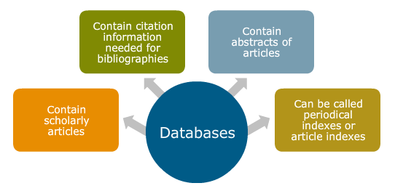
Many journals are sponsored by academic associations. Most of your professors belong to some big, general one (such as the Modern Language Association, the American Psychological Association, or the American Physical Society) and one or more smaller ones organized around particular areas of interest and expertise (such as the Association for the Study of Food and Society and the International Association for Statistical Computing).

Finding articles in databases
Your campus library invests a lot of time and care into making sure you have access to the sources you need for your writing projects. Many libraries have online research guides that point you to the best databases for the specific discipline and, perhaps, the specific course. Librarians are eager to help you succeed with your research—it’s their job and they love it!—so don’t be shy about asking.
The following video demonstrates how to search within a library database. While the examples are specific to Northern Virginia Community College, the same general search tips apply to nearly all academic databases. On your school’s library homepage, you should be able to find a general search button and an alphabetized list of databases. Get familiar with your own school’s library homepage to identify the general search features, find databases, and practice searching for specific articles.
A YouTube element has been excluded from this version of the text. You can view it online here: https://library.achievingthedream.org/bcccomposition/?p=58

Chapter 31

Essay 3 Prompt
For essay 3 complete the following tasks.

Task 1:
Read the following on Compare/Contrast essays:

http://owl.excelsior.edu/rhetorical-styles/compare-and-contrast-essay/

Task 2:
Go back over the readings about social movements and think about two that interest you the most. Find at least 3 outside sources that also discuss these movements.

Task 3:
Write an essay in which you compare and contrast the two movements in terms of goals, strategies, and outcomes.

Requirements:
1000-1500 Words
Written in Word document and uploaded on Blackboard
10-12 Point TNR Font
Two outside sources cited using MLA style

Due:

PART XI

Module 10

Chapter 32

Primary, Secondary, and Tertiary Sources
When searching for information on a topic, it is important to understand the value of primary, secondary, and tertiary sources.
Primary sources allow researchers to get as close as possible to original ideas, events, and empirical research as possible. Such sources may include creative works, first hand or contemporary accounts of events, and the publication of the results of empirical observations or research.
Secondary sources analyze, review, or summarize information in primary resources or other secondary resources. Even sources presenting facts or descriptions about events are secondary unless they are based on direct participation or observation. Moreover, secondary sources often rely on other secondary sources and standard disciplinary methods to reach results, and they provide the principle sources of analysis about primary sources.
Tertiary sources provide overviews of topics by synthesizing information gathered from other resources. Tertiary resources often provide data in a convenient form or provide information with context by which to interpret it.
The distinctions between primary, secondary, and tertiary sources can be ambiguous. An individual document may be a primary source in one context and a secondary source in another. Encyclopedias are typically considered tertiary sources, but a study of how encyclopedias have changed on the Internet would use them as primary sources. Time is a defining element.
While these definitions are clear, the lines begin to blur in the different discipline areas.

In the Humanities Social Sciences
In the humanities and social sciences, primary sources are the direct evidence or first-hand accounts of events without secondary analysis or interpretation. A primary source is a work that was created or written contemporary with the period or subject being studied. Secondary sources analyze or interpret historical events or creative works.
Primary sources
- Diaries
- Interviews
- Letters
- Original works of art
- Photographs
- Speeches
- Works of literature
A primary source is an original document containing firsthand information about a topic. Different fields of study may use different types of primary sources.
Secondary sources
- Biographies
- Dissertations
- Indexes, abstracts, bibliographies (used to locate a secondary source)
- Journal articles
- Monographs
A secondary source contains commentary on or discussion about a primary source. The most important feature of secondary sources is that they offer an interpretation of information gathered from primary sources.
Tertiary sources
- Dictionaries
- Encyclopedias
- Handbooks
A tertiary source presents summaries or condensed versions of materials, usually with references back to the primary and/or secondary sources. They can be a good place to look up facts or get a general overview of a subject, but they rarely contain original material.
Examples

In the Sciences
In the sciences, primary sources are documents that provide full description of the original research. For example, a primary source would be a journal article where scientists describe their research on the genetics of tobacco plants. A secondary source would be an article commenting or analyzing the scientists’ research on tobacco.
Primary sources
- Conference proceedings
- Interviews
- Journals
- Lab notebooks
- Patents
- Preprints
- Technical reports
- Theses and dissertations
These are where the results of original research are usually first published in the sciences. This makes them the best source of information on cutting edge topics. However the new ideas presented may not be fully refined or validated yet.
Secondary sources
- Monographs
- Reviews
- Textbooks
- Treatises
These tend to summarize the existing state of knowledge in a field at the time of publication. Secondary sources are good to find comparisons of different ideas and theories and to see how they may have changed over time.
Tertiary sources
- Compilations
- Dictionaries
- Encyclopedias
- Handbooks
- Tables
These types of sources present condensed material, generally with references back to the primary and/or secondary literature. They can be a good place to look up data or to get an overview of a subject, but they rarely contain original material.
Examples

Chapter 33

Farmers Revolt in the Populist Era

Learning Objectives
By the end of this section, you will be able to:
- Understand how the economic and political climate of the day promoted the formation of the farmers’ protest movement in the latter half of the nineteenth century
- Explain how the farmers’ revolt moved from protest to politics
The challenges that many American farmers faced in the last quarter of the nineteenth century were significant. They contended with economic hardships born out of rapidly declining farm prices, prohibitively high tariffs on items they needed to purchase, and foreign competition. One of the largest challenges they faced was overproduction, where the glut of their products in the marketplace drove the price lower and lower.
Overproduction of crops occurred in part due to the westward expansion of homestead farms and in part because industrialization led to new farm tools that dramatically increased crop yields. As farmers fell deeper into debt, whether it be to the local stores where they bought supplies or to the railroads that shipped their produce, their response was to increase crop production each year in the hope of earning more money with which to pay back their debt. The more they produced, the lower prices dropped. To a hard-working farmer, the notion that their own overproduction was the greatest contributing factor to their debt was a completely foreign concept.

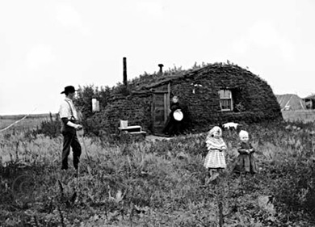
In addition to the cycle of overproduction, tariffs were a serious problem for farmers. Rising tariffs on industrial products made purchased items more expensive, yet tariffs were not being used to keep farm prices artificially high as well. Therefore, farmers were paying inflated prices but not receiving them. Finally, the issue of gold versus silver as the basis of U.S. currency was a very real problem to many farmers. Farmers needed more money in circulation, whether it was paper or silver, in order to create inflationary pressure. Inflationary pressure would allow farm prices to increase, thus allowing them to earn more money that they could then spend on the higher-priced goods in stores. However, in 1878, federal law set the amount of paper money in circulation, and, as mentioned above, Harrison’s Sherman Silver Act, intended to increase the amount of silver coinage, was too modest to do any real good, especially in light of the unintended consequence of depleting the nation’s gold reserve. In short, farmers had a big stack of bills and wanted a big stack of money—be it paper or silver—to pay them. Neither was forthcoming from a government that cared more about issues of patronage and how to stay in the White House for more than four years at a time.

FARMERS BEGIN TO ORGANIZE
The initial response by increasingly frustrated and angry farmers was to organize into groups that were similar to early labor unions. Taking note of how the industrial labor movement had unfolded in the last quarter of the century, farmers began to understand that a collective voice could create significant pressure among political leaders and produce substantive change. While farmers had their own challenges, including that of geography and diverse needs among different types of famers, they believed this model to be useful to their cause.
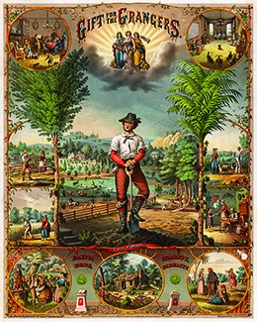
One of the first efforts to organize farmers came in 1867 with Oliver Hudson Kelly’s creation of the Patrons of Husbandry, more popularly known as the Grange. In the wake of the Civil War, the Grangers quickly grew to over 1.5 million members in less than a decade. Kelly believed that farmers could best help themselves by creating farmers’ cooperatives in which they could pool resources and obtain better shipping rates, as well as prices on seeds, fertilizer, machinery, and other necessary inputs. These cooperatives, he believed, would let them self-regulate production as well as collectively obtain better rates from railroad companies and other businesses.
At the state level, specifically in Wisconsin, Minnesota, Illinois, and Iowa, the Patrons of Husbandry did briefly succeed in urging the passage of Granger Laws, which regulated some railroad rates along with the prices charged by grain elevator operators. The movement also created a political party—the Greenback Party, so named for its support of print currency (or “greenbacks”) not based upon a gold standard—which saw brief success with the election of fifteen congressmen. However, such successes were short-lived and had little impact on the lives of everyday farmers. In the Wabash case of 1886, brought by the Wabash, St. Louis, and Pacific Railroad Company, the U.S. Supreme Court ruled against the State of Illinois for passing Granger Laws controlling railroad rates; the court found such laws to be unconstitutional. Their argument held that states did not have the authority to control interstate commerce. As for the Greenback Party, when only seven delegates appeared at an 1888 national convention of the group, the party faded from existence.
Explore
to study photographs, firsthand reports, and other information about how farmers lived and struggled at the end of the nineteenth century.
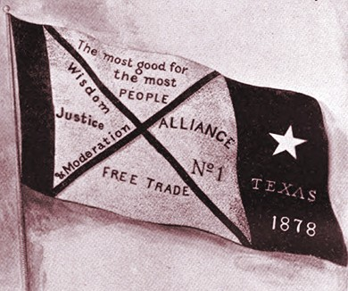
The Farmers’ Alliance, a conglomeration of three regional alliances formed in the mid-1880s, took root in the wake of the Grange movement. In 1890, Dr. Charles Macune, who led the Southern Alliance, which was based in Texas and had over 100,000 members by 1886, urged the creation of a national alliance between his organization, the Northwest Alliance, and the Colored Alliance, the largest African American organization in the United States. Led by Tom Watson, the Colored Alliance, which was founded in Texas but quickly spread throughout the Old South, counted over one million members. Although they originally advocated for self-help, African Americans in the group soon understood the benefits of political organization and a unified voice to improve their plight, regardless of race. While racism kept the alliance splintered among the three component branches, they still managed to craft a national agenda that appealed to their large membership. All told, the Farmers’ Alliance brought together over 2.5 million members, 1.5 million white and 1 million black.
The alliance movement, and the subsequent political party that emerged from it, also featured prominent roles for women. Nearly 250,000 women joined the movement due to their shared interest in the farmers’ worsening situation as well as the promise of being a full partner with political rights within the group, which they saw as an important step towards advocacy for women’s suffrage on a national level. The ability to vote and stand for office within the organization encouraged many women who sought similar rights on the larger American political scene. Prominent alliance spokeswoman, Mary Elizabeth Lease of Kansas, often spoke of membership in the Farmers’ Alliance as an opportunity to “raise less corn and more hell!”
The
discusses the role of women in rural America and how it changed throughout the end of the nineteenth century.
The alliance movement had several goals similar to those of the original Grange, including greater regulation of railroad prices and the creation of an inflationary national monetary policy. However, most creative among the solutions promoted by the Farmers’ Alliance was the call for a subtreasury plan. Under this plan, the federal government would store farmers’ crops in government warehouses for a brief period of time, during which the government would provide loans to farmers worth 80 percent of the current crop prices. Thus, farmers would have immediate cash on hand with which to settle debts and purchase goods, while their crops sat in warehouses and farm prices increased due to this control over supply at the market. When market prices rose sufficiently high enough, the farmer could withdraw his crops, sell at the higher price, repay the government loan, and still have profit remaining.
Economists of the day thought the plan had some merit; in fact, a greatly altered version would subsequently be adopted during the Great Depression of the 1930s, in the form of the Agricultural Adjustment Act. However, the federal government never seriously considered the plan, as congressmen questioned the propriety of the government serving as a rural creditor making loans to farmers with no assurance that production controls would result in higher commodity prices. The government’s refusal to act on the proposal left many farmers wondering what it would take to find solutions to their growing indebtedness.

FROM ORGANIZATION TO POLITICAL PARTY
Angry at the federal government’s continued unwillingness to substantively address the plight of the average farmer, Charles Macune and the Farmers’ Alliance chose to create a political party whose representatives—if elected—could enact real change. Put simply, if the government would not address the problem, then it was time to change those elected to power.
In 1891, the alliance formed the Populist Party, or People’s Party, as it was more widely known. Beginning with nonpresidential-year elections, the Populist Party had modest success, particularly in Kansas, Nebraska, and the Dakotas, where they succeeded in electing several state legislators, one governor, and a handful of congressmen. As the 1892 presidential election approached, the Populists chose to model themselves after the Democratic and Republican Parties in the hope that they could shock the country with a “third-party” victory.
At their national convention that summer in Omaha, Nebraska, they wrote the Omaha Platform to more fully explain to all Americans the goals of the new party. Written by Ignatius Donnelly, the platform statement vilified railroad owners, bankers, and big businessmen as all being part of a widespread conspiracy to control farmers. As for policy changes, the platform called for adoption of the subtreasury plan, government control over railroads, an end to the national bank system, the creation of a federal income tax, the direct election of U.S. senators, and several other measures, all of which aimed at a more proactive federal government that would support the economic and social welfare of all Americans. At the close of the convention, the party nominated James B. Weaver as its presidential candidate.

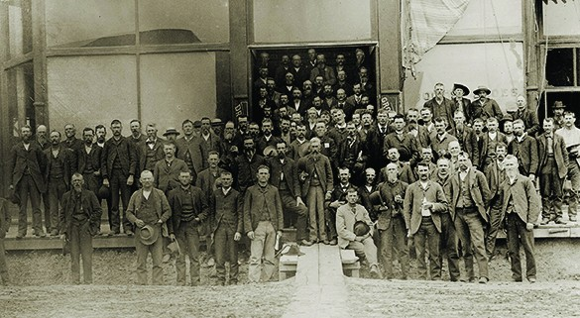
In a rematch of the 1888 election, the Democrats again nominated Grover Cleveland, while Republicans went with Benjamin Harrison. Despite the presence of a third-party challenger, Cleveland won another close popular vote to become the first U.S. president to be elected to nonconsecutive terms. Although he finished a distant third, Populist candidate Weaver polled a respectable one million votes. Rather than being disappointed, several Populists applauded their showing—especially for a third party with barely two years of national political experience under its belt. They anxiously awaited the 1896 election, believing that if the rest of the country, in particular industrial workers, experienced hardships similar to those that farmers already faced, a powerful alliance among the two groups could carry the Populists to victory.

Section Summary
Factors such as overproduction and high tariffs left the country’s farmers in increasingly desperate straits, and the federal government’s inability to address their concerns left them disillusioned and worried. Uneven responses from state governments had many farmers seeking an alternative solution to their problems. Taking note of the labor movements growing in industrial cities around the country, farmers began to organize into alliances similar to workers’ unions; these were models of cooperation where larger numbers could offer more bargaining power with major players such as railroads. Ultimately, the alliances were unable to initiate widespread change for their benefit. Still, drawing from the cohesion of purpose, farmers sought to create change from the inside: through politics. They hoped the creation of the Populist Party in 1891 would lead to a president who put the people—and in particular the farmers—first.
A Open Assessments element has been excluded from this version of the text. You can view it online here: https://library.achievingthedream.org/bcccomposition/?p=62

Review Question
- What were women’s roles within the Farmer’s Alliance?

Answer to Review Question
- Women were able to play key roles in the alliance movement. The alliance provided them with political rights, including the ability to vote and hold office within the organization, which many women hoped would be a positive step in their struggle for national women’s rights and suffrage. In the end, nearly 250,000 women joined the movement.

Glossary
Farmers’ Alliance a national conglomeration of different regional farmers’ alliances that joined together in 1890 with the goal of furthering farmers’ concerns in politics
Grange a farmers’ organization, launched in 1867, which grew to over 1.5 million members in less than a decade
Populist Party a political party formed in 1890 that sought to represent the rights of primarily farmers but eventually all workers in regional and federal elections
subtreasury plan a plan that called for storing crops in government warehouses for a brief period of time, during which the federal government would provide loans to farmers worth 80 percent of the current crop prices, releasing the crops for sale when prices rose

Chapter 34

The African American Struggle for Civil Rights

Learning Objectives
By the end of this section, you will be able to:
- Explain how Presidents Truman and Eisenhower addressed civil rights issues
- Discuss efforts by African Americans to end discrimination and segregation
- Describe southern whites’ response to the civil rights movement
In the aftermath of World War II, African Americans began to mount organized resistance to racially discriminatory policies in force throughout much of the United States. In the South, they used a combination of legal challenges and grassroots activism to begin dismantling the racial segregation that had stood for nearly a century following the end of Reconstruction. Community activists and civil rights leaders targeted racially discriminatory housing practices, segregated transportation, and legal requirements that African Americans and whites be educated separately. While many of these challenges were successful, life did not necessarily improve for African Americans. Hostile whites fought these changes in any way they could, including by resorting to violence.

EARLY VICTORIES
During World War II, many African Americans had supported the “Double-V Campaign,” which called on them to defeat foreign enemies while simultaneously fighting against segregation and discrimination at home. After World War II ended, many returned home to discover that, despite their sacrifices, the United States was not willing to extend them any greater rights than they had enjoyed before the war. Particularly rankling was the fact that although African American veterans were legally entitled to draw benefits under the GI Bill, discriminatory practices prevented them from doing so. For example, many banks would not give them mortgages if they wished to buy homes in predominantly African American neighborhoods, which banks often considered too risky an investment. However, African Americans who attempted to purchase homes in white neighborhoods often found themselves unable to do so because of real estate covenants that prevented owners from selling their property to blacks. Indeed, when a black family purchased a Levittown house in 1957, they were subjected to harassment and threats of violence.
For a look at the
that tried to move to a white suburban community, view the 1957 documentary
.
The postwar era, however, saw African Americans make greater use of the courts to defend their rights. In 1944, an African American woman, Irene Morgan, was arrested in Virginia for refusing to give up her seat on an interstate bus and sued to have her conviction overturned. In Morgan v. the Commonwealth of Virginia in 1946, the U.S. Supreme Court ruled that the conviction should be overturned because it violated the interstate commerce clause of the Constitution. This victory emboldened some civil rights activists to launch the Journey of Reconciliation, a bus trip taken by eight African American men and eight white men through the states of the Upper South to test the South’s enforcement of the Morgan decision.
Other victories followed. In 1948, in Shelley v. Kraemer, the U.S. Supreme Court held that courts could not enforce real estate covenants that restricted the purchase or sale of property based on race. In 1950, the NAACP brought a case before the U.S. Supreme Court that they hoped would help to undermine the concept of “separate but equal” as espoused in the 1896 decision in Plessy v. Ferguson, which gave legal sanction to segregated school systems. Sweatt v. Painter was a case brought by Herman Marion Sweatt, who sued the University of Texas for denying him admission to its law school because state law prohibited integrated education. Texas attempted to form a separate law school for African Americans only, but in its decision on the case, the U.S. Supreme Court rejected this solution, holding that the separate school provided neither equal facilities nor “intangibles,” such as the ability to form relationships with other future lawyers, that a professional school should provide.
Not all efforts to enact desegregation required the use of the courts, however. On April 15, 1947, Jackie Robinson started for the Brooklyn Dodgers, playing first base. He was the first African American to play baseball in the National League, breaking the color barrier. Although African Americans had their own baseball teams in the Negro Leagues, Robinson opened the gates for them to play in direct competition with white players in the major leagues. Other African American athletes also began to challenge the segregation of American sports. At the 1948 Summer Olympics, Alice Coachman, an African American, was the only American woman to take a gold medal in the games. These changes, while symbolically significant, were mere cracks in the wall of segregation.

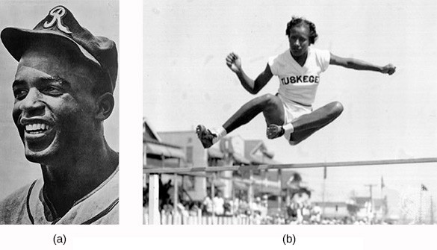

DESEGREGATION AND INTEGRATION
Until 1954, racial segregation in education was not only legal but was required in seventeen states and permissible in several others. Utilizing evidence provided in sociological studies conducted by Kenneth Clark and Gunnar Myrdal, however, Thurgood Marshall, then chief counsel for the NAACP, successfully argued the landmark case Brown v. Board of Education of Topeka, Kansas before the U.S. Supreme Court led by Chief Justice Earl Warren. Marshall showed that the practice of segregation in public schools made African American students feel inferior. Even if the facilities provided were equal in nature, the Court noted in its decision, the very fact that some students were separated from others on the basis of their race made segregation unconstitutional.

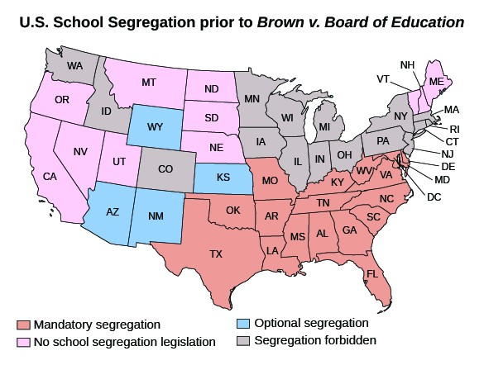

Thurgood Marshall on Fighting Racism
As a law student in 1933, Thurgood Marshall was recruited by his mentor Charles Hamilton Houston to assist in gathering information for the defense of a black man in Virginia accused of killing two white women. His continued close association with Houston led Marshall to aggressively defend blacks in the court system and to use the courts as the weapon by which equal rights might be extracted from the U.S. Constitution and a white racist system. Houston also suggested that it would be important to establish legal precedents regarding the Plessy v. Ferguson ruling of separate but equal.

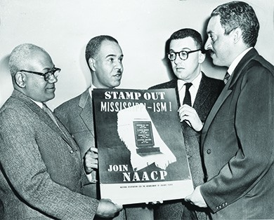
By 1938, Marshall had become “Mr. Civil Rights” and formally organized the NAACP’s Legal Defense and Education Fund in 1940 to garner the resources to take on cases to break the racist justice system of America. A direct result of Marshall’s energies and commitment was his 1940 victory in a Supreme Court case, Chambers v. Florida, which held that confessions obtained by violence and torture were inadmissible in a court of law. His most well-known case was Brown v. Board of Education in 1954, which held that state laws establishing separate public schools for black and white students were unconstitutional.
Later in life, Marshall reflected on his career fighting racism in a speech at Howard Law School in 1978:
Be aware of that myth, that everything is going to be all right. Don’t give in. I add that, because it seems to me, that what we need to do today is to refocus. Back in the 30s and 40s, we could go no place but to court. We knew then, the court was not the final solution. Many of us knew the final solution would have to be politics, if for no other reason, politics is cheaper than lawsuits. So now we have both. We have our legal arm, and we have our political arm. Let’s use them both. And don’t listen to this myth that it can be solved by either or that it has already been solved. Take it from me, it has not been solved.
When Marshall says that the problems of racism have not been solved, to what was he referring?
Plessy v. Fergusson had been overturned. The challenge now was to integrate schools. A year later, the U.S. Supreme Court ordered southern school systems to begin desegregation “with all deliberate speed.” Some school districts voluntarily integrated their schools. For many other districts, however, “deliberate speed” was very, very slow.
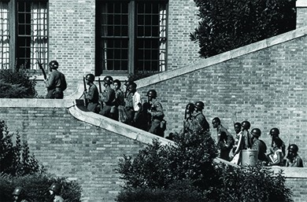
It soon became clear that enforcing Brown v. the Board of Education would require presidential intervention. Eisenhower did not agree with the U.S. Supreme Court’s decision and did not wish to force southern states to integrate their schools. However, as president, he was responsible for doing so. In 1957, Central High School in Little Rock, Arkansas, was forced to accept its first nine African American students, who became known as the Little Rock Nine. In response, Arkansas governor Orval Faubus called out the state National Guard to prevent the students from attending classes, removing the troops only after Eisenhower told him to do so. A subsequent attempt by the nine students to attend school resulted in mob violence. Eisenhower then placed the Arkansas National Guard under federal control and sent the U.S. Army’s 101st airborne unit to escort the students to and from school as well as from class to class. This was the first time since the end of Reconstruction that federal troops once more protected the rights of African Americans in the South.
Throughout the course of the school year, the Little Rock Nine were insulted, harassed, and physically assaulted; nevertheless, they returned to school each day. At the end of the school year, the first African American student graduated from Central High. At the beginning of the 1958–1959 school year, Orval Faubus ordered all Little Rock’s public schools closed. In the opinion of white segregationists, keeping all students out of school was preferable to having them attend integrated schools. In 1959, the U.S. Supreme Court ruled that the school had to be reopened and that the process of desegregation had to proceed.

WHITE RESPONSES
Efforts to desegregate public schools led to a backlash among most southern whites. Many greeted the Brown decision with horror; some World War II veterans questioned how the government they had fought for could betray them in such a fashion. Some white parents promptly withdrew their children from public schools and enrolled them in all-white private academies, many newly created for the sole purpose of keeping white children from attending integrated schools. Often, these “academies” held classes in neighbors’ basements or living rooms.
Other white southerners turned to state legislatures or courts to solve the problem of school integration. Orders to integrate school districts were routinely challenged in court. When the lawsuits proved unsuccessful, many southern school districts responded by closing all public schools, as Orval Faubus had done after Central High School was integrated. One county in Virginia closed its public schools for five years rather than see them integrated. Besides suing school districts, many southern segregationists filed lawsuits against the NAACP, trying to bankrupt the organization. Many national politicians supported the segregationist efforts. In 1956, ninety-six members of Congress signed “The Southern Manifesto,” in which they accused the U.S. Supreme Court of misusing its power and violating the principle of states’ rights, which maintained that states had rights equal to those of the federal government.
Unfortunately, many white southern racists, frightened by challenges to the social order, responded with violence. When Little Rock’s Central High School desegregated, an irate Ku Klux Klansman from a neighboring community sent a letter to the members of the city’s school board in which he denounced them as Communists and threatened to kill them. White rage sometimes erupted into murder. In August 1955, both white and black Americans were shocked by the brutality of the murder of Emmett Till. Till, a fourteen-year-old boy from Chicago, had been vacationing with relatives in Mississippi. While visiting a white-owned store, he had made a remark to the white woman behind the counter. A few days later, the husband and brother-in-law of the woman came to the home of Till’s relatives in the middle of the night and abducted the boy. Till’s beaten and mutilated body was found in a nearby river three days later. Till’s mother insisted on an open-casket funeral; she wished to use her son’s body to reveal the brutality of southern racism. The murder of a child who had been guilty of no more than a casual remark captured the nation’s attention, as did the acquittal of the two men who admitted killing him.

THE MONTGOMERY BUS BOYCOTT
One of those inspired by Till’s death was Rosa Parks, an NAACP member from Montgomery, Alabama, who became the face of the 1955–1956 Montgomery Bus Boycott. City ordinances in Montgomery segregated the city’s buses, forcing African American passengers to ride in the back section. They had to enter through the rear of the bus, could not share seats with white passengers, and, if the front of the bus was full and a white passenger requested an African American’s seat, had to relinquish their place to the white rider. The bus company also refused to hire African American drivers even though most of the people who rode the buses were black.
On December 1, 1955, Rosa Parks refused to give her seat to a white man, and the Montgomery police arrested her. After being bailed out of jail, she decided to fight the laws requiring segregation in court. To support her, the Women’s Political Council, a group of African American female activists, organized a boycott of Montgomery’s buses. News of the boycott spread through newspaper notices and by word of mouth; ministers rallied their congregations to support the Women’s Political Council. Their efforts were successful, and forty thousand African American riders did not take the bus on December 5, the first day of the boycott.
Other African American leaders within the city embraced the boycott and maintained it beyond December 5, Rosa Parks’ court date. Among them was a young minister named Martin Luther King, Jr. For the next year, black Montgomery residents avoided the city’s buses. Some organized carpools. Others paid for rides in African American-owned taxis, whose drivers reduced their fees. Most walked to and from school, work, and church for 381 days, the duration of the boycott. In June 1956, an Alabama federal court found the segregation ordinance unconstitutional. The city appealed, but the U.S. Supreme Court upheld the decision. The city’s buses were desegregated.

Section Summary
After World War II, African American efforts to secure greater civil rights increased across the United States. African American lawyers such as Thurgood Marshall championed cases intended to destroy the Jim Crow system of segregation that had dominated the American South since Reconstruction. The landmark Supreme Court case Brown v. Board of Education prohibited segregation in public schools, but not all school districts integrated willingly, and President Eisenhower had to use the military to desegregate Little Rock’s Central High School. The courts and the federal government did not assist African Americans in asserting their rights in other cases. In Montgomery, Alabama, it was the grassroots efforts of African American citizens who boycotted the city’s bus system that brought about change. Throughout the region, many white southerners made their opposition to these efforts known. Too often, this opposition manifested itself in violence and tragedy, as in the murder of Emmett Till.
A Open Assessments element has been excluded from this version of the text. You can view it online here: https://library.achievingthedream.org/bcccomposition/?p=63

Review Question
- What was the significance of Shelley v. Kraemer?

Answer to Review Question
- Shelley v. Kraemer held that state courts could not enforce agreements that prevented homeowners from selling to members of particular races. The ruling made it easier for African Americans to purchase houses in neighborhoods of their choosing.

Critical Thinking Questions
- How did some Americans turn their wartime experiences into lasting personal gains (i.e. better employment, a new home, or an education) after the war was over? Why did others miss out on these opportunities?
- What was the reason for the breakdown in friendly relations between the United States and the Soviet Union after World War II? What were the results of this conflict?
- How did fear of the Soviet Union and Communism affect American culture and society?
- What social changes took place in the United States after World War II? What role did the war play in those changes?
- How did the wartime experiences of African Americans contribute to the drive for greater civil rights after the war?

Glossary
desegregation the removal of laws and policies requiring the separation of different racial or ethnic groups
Little Rock Nine the nickname for the nine African American high school students who first integrated Little Rock’s Central High School
states’ rights the political belief that states possess authority beyond federal law, which is usually seen as the supreme law of the land, and thus can act in opposition to federal law

PART XII

Module 11

Chapter 35

Using Sources in Your Paper
Within the pages of your research essay, it is important to properly reference and cite your sources to avoid plagiarism and to give credit for original ideas.
There are three main ways to put a source to use in your essay: you can quote it, you can summarize it, and you can paraphrase it.

Quoting

Direct quotations are words and phrases that are taken directly from another source, and then used word-for-word in your paper. If you incorporate a direct quotation from another author’s text, you must put that quotation or phrase in quotation marks to indicate that it is not your language.
When writing direct quotations, you can use the source author’s name in the same sentence as the quotation to introduce the quoted text and to indicate the source in which you found the text. You should then include the page number or other relevant information in parentheses at the end of the phrase (the exact format will depend on the formatting style of your essay).

Summarizing
Summarizing involves condensing the main idea of a source into a much shorter overview. A summary outlines a source’s most important points and general position. When summarizing a source, it is still necessary to use a citation to give credit to the original author. You must reference the author or source in the appropriate citation method at the end of the summary.

Paraphrasing
When paraphrasing, you may put any part of a source (such as a phrase, sentence, paragraph, or chapter) into your own words. You may find that the original source uses language that is more clear, concise, or specific than your own language, in which case you should use a direct quotation, putting quotation marks around those unique words or phrases you don’t change.
It is common to use a mixture of paraphrased text and quoted words or phrases, as long as the direct quotations are inside of quotation marks.



Providing Context for Your Sources
Whether you use a direct quotation, a summary, or a paraphrase, it is important to distinguish the original source from your ideas, and to explain how the cited source fits into your argument. While the use of quotation marks or parenthetical citations tells your reader that these are not your own words or ideas, you should follow the quote with a description, in your own terms, of what the quote says and why it is relevant to the purpose of your paper. You should not let quoted or paraphrased text stand alone in your paper, but rather, should integrate the sources into your argument by providing context and explanations about how each source supports your argument.

Chapter 36

The Civil Rights Movement Marches On

Learning Objectives
By the end of this section, you will be able to:
- Explain the strategies of the African American civil rights movement in the 1960s
- Discuss the rise and philosophy of Black Power
- Identify achievements of the Mexican American civil rights movement in the 1960s
During the 1960s, the federal government, encouraged by both genuine concern for the dispossessed and the realities of the Cold War, had increased its efforts to protect civil rights and ensure equal economic and educational opportunities for all. However, most of the credit for progress toward racial equality in the Unites States lies with grassroots activists. Indeed, it was campaigns and demonstrations by ordinary people that spurred the federal government to action. Although the African American civil rights movement was the most prominent of the crusades for racial justice, other ethnic minorities also worked to seize their piece of the American dream during the promising years of the 1960s. Many were influenced by the African American cause and often used similar tactics.

CHANGE FROM THE BOTTOM UP
For many people inspired by the victories of Brown v. Board of Education and the Montgomery Bus Boycott, the glacial pace of progress in the segregated South was frustrating if not intolerable. In some places, such as Greensboro, North Carolina, local NAACP chapters had been influenced by whites who provided financing for the organization. This aid, together with the belief that more forceful efforts at reform would only increase white resistance, had persuaded some African American organizations to pursue a “politics of moderation” instead of attempting to radically alter the status quo. Martin Luther King Jr.’s inspirational appeal for peaceful change in the city of Greensboro in 1958, however, planted the seed for a more assertive civil rights movement.
On February 1, 1960, four sophomores at the North Carolina Agricultural Technical College in Greensboro—Ezell Blair, Jr., Joseph McNeil, David Richmond, and Franklin McCain—entered the local Woolworth’s and sat at the lunch counter. The lunch counter was segregated, and they were refused service as they knew they would be. They had specifically chosen Woolworth’s, because it was a national chain and was thus believed to be especially vulnerable to negative publicity. Over the next few days, more protesters joined the four sophomores. Hostile whites responded with threats and taunted the students by pouring sugar and ketchup on their heads. The successful six-month-long Greensboro sit-in initiated the student phase of the African American civil rights movement and, within two months, the sit-in movement had spread to fifty-four cities in nine states.

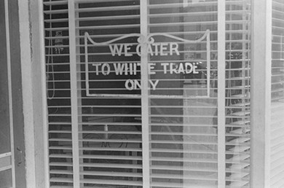
In the words of grassroots civil rights activist Ella Baker, the students at Woolworth’s wanted more than a hamburger; the movement they helped launch was about empowerment. Baker pushed for a “participatory Democracy” that built on the grassroots campaigns of active citizens instead of deferring to the leadership of educated elites and experts. As a result of her actions, in April 1960, the Student Nonviolent Coordinating Committee (SNCC) formed to carry the battle forward. Within a year, more than one hundred cities had desegregated at least some public accommodations in response to student-led demonstrations. The sit-ins inspired other forms of nonviolent protest intended to desegregate public spaces. “Sleep-ins” occupied motel lobbies, “read-ins” filled public libraries, and churches became the sites of “pray-ins.”
Students also took part in the 1961 “freedom rides” sponsored by the Congress of Racial Equality (CORE) and SNCC. The intent of the African American and white volunteers who undertook these bus rides south was to test enforcement of a U.S. Supreme Court decision prohibiting segregation on interstate transportation and to protest segregated waiting rooms in southern terminals. Departing Washington, DC, on May 4, the volunteers headed south on buses that challenged the seating order of Jim Crow segregation. Whites would ride in the back, African-Americans would sit in the front, and on other occasions, riders of different races would share the same bench seat. The freedom riders encountered little difficulty until they reached Rock Hill, South Carolina, where a mob severely beat John Lewis, a freedom rider who later became chairman of SNCC. The danger increased as the riders continued through Georgia into Alabama, where one of the two buses was firebombed outside the town of Anniston. The second group continued to Birmingham, where the riders were attacked by the Ku Klux Klan as they attempted to disembark at the city bus station. The remaining volunteers continued to Mississippi, where they were arrested when they attempted to desegregate the waiting rooms in the Jackson bus terminal.

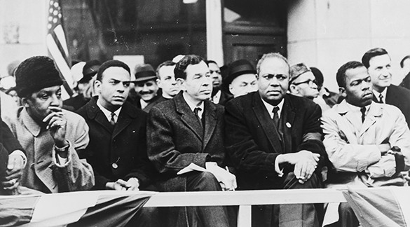

FREE BY ’63 (OR ’64 OR ’65)
The grassroots efforts of people like the Freedom Riders to change discriminatory laws and longstanding racist traditions grew more widely known in the mid-1960s. The approaching centennial of Abraham Lincoln’s Emancipation Proclamation spawned the slogan “Free by ’63” among civil rights activists. As African Americans increased their calls for full rights for all Americans, many civil rights groups changed their tactics to reflect this new urgency.
Perhaps the most famous of the civil rights-era demonstrations was the March on Washington for Jobs and Freedom, held in August 1963, on the one hundredth anniversary of Abraham Lincoln’s Emancipation Proclamation. Its purpose was to pressure President Kennedy to act on his promises regarding civil rights. The date was the eighth anniversary of the brutal racist murder of fourteen-year-old Emmett Till in Money, Mississippi. As the crowd gathered outside the Lincoln Memorial and spilled across the National Mall, Martin Luther King, Jr. delivered his most famous speech. In “I Have a Dream,” King called for an end to racial injustice in the United States and envisioned a harmonious, integrated society. The speech marked the high point of the civil rights movement and established the legitimacy of its goals. However, it did not prevent white terrorism in the South, nor did it permanently sustain the tactics of nonviolent civil disobedience.

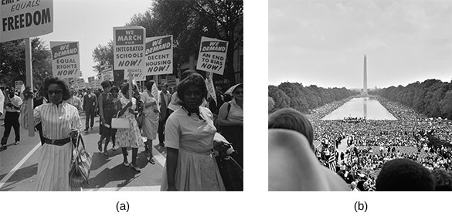
Other gatherings of civil rights activists ended tragically, and some demonstrations were intended to provoke a hostile response from whites and thus reveal the inhumanity of the Jim Crow laws and their supporters. In 1963, the Southern Christian Leadership Conference (SCLC) led by Martin Luther King, Jr. mounted protests in some 186 cities throughout the South. The campaign in Birmingham that began in April and extended into the fall of 1963 attracted the most notice, however, when a peaceful protest was met with violence by police, who attacked demonstrators, including children, with fire hoses and dogs. The world looked on in horror as innocent people were assaulted and thousands arrested. King himself was jailed on Easter Sunday, 1963, and, in response to the pleas of white clergymen for peace and patience, he penned one of the most significant documents of the struggle—“Letter from a Birmingham Jail.” In the letter, King argued that African Americans had waited patiently for more than three hundred years to be given the rights that all human beings deserved; the time for waiting was over.

Letter from a Birmingham Jail
By 1963, Martin Luther King, Jr. had become one of the most prominent leaders of the civil rights movement, and he continued to espouse nonviolent civil disobedience as a way of registering African American resistance against unfair, discriminatory, and racist laws and behaviors. While the campaign in Birmingham began with an African American boycott of white businesses to end discrimination in employment practices and public segregation, it became a fight over free speech when King was arrested for violating a local injunction against demonstrations. King wrote his “Letter from a Birmingham Jail” in response to an op-ed by eight white Alabama clergymen who complained about the SCLC’s fiery tactics and argued that social change needed to be pursued gradually. The letter criticizes those who did not support the cause of civil rights:
In spite of my shattered dreams of the past, I came to Birmingham with the hope that the white religious leadership in the community would see the justice of our cause and, with deep moral concern, serve as the channel through which our just grievances could get to the power structure. I had hoped that each of you would understand. But again I have been disappointed. I have heard numerous religious leaders of the South call upon their worshippers to comply with a desegregation decision because it is the law, but I have longed to hear white ministers say follow this decree because integration is morally right and the Negro is your brother. In the midst of blatant injustices inflicted upon the Negro, I have watched white churches stand on the sideline and merely mouth pious irrelevancies and sanctimonious trivialities. In the midst of a mighty struggle to rid our nation of racial and economic injustice, I have heard so many ministers say, “Those are social issues with which the Gospel has no real concern,” and I have watched so many churches commit themselves to a completely other-worldly religion which made a strange distinction between body and soul, the sacred and the secular.
Since its publication, the “Letter” has become one of the most cogent, impassioned, and succinct statements of the aspirations of the civil rights movement and the frustration over the glacial pace of progress in achieving justice and equality for all Americans.
What civil rights tactics raised the objections of the white clergymen King addressed in his letter? Why?
Some of the greatest violence during this era was aimed at those who attempted to register African Americans to vote. In 1964, SNCC, working with other civil rights groups, initiated its Mississippi Summer Project, also known as Freedom Summer. The purpose was to register African American voters in one of the most racist states in the nation. Volunteers also built “freedom schools” and community centers. SNCC invited hundreds of white middle-class students, mostly from the North, to help in the task. Many volunteers were harassed, beaten, and arrested, and African American homes and churches were burned. Three civil rights workers, James Chaney, Michael Schwerner, and Andrew Goodman, were killed by the Ku Klux Klan. That summer, civil rights activists Fannie Lou Hamer, Ella Baker, and Robert Parris Moses formally organized the Mississippi Freedom Democratic Party (MFDP) as an alternative to the all-white Mississippi Democratic Party. The Democratic National Convention’s organizers, however, would allow only two MFDP delegates to be seated, and they were confined to the roles of nonvoting observers.
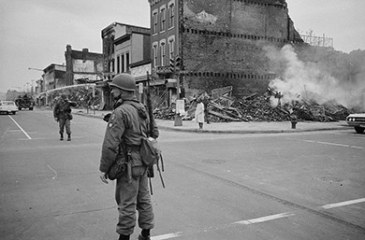
The vision of whites and African Americans working together peacefully to end racial injustice suffered a severe blow with the death of Martin Luther King, Jr. in Memphis, Tennessee, in April 1968. King had gone there to support sanitation workers trying to unionize. In the city, he found a divided civil rights movement; older activists who supported his policy of nonviolence were being challenged by younger African Americans who advocated a more militant approach. On April 4, King was shot and killed while standing on the balcony of his motel. Within hours, the nation’s cities exploded with violence as angry African Americans, shocked by his murder, burned and looted inner-city neighborhoods across the country. While whites recoiled from news about the riots in fear and dismay, they also criticized African Americans for destroying their own neighborhoods; they did not realize that most of the violence was directed against businesses that were not owned by blacks and that treated African American customers with suspicion and hostility.

BLACK FRUSTRATION, BLACK POWER
The episodes of violence that accompanied Martin Luther King Jr.’s murder were but the latest in a string of urban riots that had shaken the United States since the mid-1960s. Between 1964 and 1968, there were 329 riots in 257 cities across the nation. In 1964, riots broke out in Harlem and other African American neighborhoods. In 1965, a traffic stop set in motion a chain of events that culminated in riots in Watts, an African American neighborhood in Los Angeles. Thousands of businesses were destroyed, and, by the time the violence ended, thirty-four people were dead, most of them African Americans killed by the Los Angeles police and the National Guard. More riots took place in 1966 and 1967.
Frustration and anger lay at the heart of these disruptions. Despite the programs of the Great Society, good healthcare, job opportunities, and safe housing were abysmally lacking in urban African American neighborhoods in cities throughout the country, including in the North and West, where discrimination was less overt but just as crippling. In the eyes of many rioters, the federal government either could not or would not end their suffering, and most existing civil rights groups and their leaders had been unable to achieve significant results toward racial justice and equality. Disillusioned, many African Americans turned to those with more radical ideas about how best to obtain equality and justice.
Watch “Troops Patrol L.A.” to see how the
were presented in newsreel footage of the day.

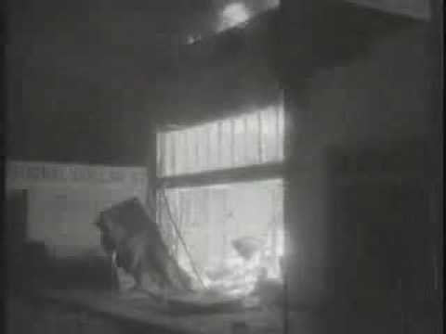
A YouTube element has been excluded from this version of the text. You can view it online here: https://library.achievingthedream.org/bcccomposition/?p=66
Within the chorus of voices calling for integration and legal equality were many that more stridently demanded empowerment and thus supported Black Power. Black Power meant a variety of things. One of the most famous users of the term was Stokely Carmichael, the chairman of SNCC, who later changed his name to Kwame Ture. For Carmichael, Black Power was the power of African Americans to unite as a political force and create their own institutions apart from white-dominated ones, an idea first suggested in the 1920s by political leader and orator Marcus Garvey. Like Garvey, Carmichael became an advocate of black separatism, arguing that African Americans should live apart from whites and solve their problems for themselves. In keeping with this philosophy, Carmichael expelled SNCC’s white members. He left SNCC in 1967 and later joined the Black Panthers (see below).
Long before Carmichael began to call for separatism, the Nation of Islam, founded in 1930, had advocated the same thing. In the 1960s, its most famous member was Malcolm X, born Malcolm Little. The Nation of Islam advocated the separation of white Americans and African Americans because of a belief that African Americans could not thrive in an atmosphere of white racism. Indeed, in a 1963 interview, Malcolm X, discussing the teachings of the head of the Nation of Islam in America, Elijah Muhammad, referred to white people as “devils” more than a dozen times. Rejecting the nonviolent strategy of other civil rights activists, he maintained that violence in the face of violence was appropriate.

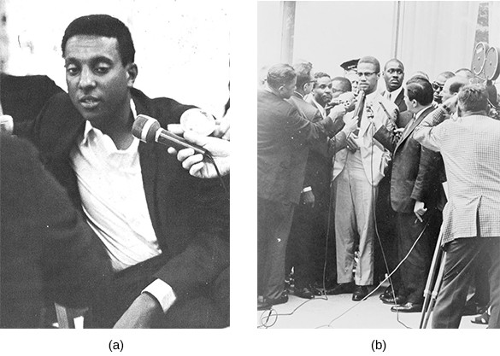
In 1964, after a trip to Africa, Malcolm X left the Nation of Islam to found the Organization of Afro-American Unity with the goal of achieving freedom, justice, and equality “by any means necessary.” His views regarding black-white relations changed somewhat thereafter, but he remained fiercely committed to the cause of African American empowerment. On February 21, 1965, he was killed by members of the Nation of Islam. Stokely Carmichael later recalled that Malcolm X had provided an intellectual basis for Black Nationalism and given legitimacy to the use of violence in achieving the goals of Black Power.

The New Negro
In a roundtable conversation in October 1961, Malcolm X suggested that a “New Negro” was coming to the fore. The term and concept of a “New Negro” arose during the Harlem Renaissance of the 1920s and was revived during the civil rights movements of the 1960s.
“I think there is a new so-called Negro. We don’t recognize the term ‘Negro’ but I really believe that there’s a new so-called Negro here in America. He not only is impatient. Not only is he dissatisfied, not only is he disillusioned, but he’s getting very angry. And whereas the so-called Negro in the past was willing to sit around and wait for someone else to change his condition or correct his condition, there’s a growing tendency on the part of a vast number of so-called Negroes today to take action themselves, not to sit and wait for someone else to correct the situation. This, in my opinion, is primarily what has produced this new Negro. He is not willing to wait. He thinks that what he wants is right, what he wants is just, and since these things are just and right, it’s wrong to sit around and wait for someone else to correct a nasty condition when they get ready.”
In what ways were Martin Luther King, Jr. and the members of SNCC “New Negroes?”
Unlike Stokely Carmichael and the Nation of Islam, most Black Power advocates did not believe African Americans needed to separate themselves from white society. The Black Panther Party, founded in 1966 in Oakland, California, by Bobby Seale and Huey Newton, believed African Americans were as much the victims of capitalism as of white racism. Accordingly, the group espoused Marxist teachings, and called for jobs, housing, and education, as well as protection from police brutality and exemption from military service in their Ten Point Program. The Black Panthers also patrolled the streets of African American neighborhoods to protect residents from police brutality, yet sometimes beat and murdered those who did not agree with their cause and tactics. Their militant attitude and advocacy of armed self-defense attracted many young men but also led to many encounters with the police, which sometimes included arrests and even shootouts, such as those that took place in Los Angeles, Chicago and Carbondale, Illinois.
The self-empowerment philosophy of Black Power influenced mainstream civil rights groups such as the National Economic Growth Reconstruction Organization (NEGRO), which sold bonds and operated a clothing factory and construction company in New York, and the Opportunities Industrialization Center in Philadelphia, which provided job training and placement—by 1969, it had branches in seventy cities. Black Power was also part of a much larger process of cultural change. The 1960s composed a decade not only of Black Power but also of Black Pride. African American abolitionist John S. Rock had coined the phrase “Black Is Beautiful” in 1858, but in the 1960s, it became an important part of efforts within the African American community to raise self-esteem and encourage pride in African ancestry. Black Pride urged African Americans to reclaim their African heritage and, to promote group solidarity, to substitute African and African-inspired cultural practices, such as handshakes, hairstyles, and dress, for white practices. One of the many cultural products of this movement was the popular television music program Soul Train, created by Don Cornelius in 1969, which celebrated black culture and aesthetics.

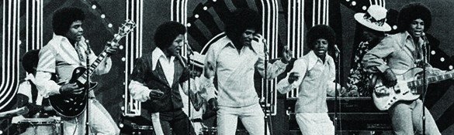

THE MEXICAN AMERICAN FIGHT FOR CIVIL RIGHTS
The African American bid for full citizenship was surely the most visible of the battles for civil rights taking place in the United States. However, other minority groups that had been legally discriminated against or otherwise denied access to economic and educational opportunities began to increase efforts to secure their rights in the 1960s. Like the African American movement, the Mexican American civil rights movement won its earliest victories in the federal courts. In 1947, in Mendez v. Westminster, the U.S. Court of Appeals for the Ninth Circuit ruled that segregating children of Hispanic descent was unconstitutional. In 1954, the same year as Brown v. Board of Education, Mexican Americans prevailed in Hernandez v. Texas, when the U.S. Supreme Court extended the protections of the Fourteenth Amendment to all ethnic groups in the United States.
The highest-profile struggle of the Mexican American civil rights movement was the fight that Caesar Chavez and Dolores Huerta waged in the fields of California to organize migrant farm workers. In 1962, Chavez and Huerta founded the National Farm Workers Association (NFWA). In 1965, when Filipino grape pickers led by Filipino American Larry Itliong went on strike to call attention to their plight, Chavez lent his support. Workers organized by the NFWA also went on strike, and the two organizations merged to form the United Farm Workers. When Chavez asked American consumers to boycott grapes, politically conscious people around the country heeded his call, and many unionized longshoremen refused to unload grape shipments. In 1966, Chavez led striking workers to the state capitol in Sacramento, further publicizing the cause. Martin Luther King, Jr. telegraphed words of encouragement to Chavez, whom he called a “brother.” The strike ended in 1970 when California farmers recognized the right of farm workers to unionize. However, the farm workers did not gain all they sought, and the larger struggle did not end.

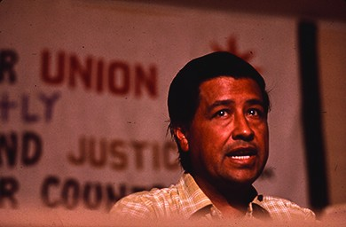
The equivalent of the Black Power movement among Mexican Americans was the Chicano Movement. Proudly adopting a derogatory term for Mexican Americans, Chicano activists demanded increased political power for Mexican Americans, education that recognized their cultural heritage, and the restoration of lands taken from them at the end of the Mexican-American War in 1848. One of the founding members, Rodolfo “Corky” Gonzales, launched the Crusade for Justice in Denver in 1965, to provide jobs, legal services, and healthcare for Mexican Americans. From this movement arose La Raza Unida, a political party that attracted many Mexican American college students. Elsewhere, Reies López Tijerina fought for years to reclaim lost and illegally expropriated ancestral lands in New Mexico; he was one of the co-sponsors of the Poor People’s March on Washington in 1967.

Section Summary
The African American civil rights movement made significant progress in the 1960s. While Congress played a role by passing the Civil Rights Act of 1964, the Voting Rights Act of 1965, and the Civil Rights Act of 1968, the actions of civil rights groups such as CORE, the SCLC, and SNCC were instrumental in forging new paths, pioneering new techniques and strategies, and achieving breakthrough successes. Civil rights activists engaged in sit-ins, freedom rides, and protest marches, and registered African American voters. Despite the movement’s many achievements, however, many grew frustrated with the slow pace of change, the failure of the Great Society to alleviate poverty, and the persistence of violence against African Americans, particularly the tragic 1968 assassination of Martin Luther King, Jr. Many African Americans in the mid- to late 1960s adopted the ideology of Black Power, which promoted their work within their own communities to redress problems without the aid of whites. The Mexican American civil rights movement, led largely by Cesar Chavez, also made significant progress at this time. The emergence of the Chicano Movement signaled Mexican Americans’ determination to seize their political power, celebrate their cultural heritage, and demand their citizenship rights.
A Open Assessments element has been excluded from this version of the text. You can view it online here: https://library.achievingthedream.org/bcccomposition/?p=66

Review Question
- How did the message of Black Power advocates differ from that of more mainstream civil rights activists such as Martin Luther King, Jr.?

Answer to Review Question
- King and his followers strove for racial integration and the political inclusion of African Americans. They also urged for the use of nonviolent tactics to achieve their goals. Black Power advocates, in contrast, believed that African Americans should seek solutions without the aid of whites. Many also promoted black separatism and accepted the use of violence.

Glossary
black separatism an ideology that called upon African Americans to reject integration with the white community and, in some cases, to physically separate themselves from whites in order to create and preserve their self-determination
Black Power a political ideology encouraging African Americans to create their own institutions and develop their own economic resources independent of whites
Black Pride a cultural movement among African Americans to encourage pride in their African heritage and to substitute African and African American art forms, behaviors, and cultural products for those of whites

Chapter 37

New Century, Old Disputes

Learning Objectives
By the end of this section, you will be able to:
- Describe the efforts to reduce the influence of immigrants on American culture
- Describe the evolution of twenty-first-century American attitudes towards same-sex marriage
- Explain the clash over climate change
As the United States entered the twenty-first century, old disputes continued to rear their heads. Some revolved around what it meant to be American and the rights to full citizenship. Others arose from religious conservatism and the influence of the Religious Right on American culture and society. Debates over gay and lesbian rights continued, and arguments over abortion became more complex and contentious, as science and technology advanced. The clash between faith and science also influenced attitudes about how the government should respond to climate change, with religious conservatives finding allies among political conservatives who favored business over potentially expensive measures to reduce harmful emissions.

WHO IS AN AMERICAN?
There is nothing new about anxiety over immigration in the United States. For its entire history, citizens have worried about who is entering the country and the changes that might result. Such concerns began to flare once again beginning in the 1980s, as Americans of European ancestry started to recognize the significant demographic changes on the horizon. The number of Americans of color and multiethnic Americans was growing, as was the percentage of people with other than European ancestry. It was clear the white majority would soon be a demographic minority.

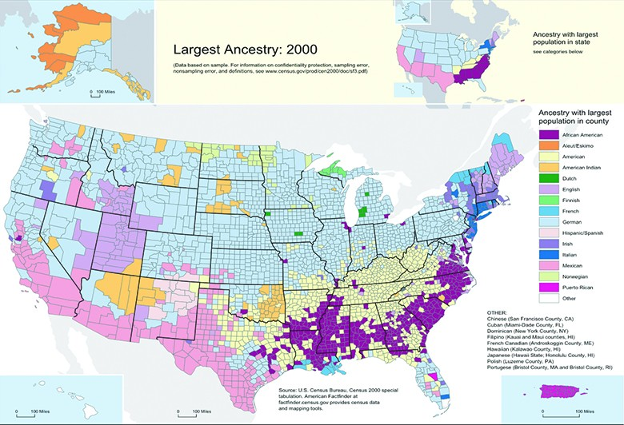
The nation’s increasing diversity prompted some social conservatives to identify American culture as one of European heritage, including the drive to legally designate English the official language of the United States. This movement was particularly strong in areas of the country with large Spanish-speaking populations such as Arizona, where, in 2006, three-quarters of voters approved a proposition to make English the official language in the state. Proponents in Arizona and elsewhere argued that these laws were necessary, because recent immigrants, especially Hispanic newcomers, were not being sufficiently acculturated to white, middle-class culture. Opponents countered that English was already the de facto official language, and codifying it into law would only amount to unnecessary discrimination.

Arizona Bans Mexican American Studies
In 2010, Arizona passed a law barring the teaching of any class that promoted “resentment” of students of other races or encouraged “ethnic solidarity.” The ban, to take effect on December 31 of that year, included a popular Mexican American studies program taught at elementary, middle, and high schools in the city of Tucson. The program, which focused on teaching students about Mexican American history and literature, was begun in 1998, to convert high absentee rates and low academic performance among Latino students, and proved highly successful. Public school superintendent Tom Horne objected to the course, however, claiming it encouraged resentment of whites and of the U.S. government, and improperly encouraged students to think of themselves as members of a race instead of as individuals.
Tucson was ordered to end its Mexican American studies program or lose 10 percent of the school system’s funding, approximately $3 million each month. In 2012, the Tucson school board voted to end the program. A former student and his mother filed a suit in federal court, claiming that the law, which did not prohibit programs teaching Indian students about their culture, was discriminatory and violated the First Amendment rights of Tucson’s students. In March 2013, the court found in favor of the state, ruling that the law was not discriminatory, because it targeted classes, and not students or teachers, and that preventing the teaching of Mexican studies classes did not intrude on students’ constitutional rights. The court did, however, declare the part of the law prohibiting classes designed for members of particular ethnic groups to be unconstitutional.
What advantages or disadvantages can you see in an ethnic studies program? How could an ethnic studies course add to our understanding of U.S. history? Explain.
The fear that English-speaking Americans were being outnumbered by a Hispanic population that was not forced to assimilate was sharpened by the concern that far too many were illegally emigrating from Latin America to the United States. The Comprehensive Immigration Reform Act proposed by Congress in 2006 sought to simultaneously strengthen security along the U.S.-Mexico border (a task for the Department of Homeland Security), increase the number of temporary “guest workers” allowed in the United States, and provide a pathway for long-term U.S. residents who had entered the country illegally to gain legal status. It also sought to establish English as a “common and unifying language” for the nation. The bill and a similar amended version both failed to become law.
With unemployment rates soaring during the Great Recession, anxiety over illegal immigration rose, even while the incoming flow slowed. State legislatures in Alabama and Arizona passed strict new laws that required police and other officials to verify the immigration status of those they thought had entered the country illegally. In Alabama, the new law made it a crime to rent housing to undocumented immigrants, thus making it difficult for these immigrants to live within the state. Both laws have been challenged in court, and portions have been deemed unconstitutional or otherwise blocked.
Beginning in October 2013, states along the U.S.-Mexico border faced an increase in the immigration of children from a handful of Central American countries. Approximately fifty-two thousand children, some unaccompanied, were taken into custody as they reached the United States. A study by the United Nations High Commissioner for Refugees estimated that 58 percent of those migrants, largely from El Salvador and Honduras, were propelled towards the United States by poverty, violence, and the potential for exploitation in their home countries. Because of a 2008 law originally intended to protect victims of human trafficking, these Central American children are guaranteed a court hearing. Predictably, the crisis has served to underline the need for comprehensive immigration reform. But, as of late 2014, a 2013 Senate immigration reform bill that combines border security with a guest worker program and a path to citizenship has yet to be enacted as law.

WHAT IS A MARRIAGE?
In the 1990s, the idea of legal, same-sex marriage seemed particularly unlikely; neither of the two main political parties expressed support for it. Things began to change, however, following Vermont’s decision to allow same-sex couples to form state-recognized civil unions in which they could enjoy all the legal rights and privileges of marriage. Although it was the intention of the state to create a type of legal relationship equivalent to marriage, it did not use the word “marriage” to describe it.
Following Vermont’s lead, several other states legalized same-sex marriages or civil unions among gay and lesbian couples. In 2004, the Massachusetts Supreme Judicial Court ruled that barring gays and lesbians from marrying violated the state constitution. The court held that offering same-sex couples the right to form civil unions but not marriage was an act of discrimination, and Massachusetts became the first state to allow same-sex couples to marry. Not all states followed suit, however, and there was a backlash in several states. Between 1998 and 2012, thirty states banned same-sex marriage either by statute or by amending their constitutions. Other states attempted, unsuccessfully, to do the same. In 2007, the Massachusetts State Legislature rejected a proposed amendment to the state’s constitution that would have prohibited such marriages.
Watch this
on the attitudes that prevailed in Colorado in 1992, when the voters of that state approved Amendment 2 to the state’s constitution and consequently denied gay and lesbian Coloradans the right to claim relief from local levels of discrimination in public accommodations, housing, or jobs.
While those in support of broadening civil rights to include same-sex marriage were optimistic, those opposed employed new tactics. In 2008, opponents of same-sex marriage in California tried a ballot initiative to define marriage strictly as a union between a man and a woman. Despite strong support for broadening marriage rights, the proposition was successful. This change was just one of dozens that states had been putting in place since the late 1990s to make same-sex marriage unconstitutional at the state level. Like the California proposition, however, many new state constitutional amendments have faced challenges in court. As of 2014, leaders in both political parties are more receptive than ever before to the idea of same-sex marriage.

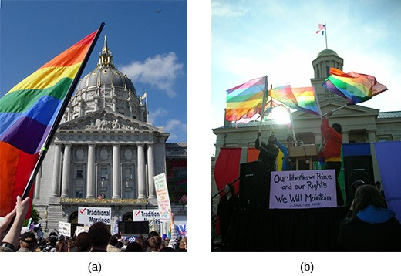

Visit the
to read more about the current status of same-sex marriage in the United States and the rest of the world.

WHY FIGHT CLIMATE CHANGE?
Even as mainstream members of both political parties moved closer together on same-sex marriage, political divisions on scientific debates continued. One increasingly polarizing debate that baffles much of the rest of the world is about global climate change. Despite near unanimity in the scientific community that climate change is real and will have devastating consequences, large segments of the American population, predominantly on the right, continue to insist that it is little more than a complex hoax and a leftist conspiracy. Much of the Republican Party’s base denies that global warming is the result of human activity; some deny that the earth is getting hotter at all. This popular denial has had huge global consequences. In 1998, the United States, which produces roughly 36 percent of the greenhouse gases like carbon dioxide that prevent the earth’s heat from escaping into space, signed the Kyoto Protocol, an agreement among the world’s nations to reduce their emissions of these gases. President Bush objected to the requirement that major industrialized nations limit their emissions to a greater extent than other parts of the world and argued that doing so might hurt the American economy. He announced that the United States would not be bound by the agreement, and it was never ratified by Congress.
Instead, the Bush administration appeared to suppress scientific reporting on climate change. In 2006, the progressive-leaning Union of Concerned Scientists surveyed sixteen hundred climate scientists, asking them about the state of federal climate research. Of those who responded, nearly three-fourths believed that their research had been subjected to new administrative requirements, third-party editing to change their conclusions, or pressure not to use terms such as “global warming.” Republican politicians, citing the altered reports, argued that there was no unified opinion among members of the scientific community that humans were damaging the climate.
Countering this rejection of science were the activities of many environmentalists, including Al Gore, Clinton’s vice president and Bush’s opponent in the disputed 2000 election. As a new member of Congress in 1976, Gore had developed what proved a steady commitment to environmental issues. In 2004, he established Generation Investment Management, which sought to promote an environmentally responsible system of equity analysis and investment. In 2006, a documentary film, An Inconvenient Truth, represented his attempts to educate people about the realities and dangers of global warming, and won the 2007 Academy Award for Best Documentary. Though some of what Gore said was in error, the film’s main thrust is in keeping with the weight of scientific evidence. In 2007, as a result of these efforts to “disseminate greater knowledge about man-made climate change,” Gore shared the Nobel Peace Prize with the Intergovernmental Panel on Climate Change.

Section Summary
The nation’s increasing diversity—and with it, the fact that white Caucasians will soon be a demographic minority—prompted a conservative backlash that continues to manifest itself in debates about immigration. Questions of who is an American and what constitutes a marriage continue to be debated, although the answers are beginning to change. As some states broadened civil rights to include gays and lesbians, groups opposed to these developments sought to impose state constitutional restrictions. From this flurry of activity, however, a new political consensus for expanding marriage rights has begun to emerge. On the issue of climate change, however, polarization has increased. A strong distrust of science among Americans has divided the political parties and hampered scientific research.
A Open Assessments element has been excluded from this version of the text. You can view it online here: https://library.achievingthedream.org/bcccomposition/?p=67

Review Question
- What was the result of the Bush administration’s unwillingness to recognize that climate change is being accelerated by human activity?

Answer to Review Question
- The administration refused to ratify the Kyoto Protocol, and, as a result, the United States has not been required to reduce its greenhouse gas emissions. Meanwhile, climate scientists have experienced interference with their work. For critics of climate change, this hampering of scientific research and consensus has provided further evidence of the lack of agreed-upon conclusions about climate change.

Glossary
civil unions a civil status offered to gay and lesbian couples with the goal of securing the main privileges of marriage without granting them equal status in marriage
greenhouse gases gases in the earth’s atmosphere, like carbon dioxide, that trap heat and prevent it from radiating into space
Kyoto Protocol an international agreement establishing regulations designed to reduce greenhouse gas emissions by the world’s industrialized nations

Chapter 38

Essay 4 Prompt
For essay 4 complete the following tasks.

Task 1:
Read the following on argumentative essays include all links below the heading:

http://owl.excelsior.edu/rhetorical-styles/argumentative-essay/

Task 2:
Choose a topic related to the larger course theme and shape a thesis around it. These will be approved by me mid-semester.

Task 4:
Write an essay in which you use at least 5 outside sources, also to be approved by me, to support, along multiple lines of argument, your thesis.

Requirements:
1500-2000 Words
Written in Word document and uploaded on Blackboard
10-12 Point TNR Font
Five outside sources cited using MLA style

PART XIII

Module 12

Chapter 39

The War on Terror

Learning Objectives
By the end of this section, you will be able to:
- Discuss how the United States responded to the terrorist attacks of September 11, 2001
- Explain why the United States went to war against Afghanistan and Iraq
- Describe the treatment of suspected terrorists by U.S. law enforcement agencies and the U.S. military

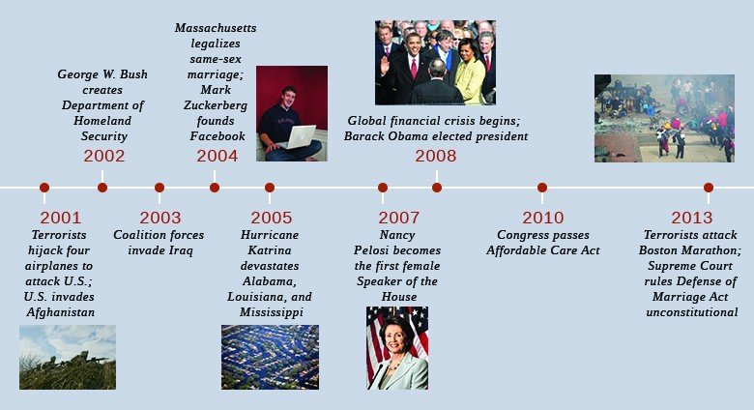
As a result of the narrow decision of the U.S. Supreme Court in Bush v. Gore, Republican George W. Bush was the declared the winner of the 2000 presidential election with a majority in the Electoral College of 271 votes to 266, although he received approximately 540,000 fewer popular votes nationally than his Democratic opponent, Bill Clinton’s vice president, Al Gore. Bush had campaigned with a promise of “compassionate conservatism” at home and nonintervention abroad. These platform planks were designed to appeal to those who felt that the Clinton administration’s initiatives in the Balkans and Africa had unnecessarily entangled the United States in the conflicts of foreign nations. Bush’s 2001 education reform act, dubbed No Child Left Behind, had strong bipartisan support and reflected his domestic interests. But before the president could sign the bill into law, the world changed when terrorists hijacked four American airliners to use them in the deadliest attack on the United States since the Japanese bombing of Pearl Harbor in December 1941. Bush’s domestic agenda quickly took a backseat, as the president swiftly changed course from nonintervention in foreign affairs to a “war on terror.”

9/11
Shortly after takeoff on the morning of September 11, 2001, teams of hijackers from the Islamist terrorist group al-Qaeda seized control of four American airliners. Two of the airplanes were flown into the twin towers of the World Trade Center in Lower Manhattan. Morning news programs that were filming the moments after the first impact, then assumed to be an accident, captured and aired live footage of the second plane, as it barreled into the other tower in a flash of fire and smoke. Less than two hours later, the heat from the crash and the explosion of jet fuel caused the upper floors of both buildings to collapse onto the lower floors, reducing both towers to smoldering rubble. The passengers and crew on both planes, as well as 2,606 people in the two buildings, all died, including 343 New York City firefighters who rushed in to save victims shortly before the towers collapsed.
The third hijacked plane was flown into the Pentagon building in northern Virginia, just outside Washington, DC, killing everyone on board and 125 people on the ground. The fourth plane, also heading towards Washington, crashed in a field near Shanksville, Pennsylvania, when passengers, aware of the other attacks, attempted to storm the cockpit and disarm the hijackers. Everyone on board was killed.

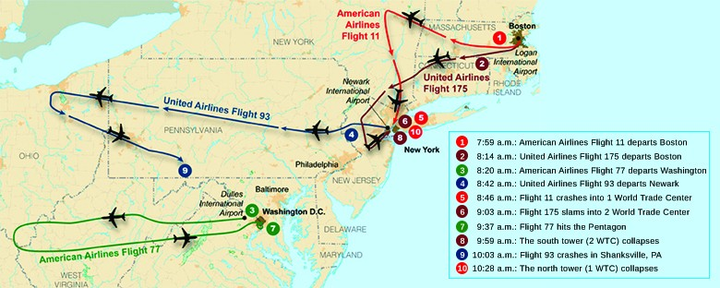
That evening, President Bush promised the nation that those responsible for the attacks would be brought to justice. Three days later, Congress issued a joint resolution authorizing the president to use all means necessary against the individuals, organizations, or nations involved in the attacks. On September 20, in an address to a joint session of Congress, Bush declared war on terrorism, blamed al-Qaeda leader Osama bin Laden for the attacks, and demanded that the radical Islamic fundamentalists who ruled Afghanistan, the Taliban, turn bin Laden over or face attack by the United States. This speech encapsulated what became known as the Bush Doctrine, the belief that the United States has the right to protect itself from terrorist acts by engaging in pre-emptive wars or ousting hostile governments in favor of friendly, preferably democratic, regimes.
Read the text of
to Congress declaring a “war on terror.”
World leaders and millions of their citizens expressed support for the United States and condemned the deadly attacks. Russian president Vladimir Putin characterized them as a bold challenge to humanity itself. German chancellor Gerhard Schroder said the events of that day were “not only attacks on the people in the United States, our friends in America, but also against the entire civilized world, against our own freedom, against our own values, values which we share with the American people.” Yasser Arafat, chairman of the Palestinian Liberation Organization and a veteran of several bloody struggles against Israel, was dumbfounded by the news and announced to reporters in Gaza, “We completely condemn this very dangerous attack, and I convey my condolences to the American people, to the American president and to the American administration.

In May 2014, a museum dedicated to the memory of the victims was completed. Watch this
and learn more about the victims and how the country seeks to remember them.

GOING TO WAR IN AFGHANISTAN
When it became clear that the mastermind behind the attack was Osama bin Laden, a wealthy Saudi Arabian national who ran his terror network from Afghanistan, the full attention of the United States turned towards Central Asia and the Taliban. Bin Laden had deep roots in Afghanistan. Like many others from around the Islamic world, he had come to the country to oust the Soviet army, which invaded Afghanistan in 1979. Ironically, both bin Laden and the Taliban received material support from the United States at that time. By the late 1980s, the Soviets and the Americans had both left, although bin Laden, by that time the leader of his own terrorist organization, al-Qaeda, remained.
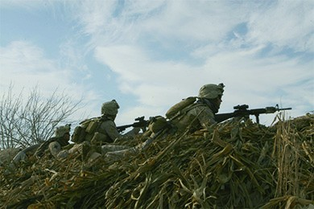
The Taliban refused to turn bin Laden over, and the United States began a bombing campaign in October, allying with the Afghan Northern Alliance, a coalition of tribal leaders opposed to the Taliban. U.S. air support was soon augmented by ground troops. By November 2001, the Taliban had been ousted from power in Afghanistan’s capital of Kabul, but bin Laden and his followers had already escaped across the Afghan border to mountain sanctuaries in northern Pakistan.

IRAQ
At the same time that the U.S. military was taking control of Afghanistan, the Bush administration was looking to a new and larger war with the country of Iraq. Relations between the United States and Iraq had been strained ever since the Gulf War a decade earlier. Economic sanctions imposed on Iraq by the United Nations, and American attempts to foster internal revolts against President Saddam Hussein’s government, had further tainted the relationship. A faction within the Bush administration, sometimes labeled neoconservatives, believed Iraq’s recalcitrance in the face of overwhelming U.S. military superiority represented a dangerous symbol to terrorist groups around the world, recently emboldened by the dramatic success of the al-Qaeda attacks in the United States. Powerful members of this faction, including Vice President Dick Cheney and Secretary of Defense Donald Rumsfeld, believed the time to strike Iraq and solve this festering problem was right then, in the wake of 9/11. Others, like Secretary of State Colin Powell, a highly respected veteran of the Vietnam War and former chair of the Joint Chiefs of Staff, were more cautious about initiating combat.
The more militant side won, and the argument for war was gradually laid out for the American people. The immediate impetus to the invasion, it argued, was the fear that Hussein was stockpiling weapons of mass destruction (WMDs): nuclear, chemical, or biological weapons capable of wreaking great havoc. Hussein had in fact used WMDs against Iranian forces during his war with Iran in the 1980s, and against the Kurds in northern Iraq in 1988—a time when the United States actively supported the Iraqi dictator. Following the Gulf War, inspectors from the United Nations Special Commission and International Atomic Energy Agency had in fact located and destroyed stockpiles of Iraqi weapons. Those arguing for a new Iraqi invasion insisted, however, that weapons still existed. President Bush himself told the nation in October 2002 that the United States was “facing clear evidence of peril, we cannot wait for the final proof—the smoking gun—that could come in the form of a mushroom cloud.” The head of the United Nations Monitoring, Verification and Inspection Commission, Hanx Blix, dismissed these claims. Blix argued that while Saddam Hussein was not being entirely forthright, he did not appear to be in possession of WMDs. Despite Blix’s findings and his own earlier misgivings, Powell argued in 2003 before the United Nations General Assembly that Hussein had violated UN resolutions. Much of his evidence relied on secret information provided by an informant that was later proven to be false. On March 17, 2003, the United States cut off all relations with Iraq. Two days later, in a coalition with Great Britain, Australia, and Poland, the United States began “Operation Iraqi Freedom” with an invasion of Iraq.
Other arguments supporting the invasion noted the ease with which the operation could be accomplished. In February 2002, some in the Department of Defense were suggesting the war would be “a cakewalk.” In November, referencing the short and successful Gulf War of 1990–1991, Secretary of Defense Rumsfeld told the American people it was absurd, as some were claiming, that the conflict would degenerate into a long, drawn-out quagmire. “Five days or five weeks or five months, but it certainly isn’t going to last any longer than that,” he insisted. “It won’t be a World War III.” And, just days before the start of combat operations in 2003, Vice President Cheney announced that U.S. forces would likely “be greeted as liberators,” and the war would be over in “weeks rather than months.”

Early in the conflict, these predictions seemed to be coming true. The march into Baghdad went fairly smoothly. Soon Americans back home were watching on television as U.S. soldiers and the Iraqi people worked together to topple statues of the deposed leader Hussein around the capital. The reality, however, was far more complex. While American deaths had been few, thousands of Iraqis had died, and the seeds of internal strife and resentment against the United States had been sown. The United States was not prepared for a long period of occupation; it was also not prepared for the inevitable problems of law and order, or for the violent sectarian conflicts that emerged. Thus, even though Bush proclaimed a U.S. victory in May 2003, on the deck of the USS Abraham Lincoln with the banner “Mission Accomplished” prominently displayed behind him, the celebration proved premature by more than seven years.

Lt. General James Conway on the Invasion of Baghdad
Lt. General James Conway, who commanded the First Marine Expeditionary Force in Iraq, answers a reporter’s questions about civilian casualties during the 2003 invasion of Baghdad.
“As a civilian in those early days, one definitely had the sense that the high command had expected something to happen which didn’t. Was that a correct perception?”
—We were told by our intelligence folks that the enemy is carrying civilian clothes in their packs because, as soon as the shooting starts, they’re going put on their civilian clothes and they’re going go home. Well, they put on their civilian clothes, but not to go home. They put on civilian clothes to blend with the civilians and shoot back at us. . . .
“There’s been some criticism of the behavior of the Marines at the Diyala bridge [across the Tigris River into Baghdad] in terms of civilian casualties.”
—Well, after the Third Battalion, Fourth Marines crossed, the resistance was not all gone. . . . They had just fought to take a bridge. They were being counterattacked by enemy forces. Some of the civilian vehicles that wound up with the bullet holes in them contained enemy fighters in uniform with weapons, some of them did not. Again, we’re terribly sorry about the loss of any civilian life where civilians are killed in a battlefield setting. I will guarantee you, it was not the intent of those Marines to kill civilians. [The civilian casualties happened because the Marines] felt threatened, [and] they were having a tough time distinguishing from an enemy that [is violating] the laws of land warfare by going to civilian clothes, putting his own people at risk. All of those things, I think, [had an] impact [on the behavior of the Marines], and in the end it’s very unfortunate that civilians died.
Who in your opinion bears primary responsibility for the deaths of Iraqi civilians?

DOMESTIC SECURITY
The attacks of September 11 awakened many to the reality that the end of the Cold War did not mean an end to foreign violent threats. Some Americans grew wary of alleged possible enemies in their midst and hate crimes against Muslim Americans—and those thought to be Muslims—surged in the aftermath. Fearing that terrorists might strike within the nation’s borders again, and aware of the chronic lack of cooperation among different federal law enforcement agencies, Bush created the Office of Homeland Security in October 2001. The next year, Congress passed the Homeland Security Act, creating the Department of Homeland Security, which centralized control over a number of different government functions in order to better control threats at home. The Bush administration also pushed the USA Patriot Act through Congress, which enabled law enforcement agencies to monitor citizens’ e-mails and phone conversations without a warrant.

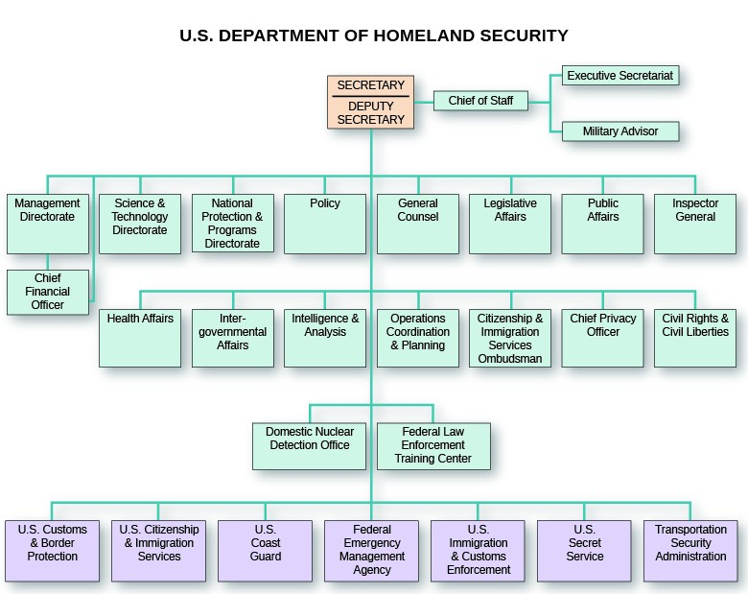
The Bush administration was fiercely committed to rooting out threats to the United States wherever they originated, and in the weeks after September 11, the Central Intelligence Agency (CIA) scoured the globe, sweeping up thousands of young Muslim men. Because U.S. law prohibits the use of torture, the CIA transferred some of these prisoners to other nations—a practice known as rendition or extraordinary rendition—where the local authorities can use methods of interrogation not allowed in the United States.
While the CIA operates overseas, the Federal Bureau of Investigation (FBI) is the chief federal law enforcement agency within U.S. national borders. Its activities are limited by, among other things, the Fourth Amendment, which protects citizens against unreasonable searches and seizures. Beginning in 2002, however, the Bush administration implemented a wide-ranging program of warrantless domestic wiretapping, known as the Terrorist Surveillance Program, by the National Security Agency (NSA). The shaky constitutional basis for this program was ultimately revealed in August 2006, when a federal judge in Detroit ordered the program ended immediately.
The use of unconstitutional wire taps to prosecute the war on terrorism was only one way the new threat challenged authorities in the United States. Another problem was deciding what to do with foreign terrorists captured on the battlefields in Afghanistan and Iraq. In traditional conflicts, where both sides are uniformed combatants, the rules of engagement and the treatment of prisoners of war are clear. But in the new war on terror, extracting intelligence about upcoming attacks became a top priority that superseded human rights and constitutional concerns. For that purpose, the United States began transporting men suspected of being members of al-Qaeda to the U.S. naval base at Guantanamo Bay, Cuba, for questioning. The Bush administration labeled the detainees “unlawful combatants,” in an effort to avoid affording them the rights guaranteed to prisoners of war, such as protection from torture, by international treaties such as the Geneva Conventions. Furthermore, the Justice Department argued that the prisoners were unable to sue for their rights in U.S. courts on the grounds that the constitution did not apply to U.S. territories. It was only in 2006 that the Supreme Court ruled in Hamdan v. Rumsfeld that the military tribunals that tried Guantanamo prisoners violated both U.S. federal law and the Geneva Conventions.

Section Summary
George W. Bush’s first term in office began with al-Qaeda’s deadly attacks on the World Trade Center and the Pentagon on September 11, 2001. Shortly thereafter, the United States found itself at war with Afghanistan, which was accused of harboring the 9/11 mastermind, Osama bin Laden, and his followers. Claiming that Iraq’s president Saddam Hussein was building weapons of mass destruction, perhaps with the intent of attacking the United States, the president sent U.S. troops to Iraq as well in 2003. Thousands were killed, and many of the men captured by the United States were imprisoned and sometimes tortured for information. The ease with which Hussein was deposed led the president to declare that the mission in Iraq had been accomplished only a few months after it began. He was, however, mistaken. Meanwhile, the establishment of the Office of Homeland Security and the passage of the Homeland Security Act and USA Patriot Act created new means and levels of surveillance to identify potential threats.
A Open Assessments element has been excluded from this version of the text. You can view it online here: https://library.achievingthedream.org/bcccomposition/?p=70

Review Question
- In what ways did the U.S. government attempt to deny the rights of prisoners taken in Afghanistan and Iraq?

Answer to Review Question
- The United States denied the rights of prisoners captured in Afghanistan and Iraq by imprisoning and interrogating them outside of the United States, where they were not protected by U.S. law. The U.S. also classified these prisoners as “unlawful combatants,” so that they would not be entitled to the protections of the Geneva Conventions.

Glossary
al-Qaeda a militant Islamist group originally founded by Osama bin Laden
Bush Doctrine the belief that the United States has the right to protect itself from terrorist acts by engaging in pre-emptive wars or ousting hostile governments in favor of friendly, preferably democratic, regimes
Taliban a fundamentalist Muslim group that ruled Afghanistan from 1996 to 2001
WMDs weapons of mass destruction; a class of weapons capable of inflicting massive causalities and physical destruction, such as nuclear bombs or biological and chemical weapons

Chapter 40

Hope and Change

Learning Objectives
By the end of this section, you will be able to:
- Describe how Barack Obama’s domestic policies differed from those of George W. Bush
- Discuss the important events of the war on terror during Obama’s two administrations
- Discuss some of the specific challenges facing the United States as Obama’s second term draws to a close
In 2008, American voters, tired of war and dispirited by the economic downturn, elected a relative newcomer to the political scene who inspired them and made them believe that the United States could rise above political partisanship. Barack Obamas story resembled that of many Americans: a multicultural background; a largely absent father; a single working mother; and care provided by maternal grandparents. As president, Obama would face significant challenges, including managing the economic recovery in the wake of the Great Recession, fighting the war on terror inherited from the previous administration, and implementing the healthcare reform upon which he had campaigned.

OBAMA TAKES OFFICE
Born in Hawaii in 1961 to a Kenyan father and an American woman from Kansas, Obama excelled at school, going on to attend Occidental College in Los Angeles, Columbia University, and finally Harvard Law School, where he became the first African American president of the Harvard Law Review. As part of his education, he also spent time in Chicago working as a community organizer to help those displaced by the decline of heavy industry in the early 1980s. Obama first came to national attention when he delivered the keynote address at the 2004 Democratic National Convention while running for his first term in the U.S. Senate. Just a couple of years later, he was running for president himself, the first African American nominee for the office from either major political party.
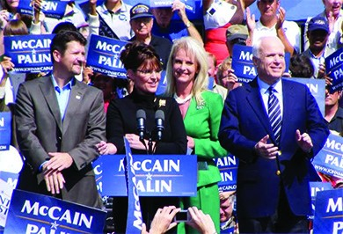
Obamas opponent in 2008 was John McCain, a Vietnam veteran and Republican senator with the reputation of a maverick who had occasionally broken ranks with his party to support bipartisan initiatives. The senator from Arizona faced a number of challenges. As the Republican nominee, he remained closely associated with the two disastrous foreign wars initiated under the Bush administration. His late recognition of the economic catastrophe on the eve of the election did not help matters and further damaged the Republican brand at the polls. At seventy-one, he also had to fight accusations that he was too old for the job, an impression made even more striking by his energetic young challenger. To minimize this weakness, McCain chose a young but inexperienced running mate, Governor Sarah Palin of Alaska. This tactic backfired, however, when a number of poor performances in television interviews convinced many voters that Palin was not prepared for higher office.
Senator Obama, too, was criticized for his lack of experience with foreign policy, a deficit he remedied by choosing experienced politician Joseph Biden as his running mate. Unlike his Republican opponent, however, Obama offered promises of hope and change. By sending out voter reminders on Twitter and connecting with supporters on Facebook, he was able to harness social media and take advantage of grassroots enthusiasm for his candidacy. His youthful vigor drew independents and first-time voters, and he won 95 percent of the African American vote and 44 percent of the white vote.

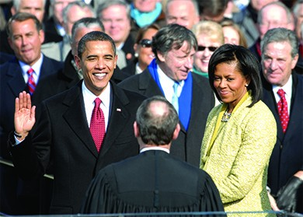

Politicking in a New Century
Barack Obamas campaign seemed to come out of nowhere to overcome the widely supported frontrunner Hillary Clinton in the Democratic primaries. Having won the nomination, Obama shot to the top with an exuberant base of youthful supporters who were encouraged and inspired by his appeal to hope and change. Behind the scenes, the Obama campaign was employing technological innovations and advances in social media to both inform and organize its base.
The Obama campaign realized early that the key to political success in the twenty-first century was to energize young voters by reaching them where they were: online. The organizing potential of platforms like Facebook, YouTube, and Twitter had never before been tappedand they were free. The results were groundbreaking. Using these social media platforms, the Obama campaign became an organizing and fundraising machine of epic proportions. During his almost two-year-long campaign, Obama accepted 6.5 million donations, totaling $500 million. The vast majority of online donations were less than $100. This accomplishment stunned the political establishment, and they have been quick to adapt. Since 2008, nearly every political campaign has followed in Obamas footsteps, effecting a revolution in campaigning in the United States.

ECONOMIC AND HEALTHCARE REFORMS
Barack Obama had been elected on a platform of healthcare reform and a wave of frustration over the sinking economy. As he entered office in 2009, he set out to deal with both. Taking charge of the TARP program instituted under George W. Bush to stabilize the countrys financial institutions, Obama oversaw the distribution of some $7.77 trillion designed to help shore up the nations banking system. Recognizing that the economic downturn also threatened major auto manufacturers in the United States, he sought and received congressional authorization for $80 billion to help Chrysler and General Motors. The action was controversial, and some characterized it as a government takeover of industry. The money did, however, help the automakers earn a profit by 2011, reversing the trend of consistent losses that had hurt the industry since 2004. It also helped prevent layoffs and wage cuts. By 2013, the automakers had repaid over $50 billion of bailout funds. Finally, through the 2009 American Recovery and Reinvestment Act (ARRA), the Obama administration pumped almost $800 billion into the economy to stimulate economic growth and job creation.
More important for Obama supporters than his attempts to restore the economy was that he fulfill his promise to enact comprehensive healthcare reform. Many assumed such reforms would move quickly through Congress, since Democrats had comfortable majorities in both houses, and both Obama and McCain had campaigned on healthcare reform. However, as had occurred years before during President Clintons first term, opposition groups saw attempts at reform as an opportunity to put the political brakes on the Obama presidency. After months of political wrangling and condemnations of the healthcare reform plan as socialism, the Patient Protection and Affordable Care Act was passed and signed into law.
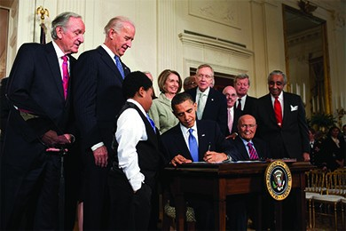
The act, which created the program known as Obamacare, represented the first significant overhaul of the American healthcare system since the passage of Medicaid in 1965. Its goals were to provide all Americans with access to affordable health insurance, to require that everyone in the United States acquire some form of health insurance, and to lower the costs of healthcare. The plan, which made use of government funding, created private insurance company exchanges to market various insurance packages to enrollees.
Although the plan implemented the market-based reforms that they had supported for years, Republicans refused to vote for it. Following its passage, they called numerous times for its repeal, and more than twenty-four states sued the federal government to stop its implementation. Discontent over the Affordable Care Act helped the Republicans capture the majority in the House of Representatives in the 2010 midterm elections. It also helped spawn the Tea Party, a conservative movement focused primarily on limiting government spending and the size of the federal government.

THE ELECTION OF 2012
By the 2012 presidential election, the Republicans, convinced Obama was vulnerable because of opposition to his healthcare program and a weak economy, nominated Mitt Romney, a well-known business executive-turned politician who had earlier signed healthcare reform into state law as governor of Massachusetts. Romney had unsuccessfully challenged McCain for the Republican nomination in 2008, but by 2012, he had remade himself politically by moving towards the partys right wing and its newly created Tea Party faction, which was pulling the traditional conservative base further to the right with its strong opposition to abortion, gun control, and immigration.

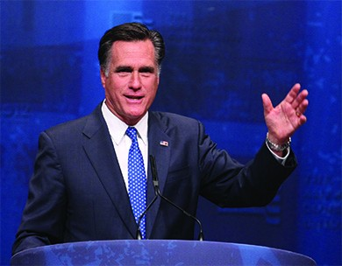
Romney appealed to a new attitude within the Republican Party. While the percentage of Democrats who agreed that the government should help people unable to provide for themselves had remained relatively stable from 1987 to 2012, at roughly 75 to 79 percent, the percentage of Republicans who felt the same way had decreased from 62 to 40 percent over the same period, with the greatest decline coming after 2007. Indeed, Romney himself revealed his disdain for people on the lower rungs of the socioeconomic ladder when, at a fundraising event attended by affluent Republicans, he remarked that he did not care to reach the 47 percent of Americans who would always vote for Obama because of their dependence on government assistance. In his eyes, this low-income portion of the population preferred to rely on government social programs instead of trying to improve their own lives.
Read the
of On the 47 percent, the
given by Mitt Romney at a Republican fundraiser.
Starting out behind Obama in the polls, Romney significantly closed the gap in the first of three presidential debates, when he moved towards more centrist positions on many issues. Obama regained momentum in the remaining two debates and used his bailout of the auto industry to appeal to voters in the key states of Michigan and Ohio. Romney’s remarks about the 47 percent hurt his position among both poor Americans and those who sympathized with them. A long-time critic of FEMA who claimed that it should be eliminated, Romney also likely lost votes in the Northeast when, a week before the election, Hurricane Sandy devastated the New England, New York, and New Jersey coasts. Obama and the federal government had largely rebuilt FEMA since its disastrous showing in New Orleans in 2005, and the agency quickly swung into action to assist the 8.5 million people affected by the disaster.
Obama won the election, but the Republicans retained their hold on the House of Representatives and the Democratic majority in the Senate grew razor-thin. Political bickering and intractable Republican resistance, including a 70 percent increase in filibusters over the 1980s, a refusal to allow a vote on some legislation, such as the 2012 jobs bill, and the glacial pace at which the Senate confirmed the Presidents judicial nominations, created political gridlock in Washington, interfering with Obama’s ability to secure any important legislative victories.

ONGOING CHALLENGES
As Obama entered his second term in office, the economy remained stagnant in many areas. On average, American students continued to fall behind their peers in the rest of the world, and the cost of a college education became increasingly unaffordable for many. Problems continued overseas in Iraq and Afghanistan, and another act of terrorism took place on American soil when bombs exploded at the 2013 Boston Marathon. At the same time, the cause of same-sex marriage made significant advances, and Obama was able to secure greater protection for the environment. He raised fuel-efficiency standards for automobiles to reduce the emissions of greenhouse gases and required coal-burning power plants to capture their carbon emissions.

Learning and Earning
The quality of American education remains a challenge. The global economy is dominated by those nations with the greatest number of knowledge workers: people with specialized knowledge and skills like engineers, scientists, doctors, teachers, financial analysts, and computer programmers. Furthermore, American students reading, math, and critical thinking skills are less developed than those of their peers in other industrialized nations, including small countries like Estonia.
The Obama administration sought to make higher education more accessible by increasing the amount that students could receive under the federally funded Pell Grant Program, which, by the 201213 academic year, helped 9.5 million students pay for their college education. Obama also worked out a compromise with Congress in 2013, which lowered the interest rates charged on student loans. However, college tuition is still growing at a rate of 2 to 3 percent per year, and the debt burden has surpassed the $1 trillion mark and is likely to increase. With debt upon graduation averaging about $29,000, students may find their economic options limited. Instead of buying cars or paying for housing, they may have to join the boomerang generation and return to their parents homes in order to make their loan payments. Clearly, high levels of debt will affect their career choices and life decisions for the foreseeable future.
Many other Americans continue to be challenged by the state of the economy. Most economists calculate that the Great Recession reached its lowest point in 2009, and the economy has gradually improved since then. The stock market ended 2013 at historic highs, having experienced its biggest percentage gain since 1997. However, despite these gains, the nation struggled to maintain a modest annual growth rate of 2.5 percent after the Great Recession, and the percentage of the population living in poverty continues to hover around 15 percent. Income has decreased, and, as late as 2011, the unemployment rate was still high in some areas. Eight million full-time workers have been forced into part-time work, whereas 26 million seem to have given up and left the job market.

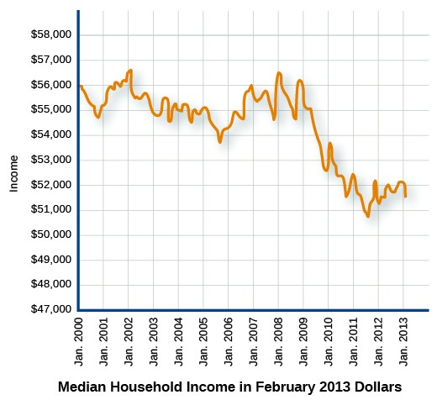

LGBT Rights
During Barack Obamas second term in office, courts began to counter efforts by conservatives to outlaw same-sex marriage. A series of decisions declared nine states prohibitions against same-sex marriage to be unconstitutional, and the Supreme Court rejected an attempt to overturn a federal court ruling to that effect in California in June 2013. Shortly thereafter, the Supreme Court also ruled that the Defense of Marriage Act of 1996 was unconstitutional, because it violated the Equal Protection Clause of the Fourteenth Amendment. These decisions seem to allow legal challenges in all the states that persist in trying to block same-sex unions.
The struggle against discrimination based on gender identity has also won some significant victories. In 2014, the U.S. Department of Education ruled that schools receiving federal funds may not discriminate against transgender students, and a board within the Department of Health and Human Services decided that Medicare should cover sexual reassignment surgery. Although very few people eligible for Medicare are transgender, the decision is still important, because private insurance companies often base their coverage on what Medicare considers appropriate and necessary forms of treatment for various conditions. Undoubtedly, the fight for greater rights for LGBT (lesbian, gay, bisexual, transsexual) individuals will continue.

Violence

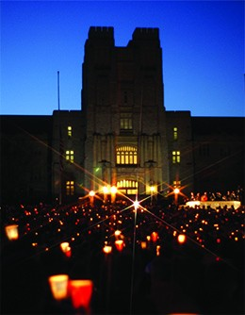
Another running debate questions the easy accessibility of firearms. Between the spring of 1999, when two teens killed twelve of their classmates, a teacher, and themselves at their high school in Columbine, Colorado, and the early summer of 2014, fifty-two additional shootings or attempted shootings had occurred at schools. Nearly always, the violence was perpetrated by young people with severe mental health problems, as at Sandy Hook elementary school in Newtown, Connecticut, in 2012. After killing his mother at home, twenty-year-old Adam Lanza went to the school and fatally shot twenty six- and seven-year-old students, along with six adult staff members, before killing himself. Advocates of stricter gun control noted a clear relationship between access to guns and mass shootings. Gun rights advocates, however, disagreed. They argued that access to guns is merely incidental.
Another shocking act of violence was the attack on the Boston Marathon. On April 15, 2013, shortly before 3:00 p.m., two bombs made from pressure cookers exploded near the finish line. Three people were killed, and more than 250 were injured. Three days later, two suspects were identified, and a manhunt began. Later that night, the two young men, brothers who had immigrated to the United States from Chechnya, killed a campus security officer at the Massachusetts Institute of Technology, stole a car, and fled. The older, Tamerlan Tsarnaev, was killed in a fight with the police, and Dzhokhar Tsarnaev was captured the next day. In his statements to the police, Dzhokhar Tsarnaev reported that he and his brother, who he claimed had planned the attacks, had been influenced by the actions of fellow radical Islamists in Afghanistan and Iraq, but he denied they had been affiliated with any larger terrorist group.

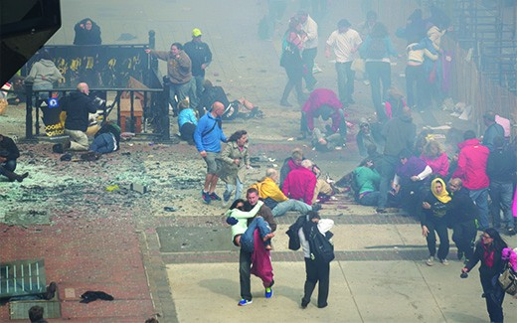

America and the World
In May 2014, President Obama announced that, for the most part, U.S. combat operations in Afghanistan were over. Although a residual force of ninety-eight hundred soldiers will remain to continue training the Afghan army, by 2016, all U.S. troops will have left the country, except for a small number to defend U.S. diplomatic posts.
The years of warfare have brought the United States few rewards. In Iraq, 4,475 American soldiers died and 32,220 were wounded. In Afghanistan, the toll through February 2013 was 2,165 dead and 18,230 wounded. By some estimates, the total monetary cost of the wars in Iraq and Afghanistan could easily reach $4 trillion, and the Congressional Budget Office believes that the cost of providing medical care for the veterans might climb to $8 billion by 2020.
In Iraq, the coalition led by then-Prime Minister Nouri al-Maliki was able to win 92 of the 328 seats in parliament in May 2014, and he seemed poised to begin another term as the countrys ruler. The elections, however, did not stem the tide of violence in the country. In June 2014, the Islamic State of Iraq and Syria (ISIS), a radical Islamist militant group consisting of mostly Sunni Muslims and once affiliated with al-Qaeda, seized control of Sunni-dominated areas of Iraq and Syria. On June 29, 2014, it proclaimed the formation of the Islamic State with Abu Bakr al-Baghdadi as caliph, the states political and religious leader.

Section Summary
Despite Republican resistance and political gridlock in Washington during his first term in office, President Barack Obama oversaw the distribution of the TARP programs $7.77 trillion to help shore up the nations banking system, and Congress authorized $80 billion to help Chrysler and General Motors. The goals of Obamas Patient Protection and Affordable Care Act (Obamacare) were to provide all Americans with access to affordable health insurance, to require that everyone in the United States had some form of health insurance, and to lower the costs of healthcare. During his second term, the nation struggled to grow modestly, the percentage of the population living in poverty remained around 15 percent, and unemployment was still high in some areas. Acceptance of same-sex marriage grew, and the United States sharply reduced its military commitments in Iraq and Afghanistan.
A Open Assessments element has been excluded from this version of the text. You can view it online here: https://library.achievingthedream.org/bcccomposition/?p=71

Review Question
- What has Barack Obama done to make college education more accessible?

Answer to Review Question
- The Obama administration has sought to make higher education more accessible by increasing the amount of money that students can receive under the federally funded Pell Grant Program, which helps millions pay for college. Obama also worked out a compromise with Congress in 2013 that lowered the interest rates charged on student loans.

Critical Thinking Questions
- What factors led to the Great Recession?
- How have conservatives fared in their efforts to defend American culture against an influx of immigrants in the twenty-first century?
- In what ways are Barack Obamas ideas regarding the economy, education, and the environment similar to those of Bush, his Republican predecessor? In what ways are they different?
- How successful has the United States been in achieving its goals in Iraq and Afghanistan?
- In what ways has the United States become a more heterogeneous and inclusive place in the twenty-first century? In what ways has it become more homogenous and exclusive?

Glossary
boomerang generation young people who must return to their parents home in order to make ends meet
Obamacare the Patient Protection and Affordable Care Act
Tea Party a conservative movement focused primarily on limiting government spending and the size of the federal government

Chapter 41

Introduction to MLA Documentation
MLA style is one of the most common citation and formatting styles you will encounter in your academic career. Any piece of academic writing can use MLA style, from a one-page paper to a full-length book. It is widely used by in many high school and introductory college English classes, as well as scholarly books and professional journals. If you are writing a paper for a literature or media studies class, it is likely your professor will ask you to write in MLA style.
The importance of using citations is explained in the following video:
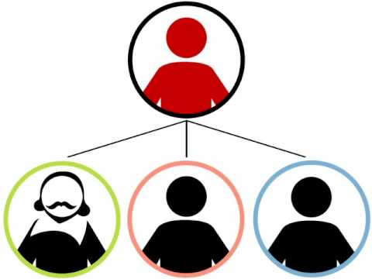
A YouTube element has been excluded from this version of the text. You can view it online here: https://library.achievingthedream.org/bcccomposition/?p=72

The Purpose of MLA Style
The MLA style guide aims to accomplish several goals:
- to ensure consistent use of the English language in academic writing;
- to ensure consistent formatting and presentation of information, for the sake of clarity and ease of navigation; and
- to ensure proper attribution of ideas to their original sources, for the sake of intellectual integrity.

Citation Resources
There are many fantastic resources out there that can make the formatting and citation process easier. Some common style guides are found at:
- The Purdue Online Writing Lab: this is a popular resource that concisely explains how to properly format and cite in various academic styles.
- EasyBib: in addition to having a style guide, this website allows you to paste in information from your research and will create and save citations for you.
Reference management websites and applications can also assist you in tracking and recording your research. Most of these websites will even create the works cited page for you! Some of the most popular citation tools are:
- Zotero
- RefME
- BibMe

The New Edition
The newest edition of the MLA Handbook, the 8th Edition, was released in April 2016. This text will focus on the newest changes, but you should be aware that some institutions or instructors may still utilize the previous 7th edition of the handbook. While the overall principles of creating a works cited page and using in-text citations remains the same, there are a few key changes and updates that make the citation process easier for our modern uses. For example, the guidelines now state that you should always include a URL of an internet source, you can use alternative author names, such as Twitter handles, and you no longer need to include the publisher (in some instances), and you don’t need to include the city where a source was published. These new changes are less nit-picky and allow for a more streamlined citation process that will work with the wide variety of source locations (i.e., YouTube videos, songs, clips from TV episodes, websites, periodicals, books, academic journals, poems, interviews, etc.).

