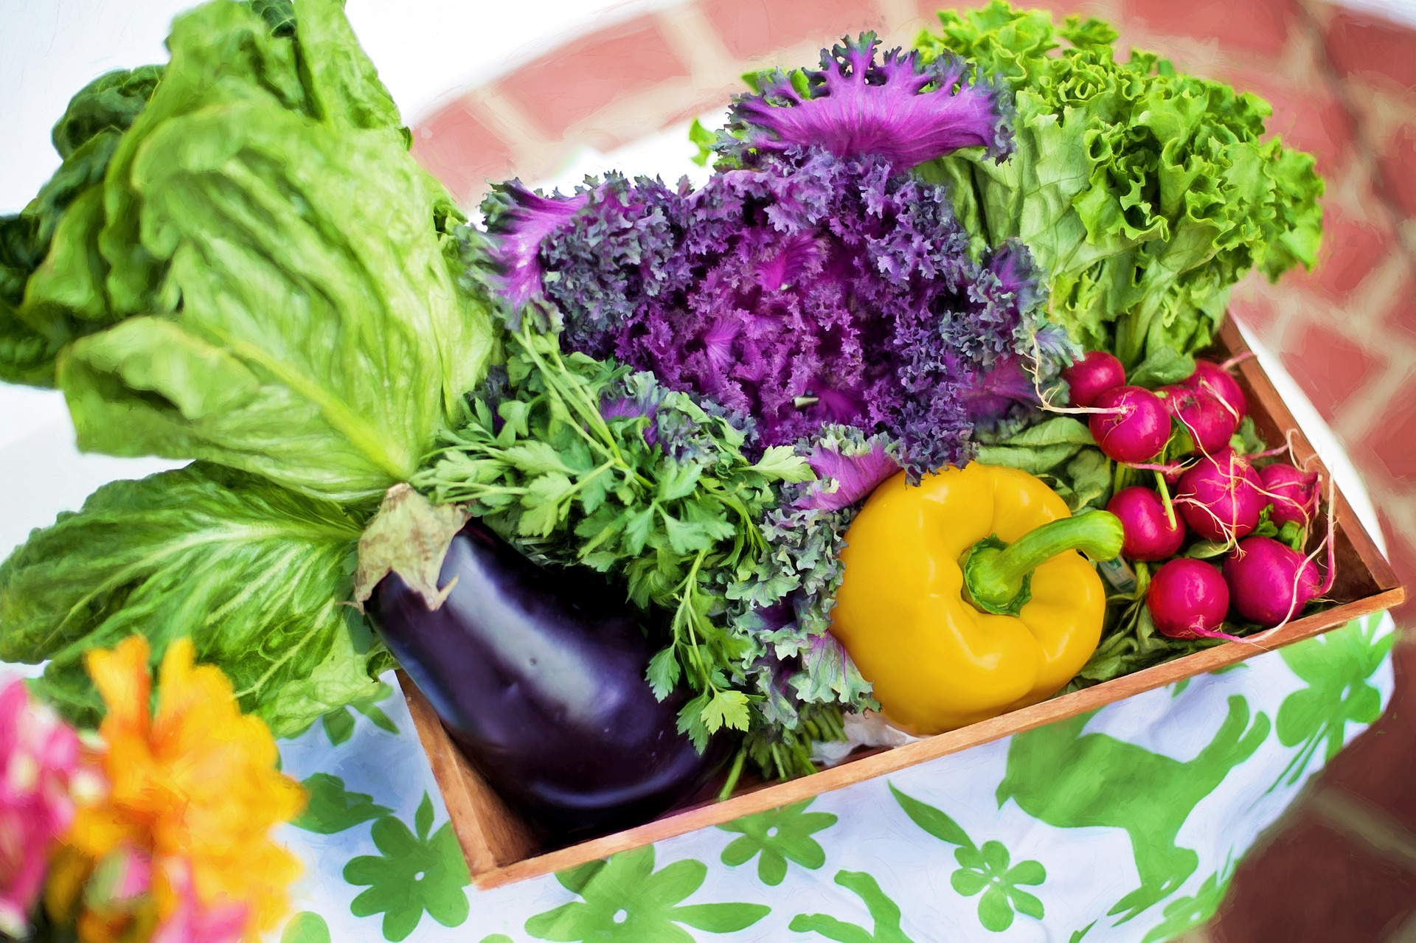

Nutrition

Nutrition

Janet Yarrow, Housatonic Community College

Nutrition by Lumen Learning is licensed under a Creative Commons Attribution 4.0 International License, except where otherwise noted.

Contents
- Faculty Resources
- Request Access
- I Need Help
- OER Text
- Main Book Resource
- The Science of Nutrition
- Introduction to Nutrition Lecture
- Digestion in the Human Body
- Digestion of Food Lecture
- Carbohydrates: Sugar, Starches, Fiber
- Carbohydrates Lecture
- Role of Nutrition in Diabetes
- Role of Nutrition in Diabetes Lecture
- Lipids: Fats, Oils, Cholesterol
- Lipids in Foods Lecture
- Protein
- Protein Lecture
- Vitamins
- Vitamins Lecture
- Minerals
- Minerals Lecture
- Weight Management
- Weight Management Lecture
- Healthy Eating Habits For Life
- Healthy Eating Habits For Life Lecture
- Controversial Issues in Nutrition
- Controversial Issues in Nutrition Lecture
- Dietary Analysis Project
- Project Instructions: 3 Week Dietary Analysis

PART I

Faculty Resources

Chapter 1

Request Access

To preserve academic integrity and prevent students from gaining unauthorized access to faculty resources, we verify each request manually.
Contact oer@achievingthedream.org and we’ll get you on your way.

Overview of Faculty Resources
This is a community course developed by an Achieving the Dream grantee. They have either curated or created a collection of faculty resources for this course. Since the resources are openly licensed, you may use them as is or adapt them to your needs.

Now Available
- Homework Questions
- Discussion Prompts
- Quizzes

Share Your Favorite Resources
If you have sample resources you would like to share with other faculty teaching this course, please send them with an explanatory message and learning outcome alignment to oer@achievingthedream.org.

Chapter 2

I Need Help

Need more information about this course? Have questions about faculty resources? Can’t find what you’re looking for? Experiencing technical difficulties?
We’re here to help! Contact oer@achievingthedream.org for support.

PART II

OER Text

Chapter 3

Main Book Resource
Human Nutrition, University of Hawai‘i at Mānoa Food Science and Human Nutrition Program

PART III

The Science of Nutrition

Chapter 4

Introduction to Nutrition Lecture
Download a PDF of the lecture here.

PART IV

Digestion in the Human Body

Chapter 5

Digestion of Food Lecture
Download a PDF of the lecture here.

PART V

Carbohydrates: Sugar, Starches, Fiber

Chapter 6

Carbohydrates Lecture
Download a PDF of the lecture here.

PART VI

Role of Nutrition in Diabetes

Chapter 7

Role of Nutrition in Diabetes Lecture
Download a PDF of the lecture here.

PART VII

Lipids: Fats, Oils, Cholesterol

Chapter 8

Lipids in Foods Lecture
Download a PDF of the lecture here.

PART VIII

Protein

Chapter 9

Protein Lecture
Download a PDF of the lecture here.

PART IX

Vitamins

Chapter 10

Vitamins Lecture
Download a PDF of the lecture here.

PART X

Minerals

Chapter 11

Minerals Lecture
Download a PDF of the lecture here.

PART XI

Weight Management

Chapter 12

Weight Management Lecture
Download a PDF of the lecture here.

PART XII

Healthy Eating Habits For Life

Chapter 13

Healthy Eating Habits For Life Lecture
Download a PDF of the lecture here.

PART XIII

Controversial Issues in Nutrition

Chapter 14

Controversial Issues in Nutrition Lecture
Download a PDF of the lecture here.

PART XIV

Dietary Analysis Project

Chapter 15

Project Instructions: 3 Week Dietary Analysis

Dietary Analysis : Week 12
For this week, you will keep a diet diary and write down everything you eat and drink for 3 days. Make sure you write down portion size too.

Dietary Analysis : Week 13
Using the diet diary, please answer these questions:
- Did you eat any foods that contained fiber at least once per day? Yes or No.
List the food that contains fiber and next to the food, write down at which meal (breakfast, lunch, dinner or snack) you ate the fiber rich food.

- List the fruits and vegetables you ate each day. Then arrange them into categories like this:
Green fruits and vegetables I ate:
Orange fruits and vegetables I ate:
Purple fruits and vegetables I ate;
Yellow fruits and vegetables I ate:
Red fruits and vegetables I ate:
Other color fruits and vegetables I ate:

- Did you eat protein foods every day? Yes or no?
Next, list the protein foods you ate and write down at which meal (breakfast, lunch, dinner, snack) you ate the protein rich food.

- What percentage of your diet was junk food/processed foods/fast foods?
List the percentage here.

Dietary Analysis: Week 14: Personalized Recommendations
Review all the dietary information you have collected.
Select 2 specific dietary changes you would like to make to improve your diet and therefore your health.

List the two specific dietary changes you would like to make:

Dietary Change 1: ________________________________

Dietary Change 2: _________________________________

For Dietary Change 1, list the steps you will take to to make this change a permanent habit. Write down at least 3 steps but you might have to write more than 3 steps, that is fine.

List the steps here:

Step 1:
Step 2:
Step 3:

For Dietary Change 2, list the steps you will to take to make this change a permanent habit. Write down at least 3 steps, more steps are okay too.

List the steps here:

Step 1:
Step 2:
Step 3:

For Dietary Change 1, write down at least 2 health benefits you except to see as a result of making these changes.

Benefit 1:

Benefit 2:

